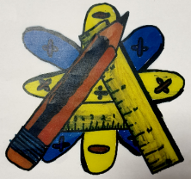
Numeracy Newsletter 1

Logo
For all new staff the numeracy logo (top right) should be displayed in each classroom and used on worksheets where numeracy is being highlighted. The numeracy logo can be found under “staff information” in the numeracy folder on the intranet.
Maths/Numeracy Week has been a great success with every faculty participating. Thanks to everyone for all their hard work. There is lots of good practice around the school and I will share it with you next week. | Copies of the numeracy and maths benchmarks have now been issued to all teaching staff. If you have not received one please let me know.
The numeracy policy and common approach document has been updated to include RMPS and Drama. It also shows how various aspects of numeracy should be taught across the curriculum. An electronic copy can be found on the intranet under “staff information” then click the numeracy folder. | 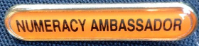  The following pupils have been appointed numeracy ambassadors:  Kailtlin Duff  James Simmons  John Wilson  Jodie Guthrie  Sean Lowrie  Laura Taylor  Ryan Grear
Sumdog license has been purchased for S1/S2 pupils and will be used to assist in the tracking of pupil’s numeracy skills.

I hope everyone has enjoyed their numeracy cartoon this week.
If you have any questions about numeracy please come and see me. Maureen Fletcher

