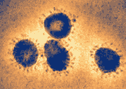
Sars
(Severe Acute Respiratory Syndrome)
Do you have it?

How its spread
Sars can only be spread
Through close personal contact
Or sneezing and coughing
Symptoms
Symptoms can include bad fever
Extremely dry cough
Shortness of breath
Difficulty with breathing

