**Ardrossan Academy**

**Science Faculty**



**S2 BGE**

**Showtime**

**Homework booklet**

**Do not lose or write on this booklet. It should be handed back to your teacher when you are finished with it.**

|  |  |
| --- | --- |
| **Homework** | **Page Number** |
|  | 2 |
|  | 3 |
|  | 4 |
|  | 5 |
|  | 6 |
|  | 7-8 |
|  | 8 |
|  | 9 |
|  | 10 |
|  | 11 |
|  | 12 |

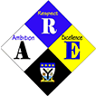

|  |  |
| --- | --- |
| **Homework 1** | **Cells** |

1 Copy the diagram of the cell shown below, and add labels using the words in the box below.

Cell membrane

Cytoplasm

Nucleus

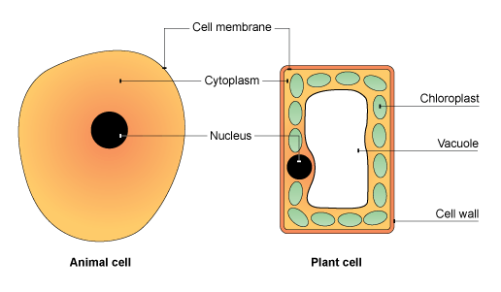

(3)

2 Copy and complete the table to give the function of each part of the cell.

|  |  |
| --- | --- |
| Cell Part | Function |
| Cell Membrane |  |
| Cytoplasm |  |
| Nucleus |  |

(3)

3a What is the term for the special dyes called that Scientists use when preparing a slide? (Hint - Methylene blue you used to stain your cheek cells is an example of one)

b. Why do Scientists use them?

c. What part of the microscope do you place your slide on?

d. What is the lens called that you look through the microscope with? (4)

|  |  |
| --- | --- |
| **Homework 2** | **Digestion** |

**Fill in the missing words and label the diagram!!**

Digestion is where food is passed from the_____________to the__________.

In the mouth, _______ is added to make the food wet and easy to swallow. ____________and ___________ are added in the stomach to help break the food down so it can pass into our intestines. ____________ is re-absorbed in the small intestines and _______________ in the large intestine to make the waste dry. The waste food is excreted from the anus.

**Keywords:** mouth anus enzymes acid nutrients water saliva

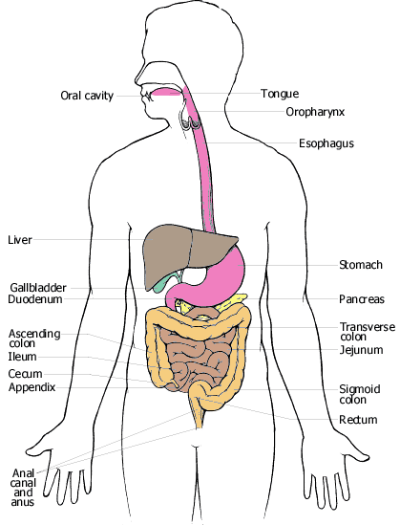

**Key words:** Mouth liver large intestine stomach Small Intestine Gullet Anus

|  |  |
| --- | --- |
| **Homework 3** | **Electricity** |

Material to be tested

Battery

Lamp

1. Each of the materials listed below was placed between the terminals in turn.

Materials: aluminium brass carbon copper

glass iron plastic polystyrene

rubber wood

a) How would you know if the material conducts electricity?

b) Copy the table and write the materials under the correct heading.

|  |  |
| --- | --- |
| Conductors | Insulators |
|  |  |

2. Use these circuit symbols to draw the circuits in your jotter.

A

1. Circuit 1. A battery connected to one lamp with a switch in series to turn the lamp on and off. Add an ammeter to measure the current going through the lamp.
2. Circuit 2. Two batteries, pointing the same way, connected to two lamps in series with a switch between the two lamps.

|  |  |
| --- | --- |
| **Homework 4** | **Electricity 2** |

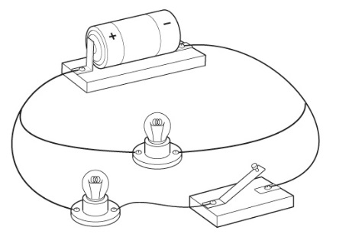1.a) Draw a circuit diagram in your jotter to show how the parts of this circuit are connected.

b) What name is given to the way the lamps are connected?

2. Copy and complete this passage, using words from the list. You may use some words more than once. **voltage current volts amperes**

A simple circuit usually consists of a battery connected to components such as lamps, motors and switches. The ________________ of the battery indicates how much energy is available to the circuit. This is measured in _______________ . The _____________ is measured using an ammeter. This is measured in _____________ .

3. Which switches need to be closed to make lamp A light?

**A**

**B**

**B**

**1**

**2**

**3**

4. Which lamp lights when switches 1 and 3 are closed?

**A**

**B**

**B**

**2**

**1**

**3**

5. What do we call the way that the lamps in Q3 and 4 are connected?