**Ardrossan Academy**

**Science Faculty**



**S3 BGE**

**Dead Earth**

**Homework booklet**

**Do not lose or write on this booklet. It should be handed back to your teacher when you are finished with it.**

|  |  |
| --- | --- |
| **Homework** | **Page Number** |
| Plant cells | 2-4 |
| Photosynthesis 1 | 5 |
| Photosynthesis 2 | 6 |
| Climate change 1 | 7 |
| Climate change 2 | 8 |
| Body-defence | 9 |
| Beating infections | 10 |
| Immunity | 11 |
| Space | 12-13 |
| Agricultural chemicals | 14 |
| Separation | 15 |



|  |  |
| --- | --- |
| **HOMEWORK** | **Plant Cells** |

1. Label the following: 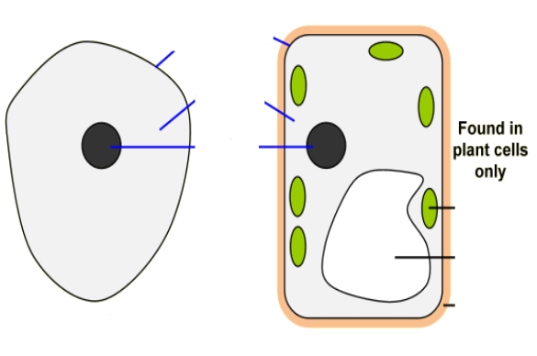
2. Refer to the diagram in Question (1) and complete the table below:

A plant cell:

|  |  |
| --- | --- |
| **Structure** | **Function(s)** |
| **A** |  |
| **B** |  |
| **C** |  |
| **D** |  |
| **E** |  |

1. Refer to the diagram in Question (1) and complete the table below:

An animal cell:

|  |  |
| --- | --- |
| **Structure** | **Function(s)** |
| **A** |  |
| **B** |  |
| **C** |  |

1. Which structure in a plant cell that makes a plant cell appear green?

_____________________________________________________________________

1. Which 3 structures can be found in a plant cell only?

_____________________________________________________________________

1. Which 3 structures can be found in both animal and plant cells?

_____________________________________________________________________

1. Draw a Venn Diagram below and group all the structures into animal only (A), plant only (P) and animals and plants (A&P)

|  |
| --- |
| Plant  A&P  Animal |

|  |  |
| --- | --- |
| **HOMEWORK** | **Photosynthesis 1** |

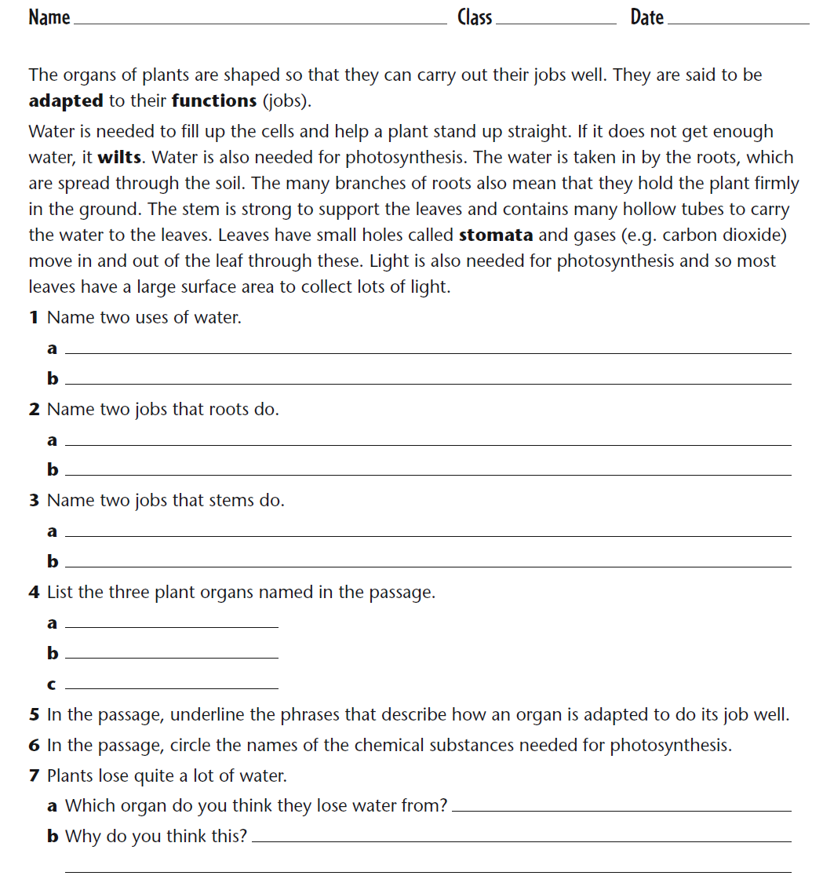

|  |  |
| --- | --- |
| **HOMEWORK** | **Photosynthesis 2** |

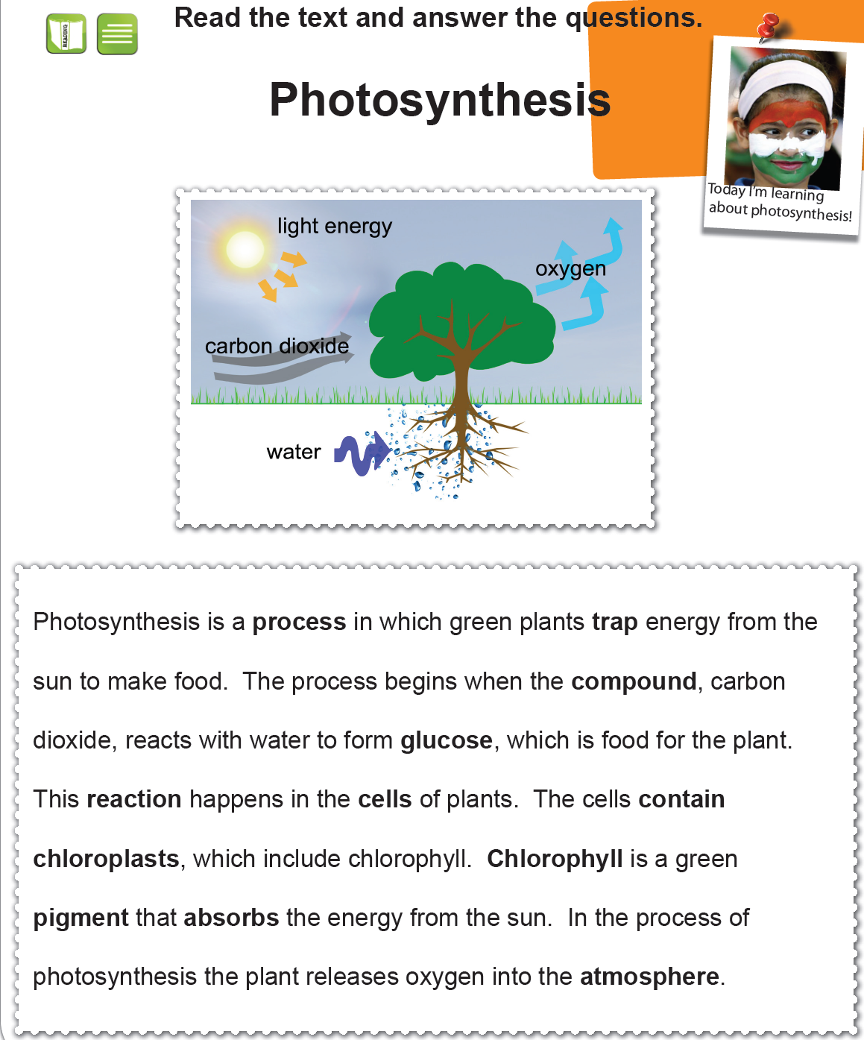

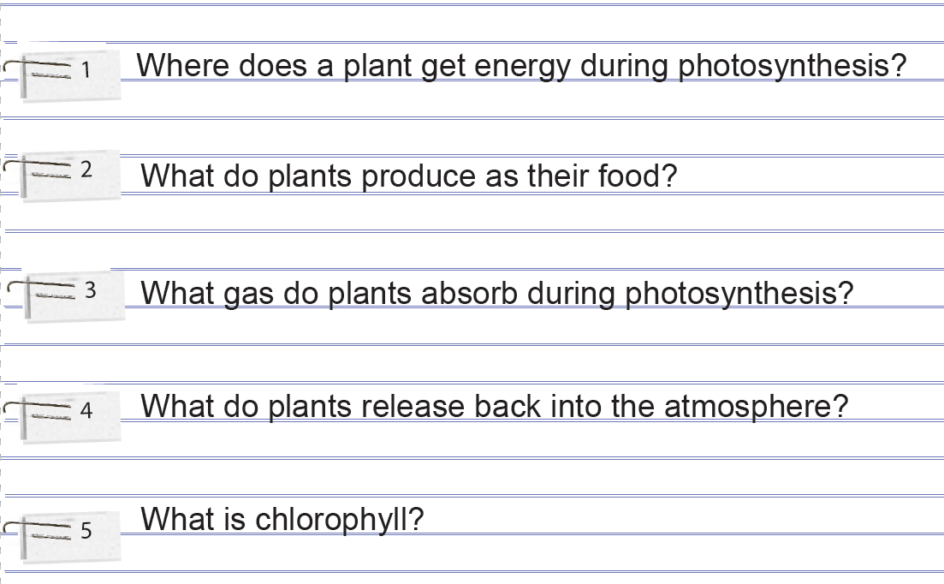

|  |  |
| --- | --- |
| **HOMEWORK** | **Climate change 1** |

You have been learning a bit about Global Warming recently. You should now know what the terms Global Warming, Climate Change and the Greenhouse Effect mean.

**Your challenge is to search the internet and prepare a power point presentation or an information sheet which covers the learning points below.**

**Learning Points**

1. **Explain which gas in the atmosphere causes the greenhouse effect.**
2. **Explain how we can reduce the amount of this gas in the atmosphere.**
3. **Describe ways that we are increasing levels of this gas in the atmosphere.**
4. **Describe some effects of global warming.**

**Criteria for your challenge**

1. You will work individually to complete the challenge.

2. Your power point presentation or information sheet should be accurate, clear and colourful.

3. Each learning point must be covered.

4. You must complete your challenge by the deadline set by your teacher.

**Available resources**

* Computer ( Use the library if you do not have a home computer).
* Good websites-

<http://www.epa.gov/climatechange/kids/greenhouse.html>

<http://www.bbc.co.uk/climate/evidence/greenhouse_effect_img.shtml>

<http://www.coolkidsforacoolclimate.com/Explained/earth.html>

|  |  |
| --- | --- |
| **HOMEWORK** | **Climate change 2** |

Scientists and governments are getting increasingly worried about rising levels of carbon dioxide in the atmosphere and the possibility that increased carbon dioxide will lead to the mean (average) temperature of the Earth increasing – an effect known as global warming.

Monitoring stations have been set up all over the world to record the concentrations of different gases in the atmosphere. The graph shows how the concentration of carbon dioxide in the atmosphere changed over four years in the northern and southern hemispheres.

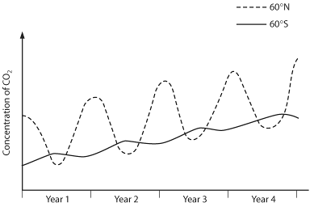

**1** a Name two natural processes which produce carbon dioxide.

**2** a Which natural process removes carbon dioxide from the air?

**3** How are human activities adding to the amount of carbon dioxide in the air?

**4** Look carefully at the line showing carbon dioxide concentration in the northern hemisphere.

**a** At which time of year do the high concentrations occur?

**b** What do you think causes the highs and lows in this line? (Hint: Think about when most plant growth occurs.)

**5** Look at the line for the southern hemisphere. Why are the highs and lows on this line in different places to the ones for the northern hemisphere?

**6** What overall trend do both lines show?

**7** Sketch a graph showing how you would expect the concentration of oxygen in the atmosphere to change over this four-year period in the northern and southern hemispheres.

**8** If you look at a globe or an atlas you will see that there is a lot more land in the northern hemisphere than in the southern hemisphere – the southern hemisphere has more ocean. Does most photosynthesis happen in land plants or in water plants in the oceans? Explain how you arrived at your answer.

|  |  |
| --- | --- |
| **HOMEWORK** | **Body-defence** |

1. Copy this out and draw lines to match the sentence beginnings with the correct endings.

scabs.

mucus.

acid.

microbes.

nose and windpipe.

microbes.

Microbes are stopped from getting into cuts by …

A sticky substance that traps microbes is called …

Mucus is made in the …

White blood cells destroy …

Antibodies can stick to …

Bacteria in the stomach are killed by …

**2** a Label the parts of this drawing represented by the **?** ______________________

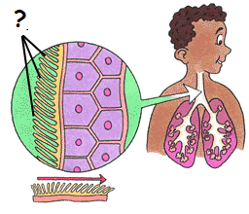**b** Explain how the labelled part helps to protect us from disease.

________________________________________________________________________________________________________________________________________________________________________________________________________________________________________________________________________________________________________________________________________________________________________________________________________________________________________________

|  |  |
| --- | --- |
| **HOMEWORK** | **Beating infections** |

Copy and complete the information below.

Fill in the gaps in these sentences using words from the box. You do not need to use all of the words:

If disease-causing *_______________* infect you, your body will make *_______________* to help to destroy them. You will get the *_______________* until your body has made enough antibodies to *_______________* all the microbes.

You can be *_______________* to stop you getting a disease. Normally, this is an injection that contains a *_______________.* This makes your body produce *_______________* against a particular microbe. If you are *_______________* by the real microbes, the *_______________* blood cells can make the *_______________* straight away and you do not get the disease.

Many scientists think that *_______________* have saved many lives and that they helped to rid the world of a disease called *______________.*

Word Bank

antibodies antibodies antibodies antibiotics destroy

disease immunised infected injection microbe

microbes red smallpox vaccine vaccines white

|  |  |
| --- | --- |
| **HOMEWORK** | **Immunity** |

1. Draw lines to match the words with their meanings.

when you are treated so that you won’t get a certain disease

substance in an injection used to   
stop you getting a disease

substance made by the body to help destroy microbes

when you can’t get a certain disease

antibody

immune

vaccine

immunisation

**2** a Neela is 2 years old. How many of these diseases will she probably be immunised against?   
Tick the correct boxes **(use the internet)**

⬜ bacterial meningitis ⬜ diphtheria ⬜ measles ⬜ mumps ⬜ polio ⬜ rubella

⬜ tetanus ⬜ tuberculosis ⬜ typhoid ⬜ whooping cough ⬜ yellow fever

**b** How else could Neela become immune to one of these diseases?

______________________________________________________________________________________

|  |  |
| --- | --- |
| **HOMEWORK** | **Space** |

ANSWER ALL OF THE QUESTIONS IN YOUR HOMEWORK JOTTER

**YOU WILL NEED GRAPH PAPER**

1 a) What is the closest object to the Earth in space? (1)

b) What word is used to describe its movement around the Earth? (1)

c) How long does it take to travel around the Earth? (1)

d) What events happen when this object lines up directly between the Earth and the Sun? (1)

2 a) Which planets are closer to the Sun than the Earth? (2)

b) What is the next planet out from the Earth, away from the Sun? (1)

c) What features to these four planets, including Earth, have in common? (2)

d) What are the names of the four remaining planets, in order? (4)

e) What do these have in common? (1)

3 The table below shows data on the distance from their star and the average temperature for four planets.

|  |  |  |  |  |
| --- | --- | --- | --- | --- |
| Planet | Nairi | Madri | Folki | Greti |
| Distance from Star (million km) | 58 | 110 | 150 | 230 |
| Temperature (°C) | 570 | 280 | 120 | 30 |

1. Use the graph paper to draw a LINE GRAPH for this data (4)
2. What conclusion can you make from this data and your graph? (1)

4 Mass, weight and gravity are related by the formula –

*Weight = Mass x Gravity*

1. Copy and complete the table below to give the correct measurements and units.

|  |  |
| --- | --- |
| Measurement | Units |
|  | Newtons per kilogram (N/kg) |
| Weight |  |
|  | Kilograms (kg) |

(3)

b) On planet Stewi, the gravity has a strength of 5 N/kg.

If a rock on the planet has a mass of 10 kg, what is its weight? (2)

5 The Earth is the only planet known to have life.

a) Apart from humans, give an example of a very complex living thing. (1)

b) Give an example of a very simple form of life. (1)

c) Name three conditions that are necessary for life to exist. (3)

d) Do you think that living things are likely to exist elsewhere in space?

Give TWO reasons for your answer. (3)

|  |  |
| --- | --- |
| **HOMEWORK** | **Agricultural Chemicals** |

1. Use what you have learned in class, or research a bit about the elements required for plant growth.

Using an arrow, match up the following minerals with their importance to plant growth

Nitrogen Flower/ fruit growth

Phosphorous Root growth

Potassium Leaf growth (2)

2. State two reasons why farmers use fertilisers (2)

(i)_________________________________

(ii)_________________________________

3. What are pesticides used for and why are they important

Use________________________________

Importance____________________________ (2)

4. What do you understand about the word ‘organic’?

_______________________________________(1)

5. Why do you think you must care be taken when using herbicides?

______________________________________ (1)

6. State one advantage and one disadvantage of using chemicals in agriculture.

Advantage______________________________

Disadvantage_____________________________ (2)

|  |  |
| --- | --- |
| **HOMEWORK** | **Separation** |

**Use the word bank in the box to fill in the gaps in your jotter.**

**Distillation** can be used to separate two or more liquids. The mixture is boiled and the gas with the lowest ________ ______ goes into the ___________ first. It ___________ into a liquid and is collected. The other liquid is left behind.

**Filtration** is used to separate a solid from a liquid using a filter. The solid cannot __________ in the liquid and it also cannot pass through the holes in the _________, but the liquid can.

**Evaporation** is used to separate a solid that is dissolved in a __________. As the liquid __________ into a gas, it leaves the solid behind, often as crystals.

**evaporates dissolve filter condenser condenses boiling point liquid**

Using the information above, explain whether you would use filtration, evaporation or distillation in each of these cases:

1. Greg lives by the sea and wants to make his own sea-salt for cooking. He gets it from seawater.
2. Eric has made some brandy at home. He wants it to be stronger by removing some of the water.
3. Boris accidentally drops 1kg of sugar in a bucket of hot water. It dissolves, but he wants to get the solid sugar back.
4. Lily is shipwrecked on an island. She needs clean water, but there isn’t any – just a swamp with muddy water.
5. Angus has a bottle of alcohol mixed with water. He wants to remove the alcohol from the water to use as a fuel.