**Ardrossan Academy**

**Science Faculty**



**S1 BGE**

**Pyrotechnics**

**Homework booklet**

**Do not lose or write on this booklet. It should be handed back to your teacher when you are finished with it.**

|  |  |
| --- | --- |
| **Homework** | **Page Number** |
| Electromagnetic Spectrum 1 | 2 |
| Electromagnetic Spectrum 2 | 3 |
| The Eye | 4 |
| The Ear | 5 |
| Chemical Reactions 1 | 6 |
| Chemical Reactions 2 | 7 |
| Light 1 | 8 |
| Light 2 | 9 |
|  |  |
|  |  |
|  |  |

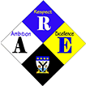

|  |  |
| --- | --- |
| **HOMEWORK** | **Electromagnetic Spectrum** |

1. There are 7 parts to the electromagnetic spectrum. Identify the two missing radiations P and Q.

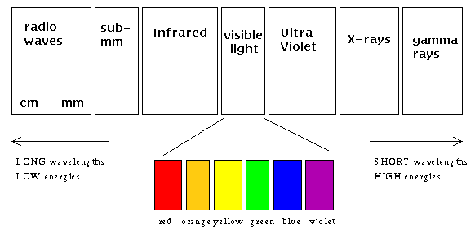

P

Q

1. What is different about each part of the electromagnetic spectrum?
2. What speed do microwaves travel?
3. Marconi discovered that radio waves could be used for wireless communication.

Write three interesting facts about Marconi, based on your research.

1. Some radiations are visible to the naked eye and some are not. Circle the radiations given below which are not visible to the eye.
2. The table below includes information about different types of radiation. Complete the table

|  |  |  |  |
| --- | --- | --- | --- |
| Description | Type of radiation | Medical use | Non-medical use |
| Sometimes called heat radiation |  | Easing pain in muscles |  |
| Can be detected by photographic film |  | Identifying broken bones |  |
| Can cause skin cancer |  |  | Identifying security markings |
| Can kill living cells |  |  | Used as a tracer in inductry |

1. Skin cancer is most likely to be caused by exposure to which type of radiation?

|  |  |
| --- | --- |
| **HOMEWORK** | **Electromagnetic Spectrum 2** |

1. Each type of radiation in the table below is used for one of the following :

A – Heating

B – Identifying invisible ink marks

C – checking for broken bones

Complete the table by matching each type of radiation with its correct use.

|  |  |
| --- | --- |
| Type of radiation | Use of radiation |
| X-rays  Ultraviolet  Infrared |  |

2. Name a material used to detect X-rays.

1. Many people wear sun tan creams to protect themselves from ultraviolet radiation. Why do people need to protect their skin from too much ultraviolet radiation?
2. Read the following passage

One difference between visible radiation, infrared radiation and ultraviolet radiation is that they have different frequencies. These frequencies are measured in a unit called terahertz.

Infrared radiation has a smaller frequency than visible radiation. Ultraviolet has a greater frequency than visible radiation.

The human eye can only see radiation with frequencies between 400 and 750 terahertz.

a) Which of the radiations described in the passage has the smallest frequency?

b) State a possible frequency for visible radiation.

|  |  |
| --- | --- |
| **HOMEWORK** | **The Eye** |

Apart from functioning eyes, we need ........... in order to see. Light passes through the transparent covering over the front of the eye. This is called the ………... . The light sensitive ring that controls the amount of light going into the eye, and looks like a black dot is called the ............... The light is let through and is focused by the ............. onto the back of the eye. The light passes through the liquid in the eye until it reaches the light sensitive lining at the back of the eye known as the .……….. The nerve cells in the retina send messages to the brain along the ..………. ………...

Choose a word to fill each gap.

Optic Nerve Lens Cornea

Light Retina Pupil

|  |  |
| --- | --- |
| **HOMEWORK** | **The Ear** |

1. Label the diagram using the following words

Auditory canal Auditory nerve Ear-drum Cochlea Outer ear

(b)

(a)

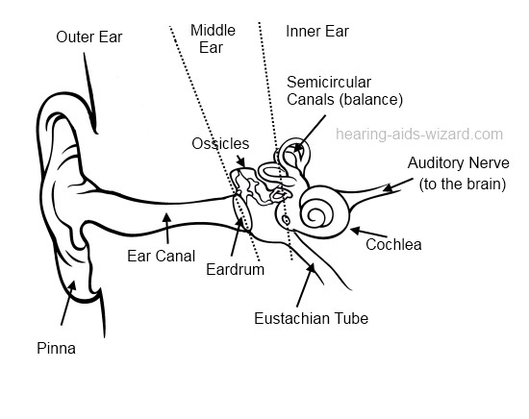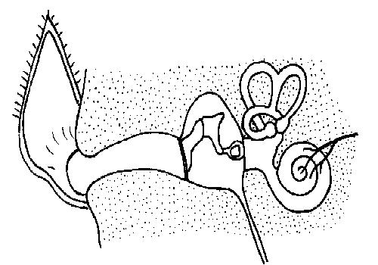

(c)

(e)

(d)

1. *These statements about how we hear are jumbled up. You need to write them in the correct order.*

The vibrations pass along the auditory nerve to your brain.

The ear-drum vibrates when a sound hits it.

Your brain sorts the message and you hear the sound.

Your outer ear channels the sound waves into your ear.

The vibrating ear-drum makes the little bones in your ear vibrate.

The sound waves travel along the auditory canal.

|  |  |
| --- | --- |
| **HOMEWORK** | **Chemical Reactions 1** |

Jose placed a small piece of potassium into a trough of water. The potassium burned with a lilac flame and a hissing noise was heard as a gas was produced, the gas when tested was found to be hydrogen while the water in the trough had been changed to potassium hydroxide.



1. State three signs that a chemical reaction took place.

1. Write a word equation for the chemical reaction that took place in Jose’s experiment.
2. Dominic carried out the following experiment.



What two pieces of evidence tells you that a chemical reaction has taken place?

4. Explain why boiling water is a physical change and not a chemical one.

5. Oxygen gas is produced when hydrogen peroxide is added to manganese dioxide. Anina wanted to find out if different concentrations of the hydrogen peroxide affected the rate of the reaction. She set up the following.



Which test tube gave the fastest reaction? Why did this test tube react the quickest?

|  |  |
| --- | --- |
| **HOMEWORK** | **Chemical Reactions 2** |

1. Fill in the table for the examples given



2. A scientist thinks that he has discovered a new element. It is a shiny, silver material and he decides to call it glasgium. The scientist showed that glasgium reacts with oxygen to form a new substance which is a white powder called glasgium oxide.

a) Write a word equation for this reaction.

b) Explain why this is an example of a chemical change.

c) Another scientist timed how long it took for a lump of glasgium to react with water by measuring the volume of hydrogen gas produced. Her results are shown

below.



i) How long did it take for all the glasgium to react?

ii) Draw a line graph of the scientists results.

|  |  |
| --- | --- |
| **HOMEWORK** | **Light 1** |

1. The diagram below shows a ray of light **reflecting** from a plane mirror.

**Draw and label** the diagram with these terms:

**angle** **of** **incidence** **angle** **of** **reflection**  **incident** **ray** **reflected** **ray normal** **mirror**



2. The diagram shows a beam of light arriving at a perspex block.

a) Show, by drawing on the diagram, where the ray goes after it enters the block.

b) What is this change of direction of light called?

|  |  |
| --- | --- |
| **HOMEWORK** | **Light 2** |

1. Describe how you would use a convex lens as a magnifying glass.

2. Draw and complete the following diagrams for lenses.

***Mark*** in your diagram the ***focus*** and the ***focal length***.

3. What happens to the parallel rays of light once they pass through a concave lens?

4. Draw a diagram to show the shape of a concave lens.