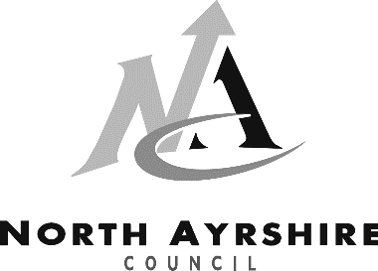
EDUCATION SERVICE
Registration for Primary School
Parent/Carer Information
As your child will turn 5 between 1 March 2021 and 28 February 2022 you should make arrangements to register your child for primary education as from August 2021.

Registration for August 2021 is an online process and will take place during the period Monday 11 January 2021 and Friday 29 January 2021.

You should register your child’s details for your catchment primary school for your address by following the link below or telephoning 01294 310000.

P1 Registration Form

If any additional supporting documents are required, the school will contact you directly.

Placing Request
You have the choice to submit a placing request to a primary school outwith your catchment area but you must first register with your catchment primary school.

If you decide to make a placing request, then you should complete a placing request form before 15 March 2021. More information on placing requests and how we process these can be found on our website.

It is important to note that if you do submit a placing request you will be responsible for any transport costs, other than exceptional circumstances.

Transport
If you live more than 2 miles from your catchment primary school you can apply for free school transport.

