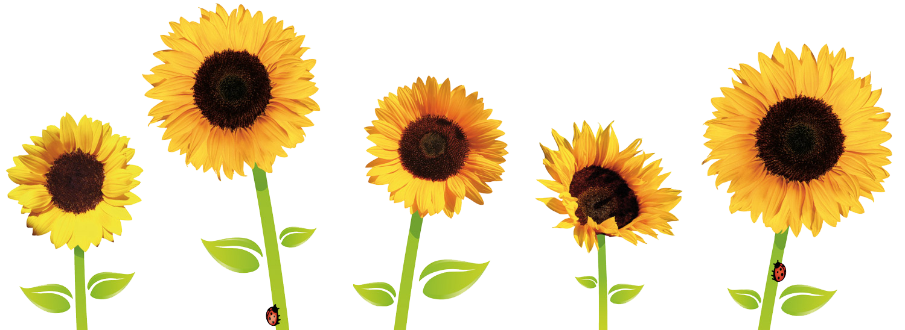

Growing a Sunflower
Below are a selection of activities and experiences you and your child can enjoy at home over the next few weeks.
Please keep photographs and drawings of the activities you choose to do. We will display them all on our return to the Early Years Class.

Literacy & English
- Watch and listen to the story of ‘The Little Seed’ by Eric Carle.
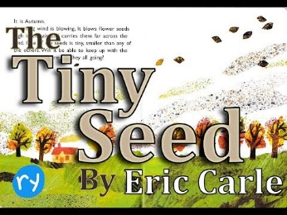
- Sing ‘Planting the seed’ song from the sheet provided.
- Name the different parts of the growing sunflower – stem, leaf, petal, roots, bud etc.
- Watch Topsy & Tim planting seeds on the clip below -
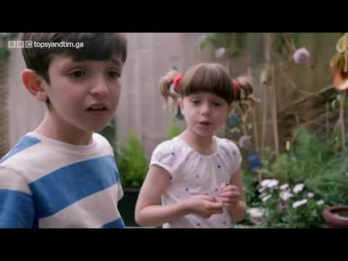

Numeracy & Maths/ STEM
- Measure the growing sunflower using a measuring tape, sticks, hands, lego bricks.
- Make your own sunflower diary - draw the changes you can see as it grows.
- Discuss the life cycle process – from seed to sunflower.
Health & Wellbeing
- Encourage children to take responsibility for caring for their sunflower.
- What will have to do to make it grow?

There will be prize for the tallest sunflower!

