Speedy 6: Spicy
Copy and complete the column method addition, subtraction, multiplication and division questions.
If you need a reminder on how to solve these, check out the Learn Screens in the ‘Column Methods’ folder in your Classwork section on Education City.
Questions
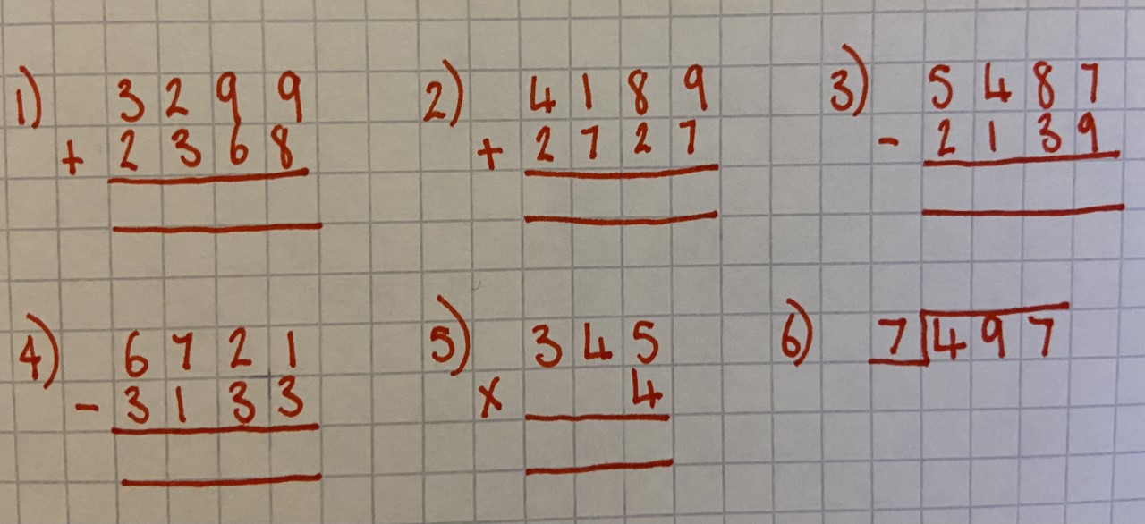

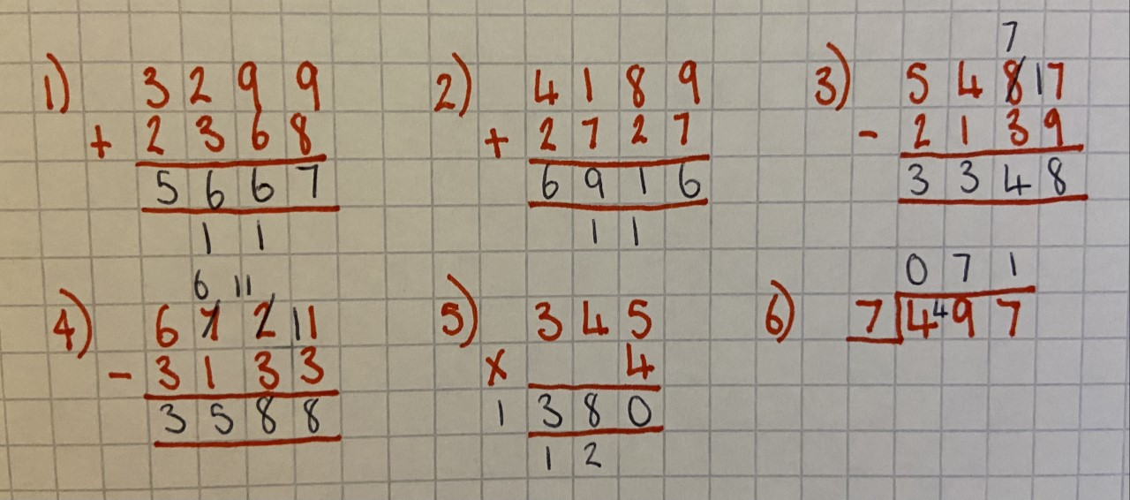
Answers

