3D Shape Hunt
Name: Date:
Be a shape detective and look out for these 3D shapes around your home. Write about them in the table below.
Shape  Name and sketch | Location  Where can you find them in your house? | Properties  Number of sides & edges
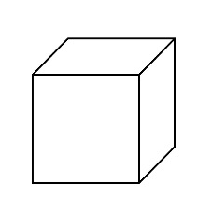
Cube

cube
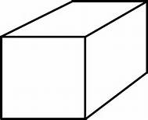

cuboid
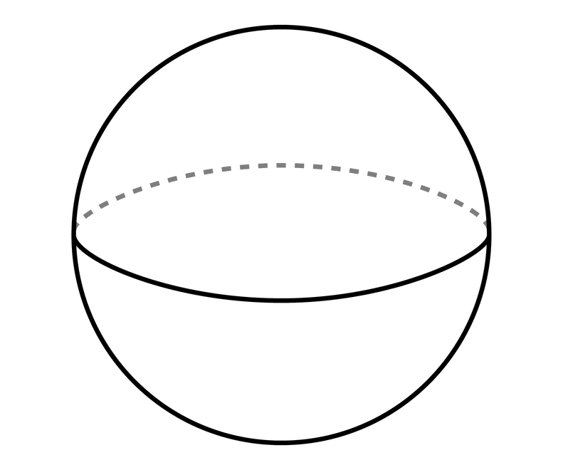

sphere
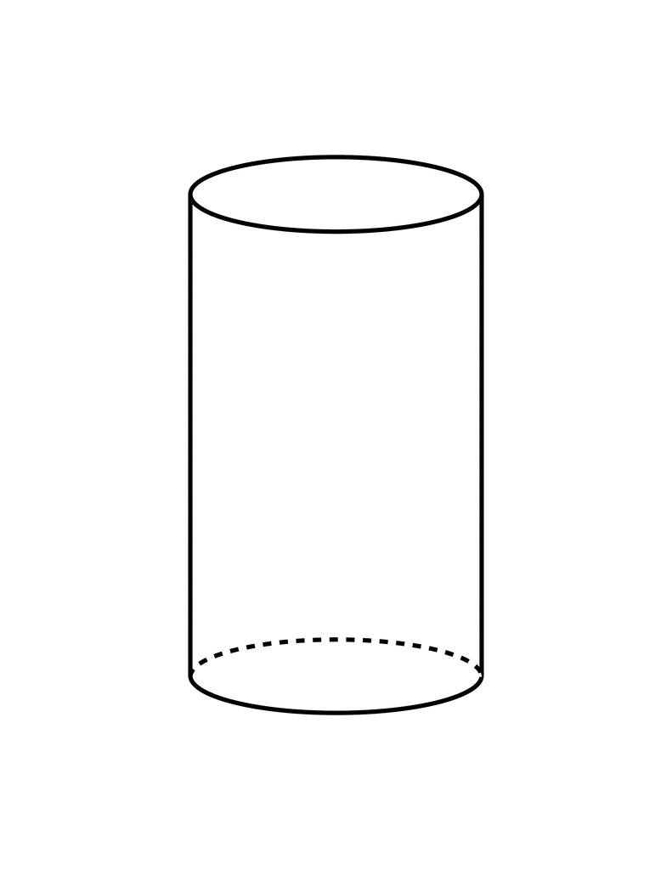

cylinder
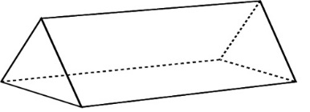

triangular prism
________________
edges faces flat straight circle triangle square rectangle

