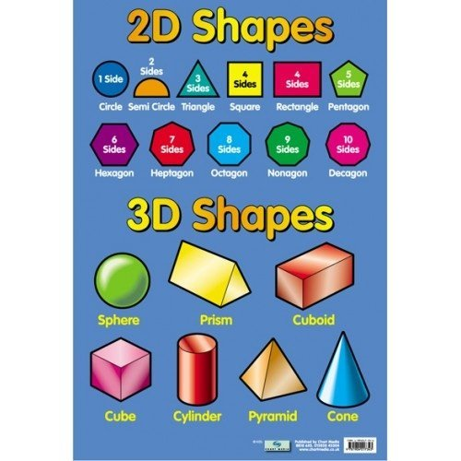

**Square Based Pyramid**

**Triangular Prism**