P2 Activity Grid
Relax and Read  Find a quiet spot with your favourite book and get lost in the story.  Share your reading with an adult. | Winter Time Theme  Try out some of these activities throughout your week.  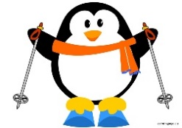 |  | Internet Research  Use the internet to research the winter Olympics. Try to find out when it is, where it will take place and what some of the events will be.
Art Attack  - Paint a picture of a penguin.  Or  - Create a picture to show what you like best about winter time.  Or  - Design a snow globe. | Winter Menu  - Create the perfect winter menu.  - What would be your ideal meal for the chilly months?  - Include a starter, main and pudding. |  | Free Writing  Write a story that starts with ‘My snowman came alive today and he…’
Winter Walk  Go on a sensory winter walk with an adult. What can you see? What can you smell or hear?  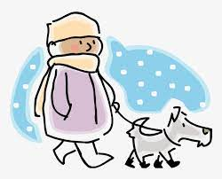 | Family Fun  - Play a board game.  - Have a movie afternoon/night.  - Help with setting the table and clearing up. | Winter Clothes  - Draw a picture of someone dressed for a cold winter day.  - Label the clothes they are wearing to keep them warm and dry. | Do you want to build a snowman?  Use an old toilet roll tube to create your very own snowman.  