Name __________________________ Date ___________________
Predicting
We are learning to predict what the book might be about from only looking at the front cover. Select a book from your house and think about who the characters might be, the setting and what the story might be about.
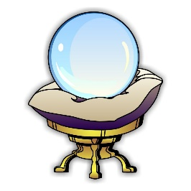
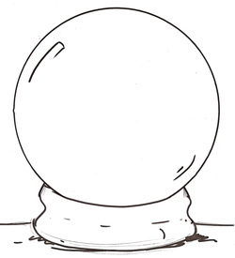

In this story I predict that:
_____________________________________________________________________________________________________________________________________________________________________________________________

