Logging into and Using Glow – A Guide for Parents

**How does my child get access?**

Your child will be given access by the school via a unique login using a secure username and password. This gives the child access to information and resources suitable to them.

Go to <https://sts.platform.rmunify.com/account/signin/glow> and you will be taken to the website shown below.

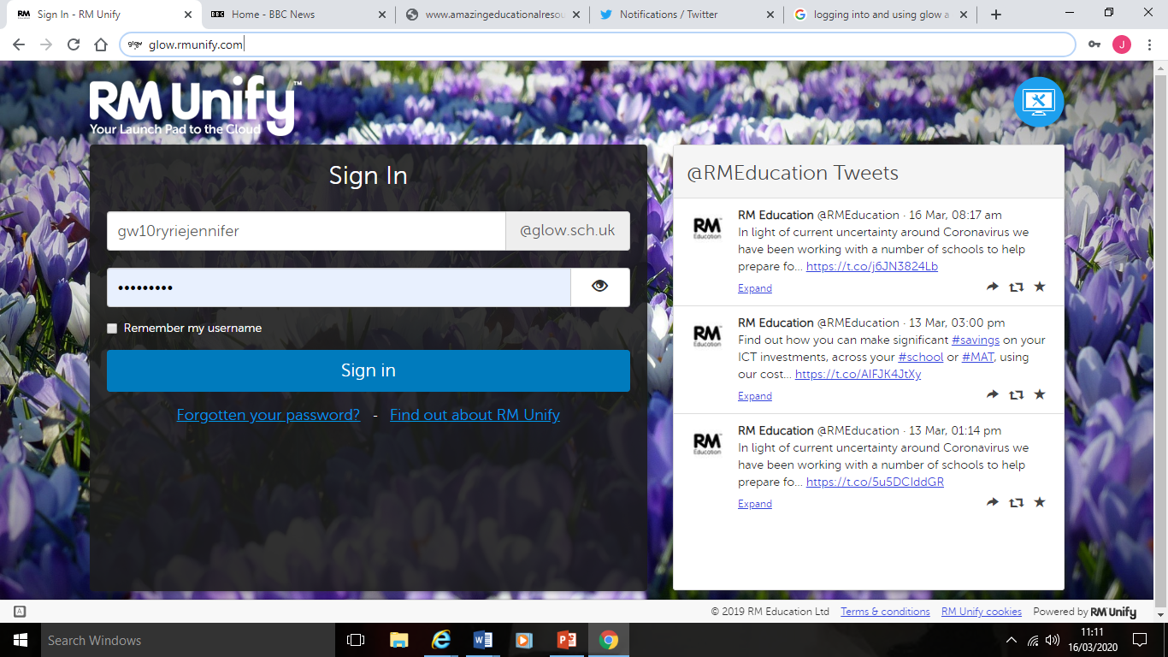

Enter your child’s username (first part of email address) i.e. **gw10bloggsjoe** into the first box.

Enter your child’s password into the second box and press ‘Sign In’

You may then be prompted to accept the Glow usage policy.

This will take you to the *Glow Launch Pad* which will look similar to the one below.

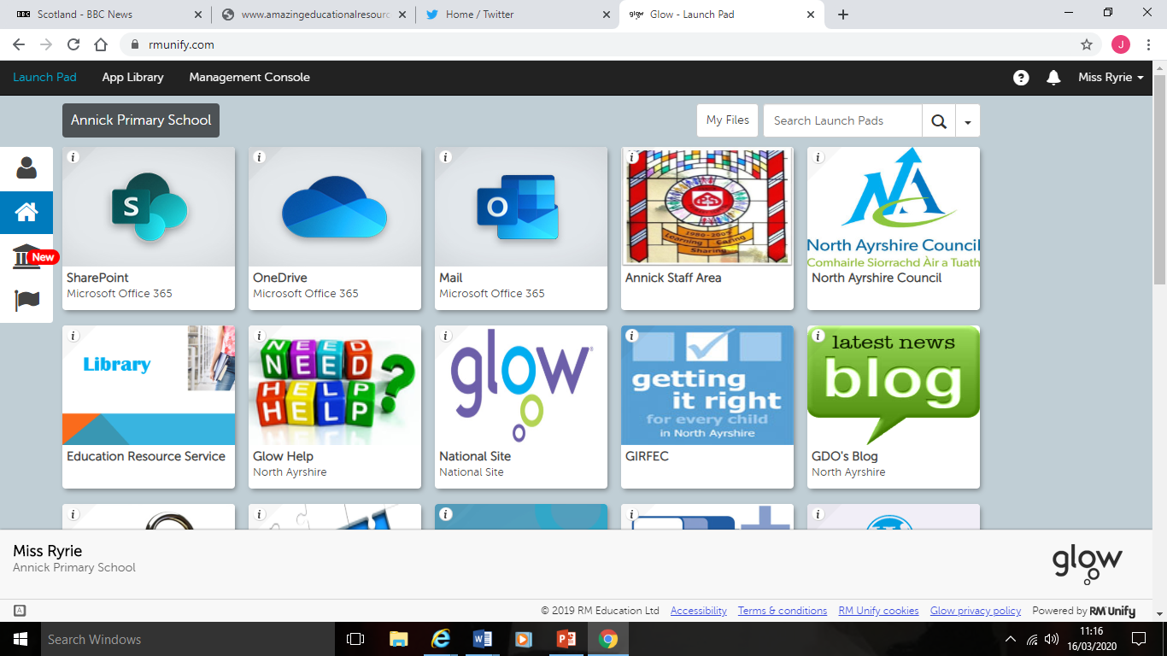

All communication can be accessed through the *Mail* tile. Clicking on this will transfer you to your child’s mail box where they will be able to access any tasks or communication from their teacher.

When you select it you may be prompted to set Language and Time zone. Please select English (United Kingdom) and Dublin, Ediinburgh, Lisbon, London Timezone. Once complete, click save, Mailbox will open.

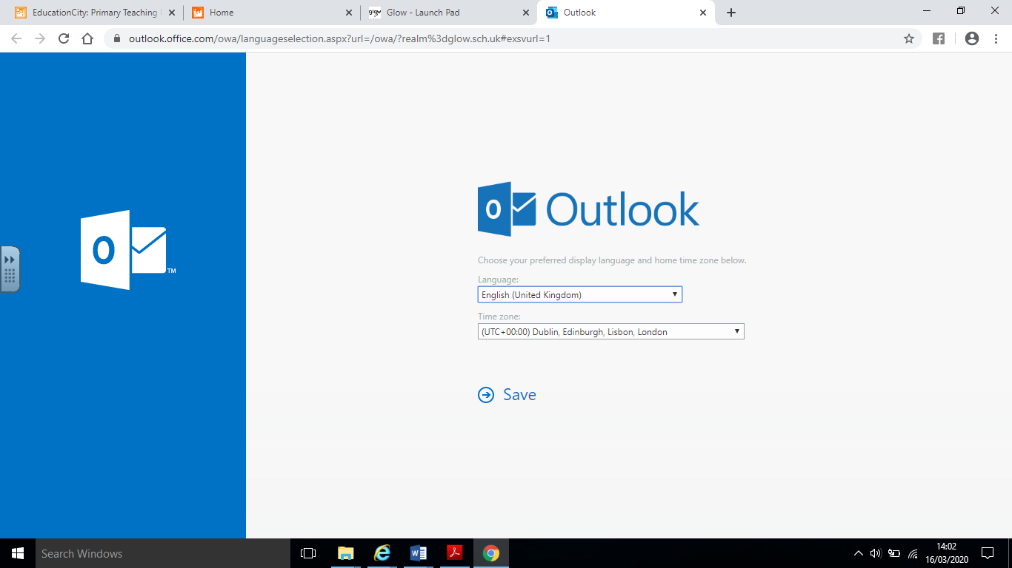

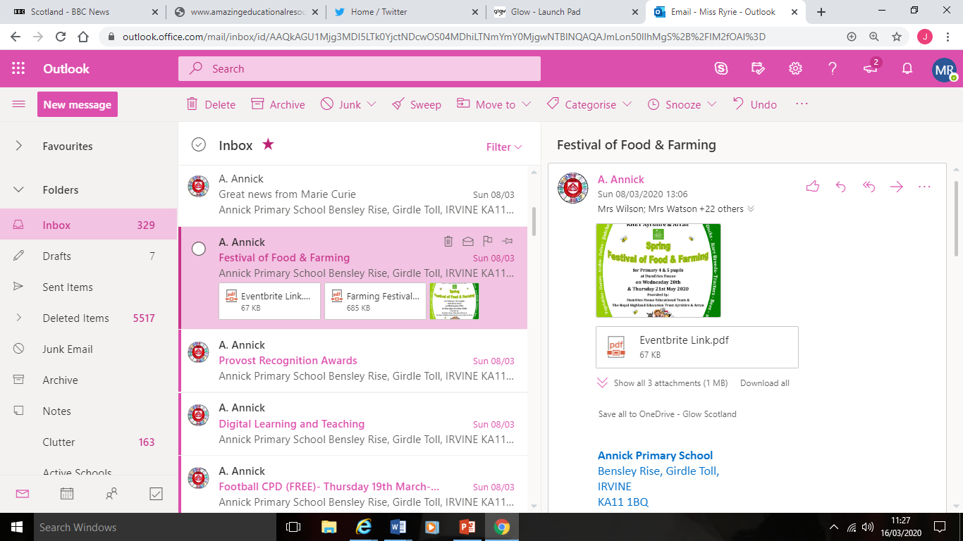

Emails will appear here which when opened, will appear on the right hand side of the screen as shown.

Your child has been added to a *Glow Group* for his/her class. Teachers will set tasks through this.

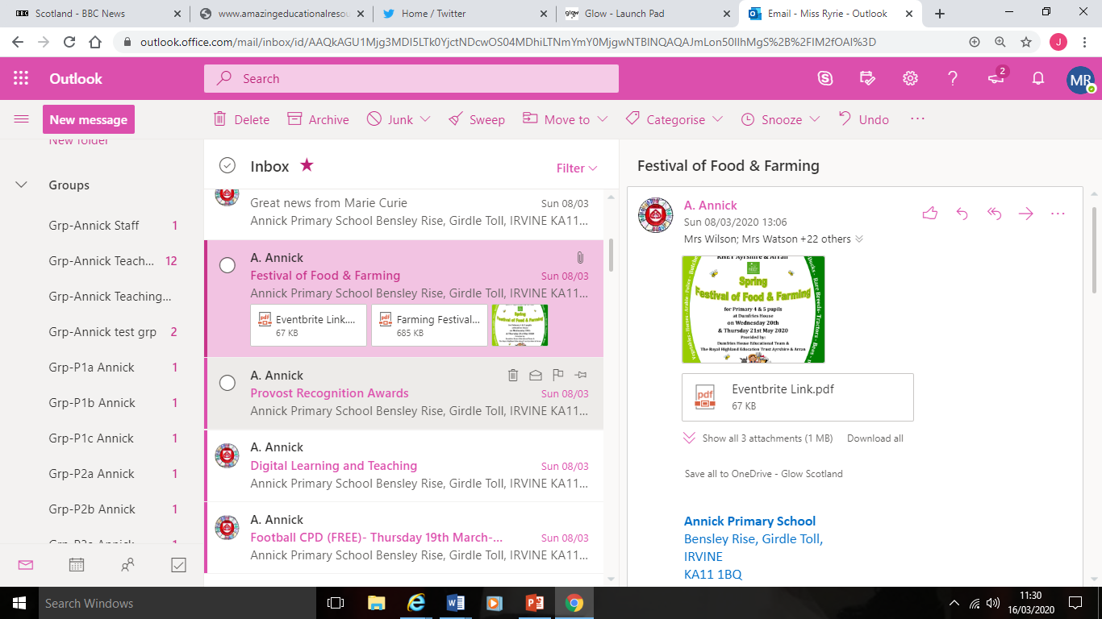

Your child’s class group can be accessed on the left hand side of the screen as shown above.

When your child selects their class group, it will appear like this:

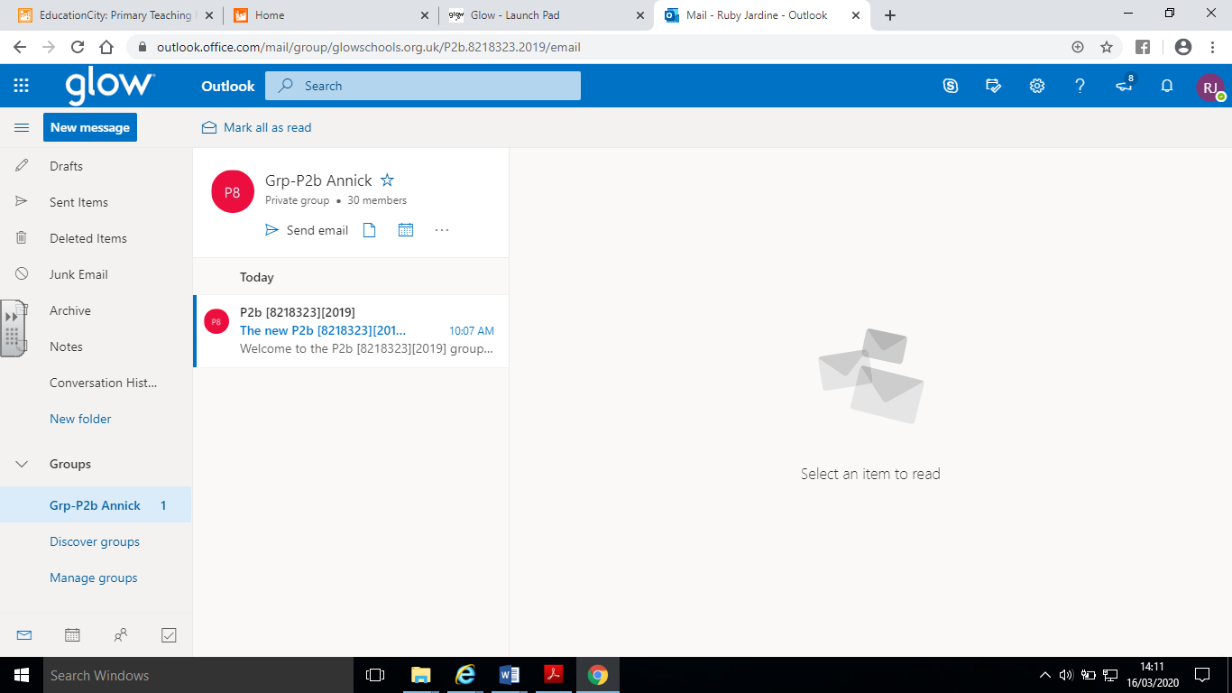

Emails containing information from the teacher will appear here.

Activities/information may also be uploaded using the Document store feature. To access this

click on the “…” symbol at top and select site.

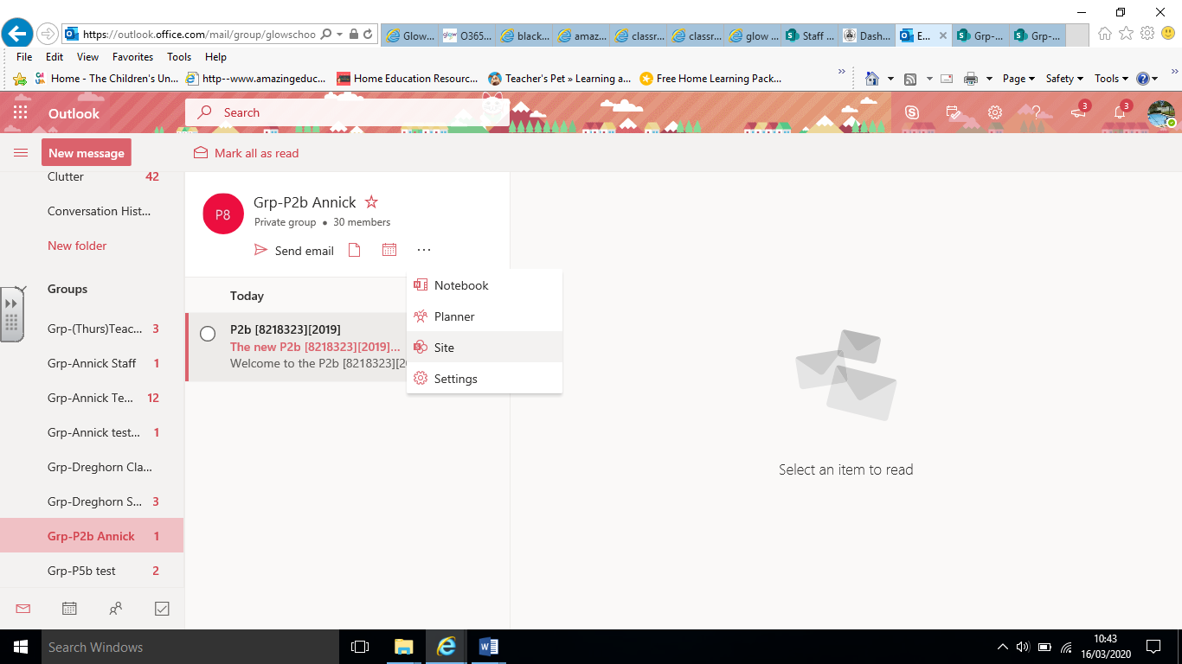

You will then see a screen like this, select ‘Documents’ from left hand side to access any uploaded documents.

