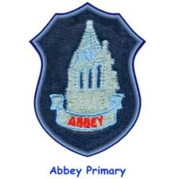

**Learning across the curriculum**

This term we will be learning all about Scotland and our national bard, Robert Burns. After the February holiday, we will turn our attention to learning through art as well as Children’s rights and responsibilities.

**Numeracy and maths**

* In numeracy we will be working on whole number, applying mental strategies to calculations, multiplication and division. We will also be looking at fractions, decimals and percentages.
* In maths we will be working on measurement concepts with estimates and looking at how to use bargraphs and pictograms.
* At home parents/carers can help by encouraging your child to log on to Sumdog regularly, this will support the development of their mental agility. ​ Your child should be practising multiplication facts to ensure they can recall stations quickly and accurately.​

**Literacy**

* Our class novel this term will be: The Spiderwick Chronicles by Tony Diterlizzi and Holly Black.
* In writing we will be working on learning to write stories and using interesting vocabulary, connectives and openers and also using punctuation correctly.
* The reading strategies that we will be focusing on will be inferring and monitoring.
* In handwriting we will be working with letterjoin to revise all joins and then apply our skills to writing sentences.

At home parents/carers can help by encouraging your child to read at home.

**Reminders:**

Our PE days are Tuesday and Thursday.

Our Outdoor Learning Day is a Thursday.

Homework will be issued on Tuesday and should be returned the following Monday.

**Health and Wellbeing**

In Health and wellbeing we will focus on being respectful and responsible and getting active .

Each month we will focus on one of our school values.

January – Respect

February – Love

March - Kindness

In P.E. we will be taking part in gymnastics and football.

P4/5F Term 3 Newsletter