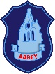
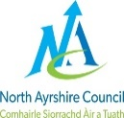
Abbey Primary Standards and Quality Report 2021-2022
This has been produced to share information
Our School  Abbey Primary is a well-established school in the heart of Kilwinning. Our main building was 100 years old in May 2021 although has had additional extensions over the years.  Our vision is simple, ‘We are a family of learners who lead together in a nurturing, exciting and motivating learning environment. We aim to ensure your child experiences some Abbey magic during their time here.  We recognise and appreciate, especially during these unprecedented times, that to achieve the best for our 285 pupils and 58 early years children requires a team effort, and, through working together, we can do just that. As a school family, we are proud of our school. We value the support and contributions of parents/carers and of our wonderful children. | Our School Improvement Plan  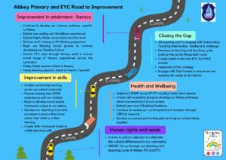  SIP 2022-2023 | Looking Back  Last year we worked hard to build upon our school experiences, focusing on  - The development of our literacy curriculum  - Developing our school environment- ensuring it is fit for purpose  - Embedding our visible curriculum planning for teachers and learners  - Linking with our parents to develop our DYW  Last session across all stages children were asked to review their learning on a weekly basis. We introduced Glow blogs for P4-P7 to allow parents to have a better understanding and awareness of their children’s learning.
Our Attainment Overview  Throughout the year we gather lots of information on how our children are progressing in their learning. To monitor their progress we watch children working through tasks, listen to what they say, ask important questions, set challenges and use some standardised assessments. We get together and look carefully at the Curriculum for Excellence experiences and outcomes to ensure children are making progress.  North Ayrshire Council also ask us to summarise our children’s progress in reading, writing, listening and talking as well as numeracy and maths. They ask us to look particularly at children who have reached the end of the Early, First and Second Levels: P.1, P.4 and P.7.  - Majority of our children in Primary 1 are making good progress through early level reading, writing, Talking &listening and numeracy.  - Majority of children in Primary 4 are making good progress through first level reading, writing, Talking &listening and numeracy.  - Majority of children in Primary 7 are making good progress through first level reading, writing, Talking & listening and numeracy. | Our Achievements  Last year we continued to develop our improvement journey. Lots of exciting changes happened and are beginning to be embedded within our school.  - Our Parent body donated over £2000 which was then topped up by the amazing work of our Parent Council.  - We were able to host our first School Sports Day in over two years!  - We developed our library- in the heart of our school and Taylor Wimpey donated £250 towards some of our books and equipment  - We developed our play journey within Primary 1 and we are beginning to look at how we develop this across our school  - We introduced our new spelling and phonics activities to support our learners  - We had a very successful Education Scotland Visit across our school and EYC allowing us to continue on our improvement journey.
about our School’s progress and achievements and our future plans

