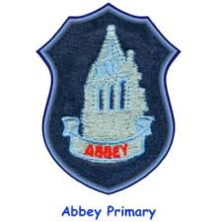

**Literacy**

**Our class novel:**

* Finishing ‘*The Twits* ‘by Roald Dahl
* ‘*Storm’* by Kevin Crossley-Holland

In **writing we will be working on narratives:**

* Writing stories
* Setting and character descriptions.

**In reading we will be focusing on these skills:**

* Monitoring – meaning of tricky words.
* Summarising – identifying main ideas

**In handwriting we will be working on:**

* Individual letter formation

**At home parents can help by…**

* Reading each night.

**Health and Wellbeing**

**Our focus will be:**

* **Building Resilience**: Respect Yourself Unit
* **Food and Health**: Preparing food safely, the journey of food from farm to fork and a healthy diet.
* **Emergency situations**: how to respond
* **Ball skills**: bouncing, passing and catching
* **Gymnastics**: Balancing, rolling, jumping and weight on hands.

**Reminders**

**P.E** is every Monday and Tuesday – please remember indoor shoes.

**Outdoor Learning** is every Thursday – please bring a change of shoes in a plastic bag and wear appropriate clothing for all weathers.

**Numeracy and maths**

**In numeracy we will be working on:**

* Place value of numbers
* 4 times table
* Quarters
* Addition and subtraction strategies.

**In maths we will be working on:**

* Symmetry
* Money: Totalling notes and coins

**At home parents can help by…**

* Practising previously taught times tables.
* Revising last term’s focus of using right and left when giving/following directions.

**Learning across the curriculum**

**Science/Wellbeing**: Human Body

**Religious Education**: Judaism: Hanukkah / Christianity: Advent

**Expressive Arts: Art:** Line drawings / Chalk and pastels

P4R Termly Newsletter