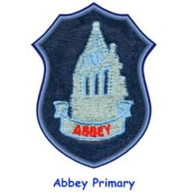

**Learning across the curriculum**

This term we will be completing the primary school engineering challenge which will cover many aspects of the curriculum.

**Health and Wellbeing**

Our Health and wellbeing focus will be about respecting ourselves. Finding out why we are all unique and being proud ourselves.

We will also be looking at the wellbeing indicators of achieving and nurture as a whole school community.

**Reminders**

* Homework is issued out on a Tuesday.
* Outdoor learning is on a Tuesday (Please dress warmly)
* P.E. Day is Thursday.

**Numeracy and maths**

* In numeracy we will be working on addition and subtraction of 3-digit numbers, fractions, multiplication and division.
* In maths we will be working on measurement
* At home parents can help learning by encouraging children to go on Sumdog.

At home parents can help by…

**Literacy**

* Our class novel this term will be:

Finishing ‘The Midnight Gang’

Next novel: ‘The Hogdeheg’ By Dick King-Smith.

* In writing we will be working on narrative writing.
* We will be focusing on our questioning and inference skills in reading.
* In handwriting we are focusing on doubling letters.
* At home parents can help by encouraging reading for enjoyment.

P5FG Termly Newsletter