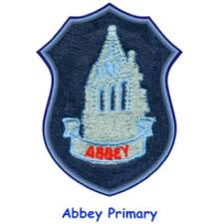

**Learning across the curriculum**

**Animals & Extinction**

**Climate Change – COP26**

**Badminton & Hockey**

**Hanukkah (RME)**

**Colours/animals (French)**

**Health and Wellbeing**

Our Health and wellbeing focus will be:

Achieving & Nurtured wellbeing indicators.

Building Resilience – Respect Yourself

Anti-bullying Week

**Reminders**

* **Outdoor day is on a Wednesday.**
* **Gym is on a Friday.**
* **Homework given out on a Tuesday, returned following Monday.**

**Numeracy and maths**

* In numeracy we will be working on Fractions, decimals & percentages, algebra & whole numbers.
* In maths we will be working on Time problems & Angles.

At home parents can help by encouraging their child to play Sum Dog maths homework challenges

**Literacy**

* Our class novel this term will be: Complete Born to Run & A pattern of Secrets.
* In writing we will be working on recounts.
* We will be focusing on questioning and summarising skills in reading.
* In handwriting we will continue linked script using Letter Join.
* At home parents can help by encouraging their child to compete reading homework tasks.

P7M Termly Newsletter