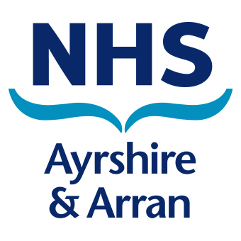
Health Protection Team
Public Health Department
Afton House
Ailsa Hospital
Dalmellington Road
Ayr
KA6 6AB

Medical In Confidence  Parents / Guardians of children attending  Abbey Primary School | Date | 30th August2021
 | Enquiries to | Health Protection Team
 | Direct line | 01292 885858
 | Email | HPteam@aapct.scot.nhs.uk

Dear Parent/Carer/Staff Member,

COVID-19 information letter to parents and carers and staff

We have become aware of a case of confirmed COVID-19 (Coronavirus) with links to Abbey Primary School.

Children and education staff will no longer be automatically asked to self-isolate if there is a positive COVID-19 case identified within a school or nursery and only significant close contacts of the case need to self-isolate.

All significant close contacts of this case have already been identified by Test and Protect and advised to follow the latest guidance regarding self-isolation and testing.

What do I need to do now?
You or your child do not need to self-isolate unless you are contacted by Test and Protect (this could be a phone call or a text). If you or your child has not been contacted by Test and Protect and showing no symptoms of COVID-19, they can continue to attend school or nursery as normal.

What do I do if my child / I are identified as a close contact by Test and Protect?
If you or your child are identified as a close contact by Test and Protect, please follow the guidance provided by them and book a PCR laboratory test.

What actions are being taken by the school?
The school have multiple actions in place to lower the risk of COVID-19 transmission, including regular staff and secondary pupil Lateral Flow testing (rapid 30 minute home testing), enhanced cleaning and social distancing.

What do I do if I / my child develops symptoms of COVID-19?
If you or your child develops symptoms of COVID-19, you should self-isolate immediately and book a PCR test. Please let your school know if your child will be absent and why.

To book a PCR test visit www.gov.uk/get-coronavirus-test or https://www.nhsinform.scot/test-and-protect or by calling 0800 028 2816.

Do not use Lateral Flow Device Tests if you are showing symptoms of COVID-19.

What are the symptoms of COVID-19?
The main symptoms of COVID-19 are:
- new cough;
- high temperature (37.8 or above);
- and/or loss of taste and smell.

There may be other milder symptoms which can include hay fever symptoms, sore throat, runny nose, headaches, vomiting and diarrhoea.

What if cases continue to rise in the school?
If there are further cases of COVID-19 in the school, Test and Protect and NHS Ayrshire & Arran’s Health Protection team will work together with the school and Local Authority to manage the situation. We will make sure we keep all staff, parents and carers informed of any changes.

What actions can I take to stop COVID-19 from spreading?
- Please try to get into the habit of testing regularly – twice a week. Staff in all schools and all secondary pupils can pick up test kits from their school. It only takes a few minutes to do the test, and you’ll have the result in less than 30 minutes.
- If you are 16 years or over book your COVID-19 vaccination. It’s our best defence against COVID-19.
- 16 and 17 year olds can self-register for an appointment sent by text or email, or attend a drop-in clinic. Visit https://www.nhsinform.scot/vaccineregistration to register.
- For details of the latest drop-in COVID-19 Vaccination clinics in Ayrshire and Arran, visit https://www.nhsaaa.net/coronavirus-covid-19/covid-19-vaccination-appointments/
- Continue to wash your hands regularly with soap and water for at least 20 seconds.
- Be on the lookout for COVID-19 symptoms, if you are concerned; self-isolate and book a PCR test if you feel unwell.

What if I have further questions?
Please refer to our Frequently asked Questions guide if you have more questions. Please visit NHS Inform for the most up to date guidance and advice. Alternatively, please contact the NHS Ayrshire and Arran Health Protection Team on 01292 885858.

Yours sincerely

Lynne McNiven
Director of Public Health

