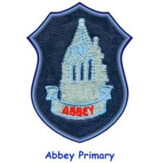
Using Seesaw in Abbey Primary
Level:

What do we currently do? What else can we see it being used for? Timescale

