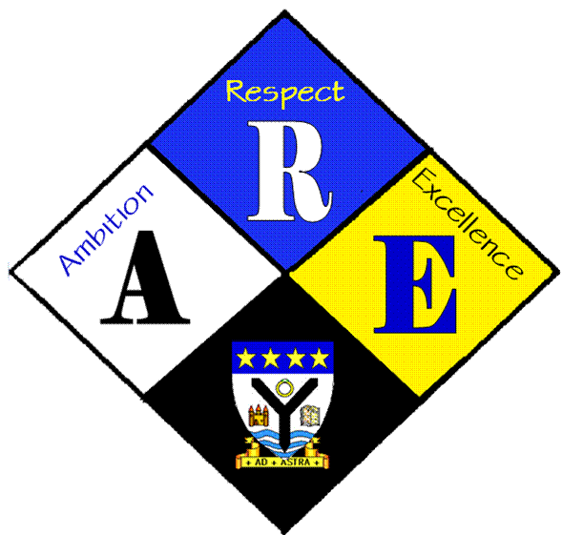
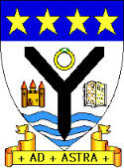
RSSA Steering group.

Year Group | RSS steering Group | Date: | 9/11/2016
Present: | Lewis Beck  Lauren Scott  Megan Henderson  Lauren Harker  Matthew McGowan  Dr Cannon  Christopher Ribbeck  Mr Hutchison  Iona Barclay

Item | Issues to be Discussed | Notes
Anti-bullying week | money | Money raised will be split between respectme and children in need. Letters will be written to accompany cheques.  Final preparations made for activities.  More posters put up.  Notice in daily bulletin written  Rota checked and teachers notified
 | House activities | Discussed celebration of all children’s abilities. Extending house activities to include events other than sport. Eg science quiz, mathletics with a big end of year relay with a team from each house.  Need to discuss with house captains /Mr Milligan – Dr Cannon

