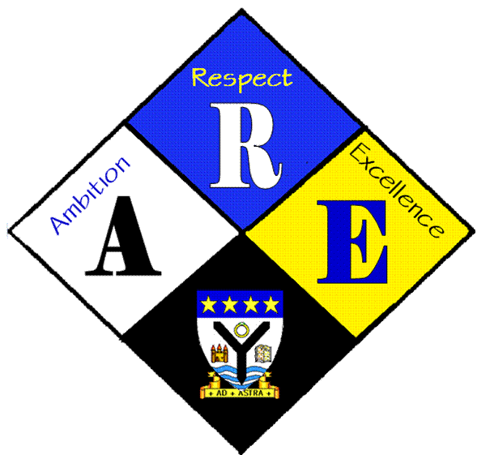
RSSA Steering group.

Year Group | RSS steering Group | Date: | 7/12/2016
Present: | Lewis Beck  Lauren Scott  Megan Henderson  Lauren Harker  Matthew McGowan  Dr Cannon  Christopher Ribbeck  Mr Hutchison  Iona Barclay

Item | Issues to be Discussed | Notes
Article 19 | What we can include on our charter | Pupils need somewhere to report things they are concerned about confidentially – a problem box. Dr C will talk to pastoral support about this.  The community police office visits are very useful – need to get a timetable of proposed visits and publicise.  A system to report bullying. Arrange a meeting with Mr Milligan to discuss anti-bullying ambassador training  Use of stronger penalties for bullying / staggered lunch breaks  (more to do on this)
website | website | Christopher has started to collect info in categories for the website

