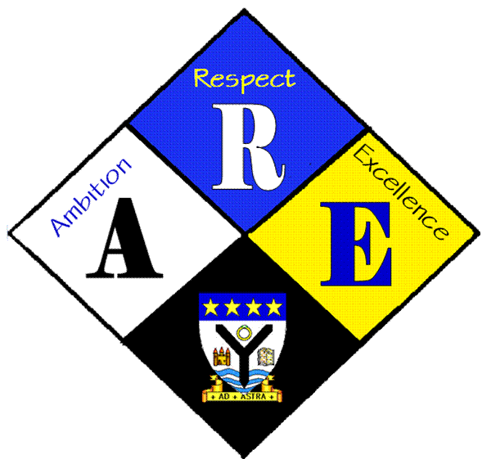
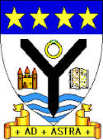
RSSA Steering group.

Year Group | RSS steering Group | Date: | 30/11/2016
Present: | Lewis Beck  Lauren Scott  Megan Henderson  Lauren Harker  Matthew McGowan  Dr Cannon  Christopher Ribbeck  Mr Hutchison  Iona Barclay

Item | Issues to be Discussed | Notes
Anti-bullying week | Notice board | Display was produced showing activities from anti-bullying week  Copies of ROC certificate and day for change certificate were framed and put up.
website | website | MrBehan has made our sections. Need to start gathering info to put in each section and send to him (Christopher / Dr Cannon)

