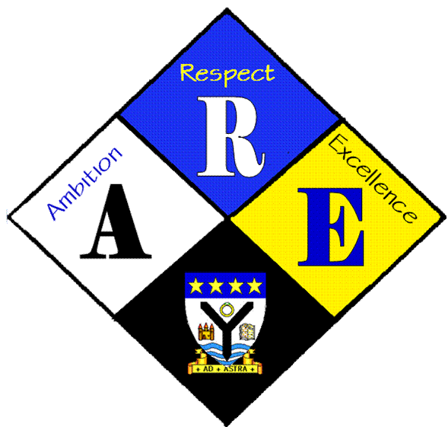
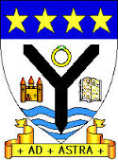
RSSA Steering group.

Year Group | RSS steering Group | Date: | 26/10/2016
Present: | Lewis Beck  Lauren Scott  Megan Henderson  Lauren Harker  Matthew McGowan  Dr Cannon  Christopher Ribbeck  Mr Hutchison  Iona Barclay

Item | Issues to be Discussed | Notes
Anti-bullying week | posters | Posters made for dress down day and put up around school.  Anti bullying posters given out to all staff for display in their rooms.
 | Wrist bands | Rota set up for selling wrist bands around the school next week.
 | Money raised | Discuss what to do with the money raised with Mr Milligan.  Suggestions – respectme, children in need

