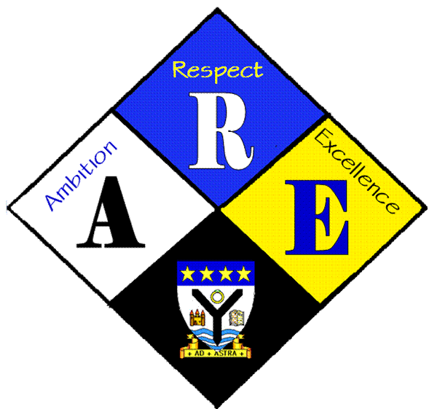
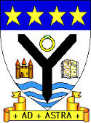
RSSA Steering group.

Year Group | RSS steering Group | Date: | 23/11/2016
Present: | Lewis Beck  Lauren Scott  Megan Henderson  Lauren Harker  Matthew McGowan  Dr Cannon  Christopher Ribbeck  Mr Hutchison  Iona Barclay

Item | Issues to be Discussed | Notes
Anti-bullying week | money | Letters written for respectme and children in need to accompany cheques
website | Our page | Christopher contacted Mr Behan to detail the sections we need on the website
Notice board | What to put on it | Need to include  Photos from antibullying week  Certificates  Letters we have written /received  Our school charter so far

