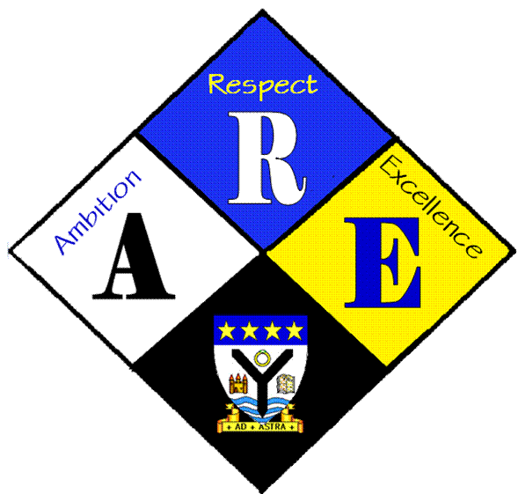
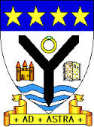
RSSA Steering group.

Year Group | RSS steering Group | Date: | 19/10/2016
Present: | Lewis Beck  Lauren Scott  Megan Henderson  Lauren Harker  Matthew McGowan  Dr Cannon  Christopher Ribbeck  Mr Hutchison  Iona Barclay

Item | Issues to be Discussed | Notes
Anti-bullying week | Dress down day | Iona to ask Miss Chalmers if its ok to have a full dress down day on the 18th of November. Pay £1
 | Wrist bands | Wrist bands have been purchased from Anti-bullying UK, they will be sold during anti bullying week to raise money.
Anti-bullying group | Other activities.  Video for PS  Starter flash cards for lessons  Poster selfies | Videohas been circulated to all PS teachers.  Dr Cannon will send flash card presentation to all staff to use as discussion points in lessons  Poster selfies will be posted on twitter
St matthews | Football match | Dr cannon has contacted the RSS group at St Matthews to discuss joint activities for next year.

