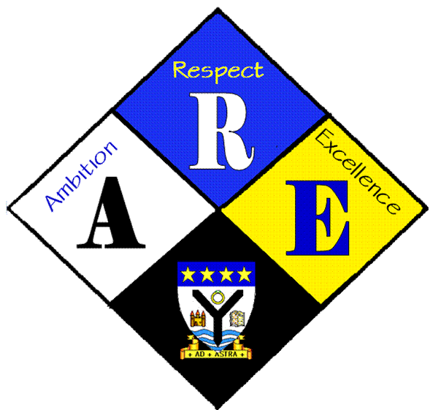
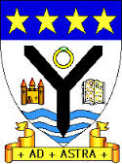
RSSA Steering group.

Year Group | RSS steering Group | Date: | 16/11/2016
Present: | Lewis Beck  Lauren Scott  Megan Henderson  Lauren Harker  Matthew McGowan  Dr Cannon  Christopher Ribbeck  Mr Hutchison  Iona Barclay

Item | Issues to be Discussed | Notes
Anti-bullying week | money | All RSS ambassadors spent lunchtime selling wristbands and taking photos

