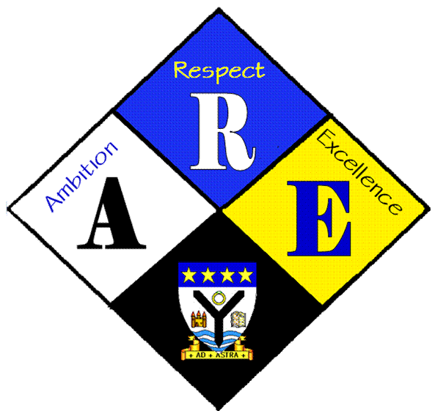
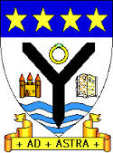
AGENDA OF STUDENT COUNCIL MEETINGS.

Year Group | RSS steering Group | Date: | 28/09/2016
Present: | Ross Gibb  Megan Henderson  Matthew McGowan  Dr Cannon  Christopher Ribbeck  Mr Hutchison  Iona Barclay

Item | Issues to be Discussed | Notes
Anti-bullying week | Ideas to raise awareness and funds for anti-bullying week | A number of ideas were discussed including non-uniform, a bake off, a poster competition and a quiz. In particular the idea of a non-uniform was popular and will be discussed further.
School Charter | Article 31 | Adults should:  - Ensure that there is some degree of consistency across the school (ie policies being implemented)  - Attempt to provide more clubs with a greater variety  - Clubs should be run by an adult who is enthusiastic and knowledgeable about the activity.
Anti-bullying group | Mr Milligan has a group of pupils looking at developing material to help raise awareness of bullying and how to help across the school. We have a box of posters and some ideas to help out. | Pupils should:  - Respect each other’s right to relax and play in whichever way they choose  - Take a more active role in voicing which clubs they wish to participate in  - Make a commitment to continue to attend any clubs over a reasonable period of time  - Ensure that they behave in a well-mannered and respectful way towards each other

