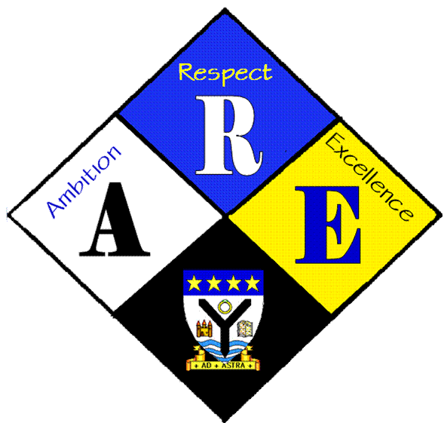
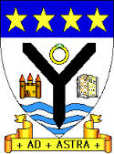
AGENDA OF STUDENT COUNCIL MEETINGS.

Year Group | RSS steering Group | Date: | 21/9/2016
Present: | Lauren Harker  Matthew McGowan  Dr Cannon  Christopher Ribbeck  Mr Hutchison  Ross Gibb  Aaron Berry man  Iona Barclay

Item | Issues to be Discussed | Notes
Charter | Right 15 – Children have the right to meet in groups. | Teacher should  Ensure that there is a broad range of activities available for pupils.  Follow their interests and lead or take part in groups they enjoy too.  Seek pupils’ opinions about the organisation of groups and clubs.  Enable pupils to lead some activities if they want to.  Pupils should.  Play an active role in all groups that they attend.  Show commitment to the groups and activities they attend through attendance and communication.  Respect everyone’s right to be a part of any group.
UNICEF | Dr Cannon suggested linking up with St Matthew’s to organise a joint activity to support UNICEF, possible a soccer aid tournament Ardrossan & Saltcoats V Rest of the World was suggested | Dr Cannon to contact RSS co-ordinator at St Matthew’s to discuss.

