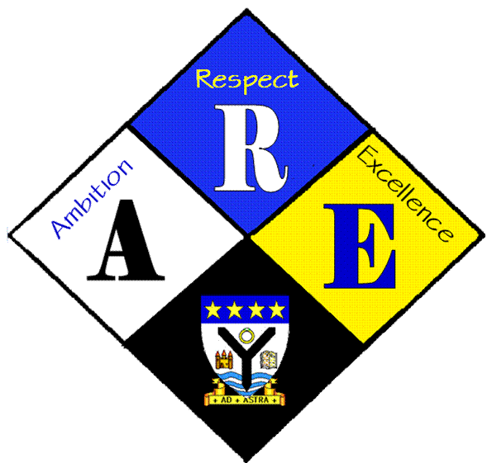
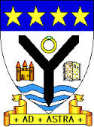
AGENDA OF STUDENT COUNCIL MEETINGS.

Year Group | RSS steering Group | Date: | 5/10/2016
Present: | Lewis Beck  Lauren Scott  Megan Henderson  Lauren Harker  Matthew McGowan  Dr Cannon  Christopher Ribbeck  Mr Hutchison  Iona Barclay

Item | Issues to be Discussed | Notes
Anti-bullying week | The idea of a bake off or bake sale to raise funds was discussed. This would require back up from HE. | Iona will speak to Miss Devlin and Miss Bruce about this to ensure that we can proceed and no similar activities are planned.
Non-uniform day | Week ending the 18th of Nov is antibullying week. Group suggested a non-uniform day with wear blue to support anti-bullying. Pupils donate £1 and this goes to charity to support victims of bullying. | Lauren and Megan are going to speak to Miss Chalmers to ask for permission to hold a non-uniform day during that week or the week before to coincide with the holiday.
Anti-bullying group | Mr Milligan has a group of pupils looking at developing material to help raise awareness of bullying and how to help across the school. We have a box of posters and some ideas to help out. | Christopher and Iona will speak to Mr Milligan about joining with his group for anti-bullying week to promote the schools stance against bullying.

