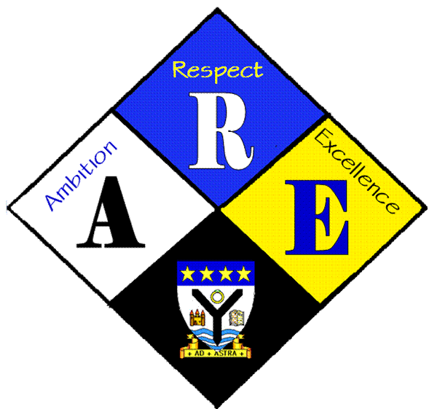
AGENDA OF STUDENT COUNCIL MEETINGS.

Year Group | RSS steering Group | Date: | 7/9/2016
Present: | Lauren Harker  Matthew McGowan  Dr Cannon  Christopher Ribbeck  Mr Hutchison  Ross Gibb  Aaron Berry man  Iona Barclay

Item | Issues to be Discussed | Notes
ROC | status | Our ROC status has been confirmed, need to contact Miss Chalmers to ask what she would like to do with the certificate.
Twitter | What to post | Dr Cannon has started a twitter account and put a few things on it.  Photos and information of everything we do to promote RSS should go on.
School charter | Which rights should it include | We went through the rights and made sure the 10 we had were applicable to the school. Next week we can highlight how the school can demonstrate those rights.

