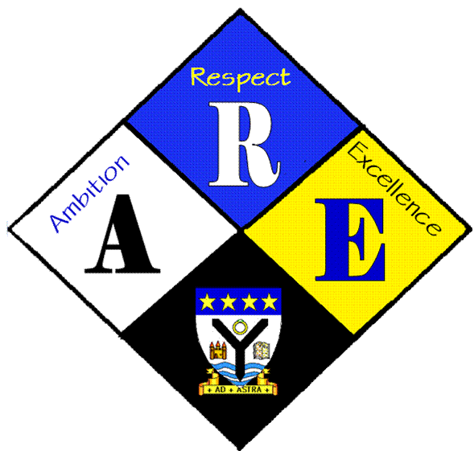
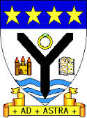
AGENDA OF STUDENT COUNCIL MEETINGS.

Year Group | RSS steering Group | Date: | 31/8/2016
Present: | Lauren Harker  Matthew McGowan  Dr Cannon  Christopher Ribbeck  Mr Hutchison  Ross Gibb  Aaron Berry man  Iona Barclay

Item | Issues to be Discussed | Notes
Matters arising  RSSA | What is RSSA | Dr Cannon explained what the RSSA award is and gave an outline of what we need to do over the next year.
School Charter | What needs to be achieved to create the school charter? The key rights applicable to the school have been identified by the senior pupil council. The RSS steering group will review the selection and start to identify rights to be included in the charter. | Next week Dr Cannon will bring along the rights and we will prioritise before starting on the charter.
Publicity | Currently all RSSA info is spread via the ardrossan academy twitter feed. The pupils would like their own twitter feed to cover only RSS activities.  The group would like to have a page on the ardrossan academy website detailing activities within the school. | Dr Cannon to speak to Miss Chalmers and confirm that this is ok.  Christopher Ribbeck will manage content and pass on to Mr Behan via Glow
Clubs | Lauren suggested that links to other groups such as LGBT should be made as rights are closely linked. She also suggested that the school should have more groups based on supporting children. | RSSA group will take this up with the pupil council.

