**Celebrating Pupil Achievement**

**2015-2016**

The young people of Ardrossan Academy achieve in a variety of different areas and contexts including learning, sports, creative arts, volunteering, charities, service and personal achievements.

We are very proud of the achievements of our pupils in school and in their wider lives.

This booklet contains a selection of outstanding achievements in session **2015-2016**.

Our school motto is Ad Astra – To the Stars. Ardrossan Academy strives to ensure our pupils are given every opportunity to fulfil their potential and reach their goals.

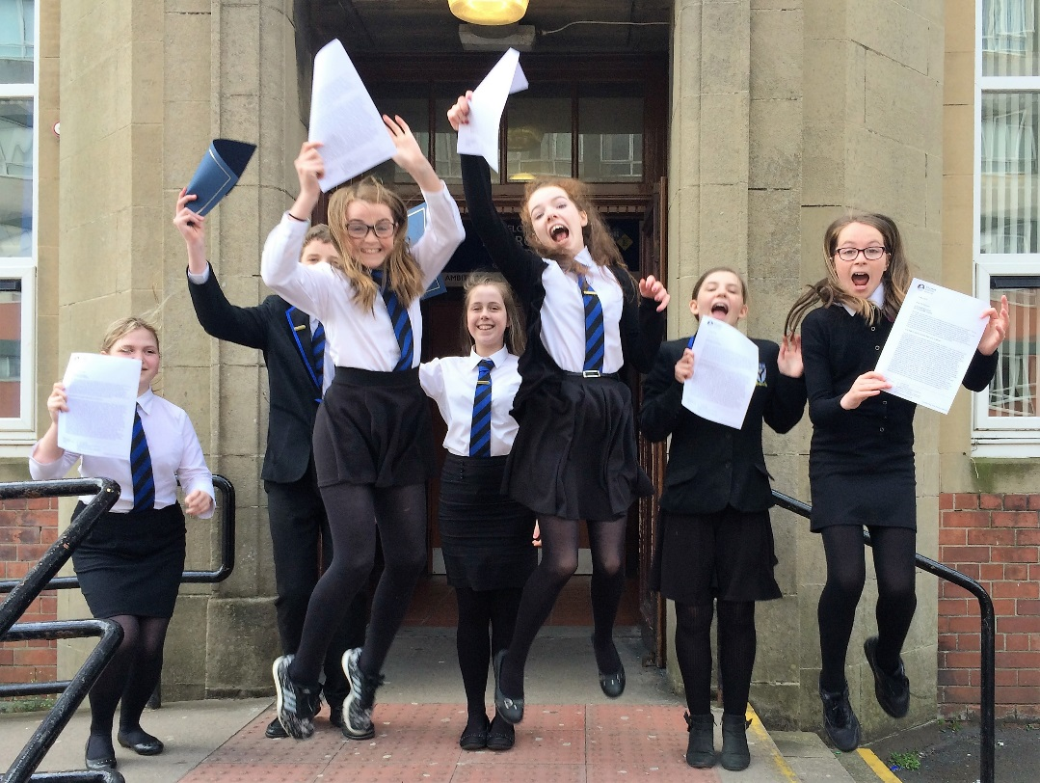

**“The greatest danger for most of us is not that our aim is too high and we miss it, but that it is too low and we reach it”.** *Michelangelo*

[](http://www.google.co.uk/url?sa=i&rct=j&q=&esrc=s&frm=1&source=images&cd=&cad=rja&uact=8&ved=0ahUKEwjN0PaO18fNAhWHKMAKHYD8CjMQjRwIBw&url=http://www.clipartpanda.com/categories/sport-clip-art-pictures&psig=AFQjCNFCcPwBG8nsBqC4e_fUlB6-lMJ-Ug&ust=146709863849)

**SPORT**

* S5 pupil **Aria Pascual** was nominated in the Up and Coming Youngster Award category in the West FM Cream of Ayrshire Awards. She was also nominated as Young Sports Personality in the NAC Sports Awards.
* S2 pupils **Megan Pettigrew** and **Craig Johnston** were the individual champions for S1 House X-Country in September.
* S4 pupil **Rachel Holmes** was the winning girl (13 years) at the North Ayrshire & Arran Amateur Swimming Club Championships in September.
* S5 pupils **Aria Pascual** and **Heather Howat** were selected as Young Sports Ambassadors for the school.
* S5 pupils **Sarah Tait**, **Melissa Pirrie** and **Naeve Wilson** were part of the Kilmarnock U-15 Ladies football team who won the League Cup in November.
* **Aria Pascual** attended the JKA 4 NATIONS (Karate) in London in November & won a Gold medal & title of JKA 4 Nations Kumite Champion (Female 13-15). Aria won a gold medal for Kumite (13-15 female) and overall best competitor award at the KWF Scottish Shotokan Championships in November. Aria became the JKA Scottish Kata Champion, Kumite Champion & Best Scottish Junior Competitor 2016 in March. Aria attended the KWF karate competition in April winning Gold in kata, Female 14-16 years, & Bronze in Female Kumite 15-16 years. The highlight of Aria’s year was when she won GOLD in the Girls' 15yrs individual Kata at the JKA European Karate Championships in Serbia in May. Aria competed in the SKGB Scottish Kata Championships in June and won a silver and bronze medal in her category.
* **Sophie Calder, Ebony Clarke, Bethany Conn, Naomi Myers, Tegan Myers, Katy Garry, Mhairi Stewart, Kerr Carson** and **Tyron Christie** all completed the 2 year School of Basketball programme.
* **Joshua Davidson, Andrew Dunn, Connor Griffiths, Declan MacLachlan, Cameron Moffat** and **Alexander Orderley** all completed the 2 year School of Rugby programme.
* S2 pupil **Ellie Davidson** won a bronze medal in U-13 60m hurdles at the Scottish National Championships in March.
* S2 pupil **Eilidh Murray** competed at Crufts in March as part of the Scottish team. She achieved a 6th place rosette and completed two clear runs.
* S3 pupil **Iona Barclay** was the JKA Scottish Junior Team Kumite Champion, Junior Team Kata Silver medallist & individual Kumite bronze medal in March.
* S3 pupil **Alexander Orderley** was part of the NAAC under 15 boys team who won bronze in the national indoor relay final in March.
* S2 pupils **Emma Donachy** & **Megan Pettigrew** competed successfully in the National Youth Road Race championships in Gourock in April.
* S4 pupil **Greg Kean** was selected for the Boys Club of Scotland international football team in April and played against Wales.

[](http://www.google.co.uk/url?sa=i&rct=j&q=&esrc=s&frm=1&source=images&cd=&cad=rja&uact=8&ved=0ahUKEwjN0PaO18fNAhWHKMAKHYD8CjMQjRwIBw&url=http://www.clipartpanda.com/categories/sport-clip-art-pictures&psig=AFQjCNFCcPwBG8nsBqC4e_fUlB6-lMJ-Ug&ust=146709863849)

**SPORT (**continued)

* S2 pupil **Andrew Buchanan** won gold in the Ayrshire Athletics Championships for U13s boys 100m & silver in the 200m in May.
* **Ryan Skimming**, **Ellie Davidson** & **Andrew Buchanan** won the S1 School Sports Championships in May.
* **Alexander Orderley** & **Kerrie Grier** won the S2 School Sports Championships in May.
* **Robert Frew** & **Gaby Seaton** won the S3 School Sports Championships in May.
* A number of our pupils competed at the Ayrshire Athletics Championships in May.
* S6 pupil **Calvin Bruce** competed in the JKA European Karate Championships in Serbia in May.

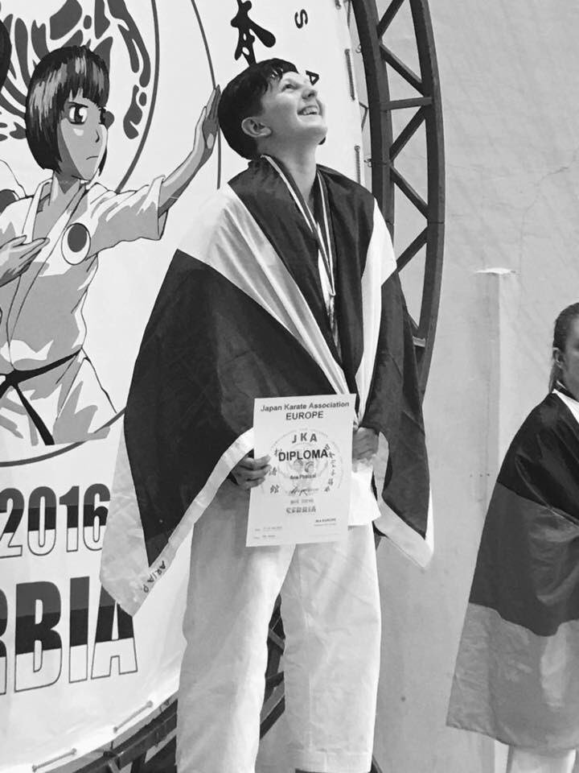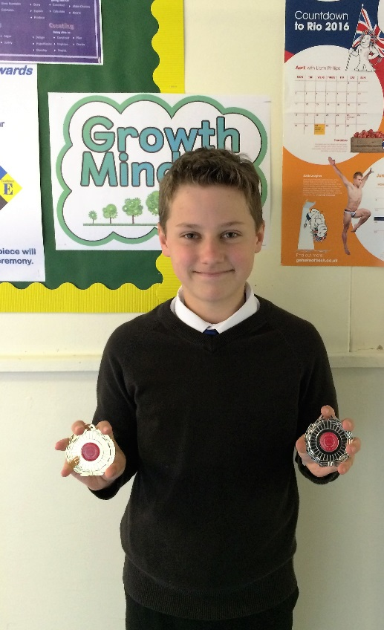

[](http://www.google.co.uk/url?sa=i&rct=j&q=&esrc=s&frm=1&source=images&cd=&cad=rja&uact=8&ved=0ahUKEwjKmNv1g8jNAhWJAsAKHT8JBKgQjRwIBw&url=http://www.clipartbest.com/clipart-bTy946pTL&psig=AFQjCNGmr4Ue1IBZp2_i_rGVxp29m-2YhA&ust=146711079233)[](https://www.google.co.uk/url?sa=i&rct=j&q=&esrc=s&frm=1&source=images&cd=&cad=rja&uact=8&ved=0ahUKEwjQxdGSg8jNAhWCIcAKHc4UAWsQjRwIBw&url=https://naomidancer13.wordpress.com/2011/11/10/csusm/&psig=AFQjCNFq6FESQd4eUGXEY0lDC6scphBShw&ust=146711043787)

**CREATIVE ARTS**

* S5 pupil **Courtney Kirk** participated in the Open Mic UK competition. Courtney sang Whitney Houston’s ‘How Will I Know?’ and got through to the regional final in Glasgow.
* The pupil choir performed at Morrison’s and Asda in December as well as Caledonia Care Home, South Beach Nursing Home and Arran View Care Home.
* **Calvin Bruce, Cameron McMenemy, Aiden Lundy, Sammy Lindie, Lauren Harker, Phillip Moore, Stephanie Murray, Rachel Lawson, Jillian Cameron**, Junior Choir, Drama Club and the Ceilidh Band all performed at the Burns Supper in January.
* **Calvin Bruce, Rebecca Sharp, Robyn Gurney, Kiani Blades, Zoe Fox, Lyle Robertson, Ben Cummings, Fraser Reid, Cara Mackie, Courtney Kirk, Josef Bacon, Dylan Gibson** and **Lauren Blades** competed in the Young Musician, Young Singer & Young Rock and Pop Musician school heats in January.
* S6 pupil **Calvin Bruce** represented the school at the NAC Young Singer and Young Musician competition in February.
* S5 pupil **Kiani Blades** represented the school at the NAC Young Rock and Pop Musician competition in February.
* Our young musicians performed at the Music Café event at the Royal Concert Hall in Glasgow in February.
* S6 pupil **Calvin Bruce** was selected in February to complete a week of work experience with the RSNO as conductor of the orchestra.
* **Lucas McQuade**, also S5, spent the day as an extra on the set of new a Zombie Apocalypse movie, filmed in Glasgow in April. Lucas enjoyed having the grotesque make-up applied and experiencing what it was like on a movie set. The
* S4 pupil **Anna Reid** won the Ayrshire wide Burns competition singing 'Bonnie Wee Thing' in March and represented Ayrshire in the national final in April.
* S4 pupil **Rachel Lawson** won 3rd place at the Ayrshire Music Festival in March.
* **Rachel Lawson, Dylan Gibson, Kiani Blades & Rebecca** **Sharp** performed at the Ad Astra Award ceremonies in March
* S4 pupils **Rachel Lawson** and **Anna Reid** and S6 pupil **Josef Bacon** performed with the Pan-Ayrshire School choir supporting the Military Wives Choir in April.
* **Calvin Bruce, Rebecca Sharp, Linzi Smith, Lyle Robertson, Anna** **Reid** and **Rachel Lawson** participated in an open day at the Royal Conservatoire Scotland in June.
* **Anna Reid, Rachel Lawson** and the **Ceilidh Band** performed at the Junior Prize Giving ceremony in June.
* S2 pupils **Rachel Davidson**, **Eilidh Shearer**, **Eilidh Murray** & S3 pupils **Iona Barclay** and **Denisa Levai** all passed Associated Board of Music exams this session.
* S4 pupil **Erin Sallens** designed the winning cover of the 2016-2017 BGE Learning Journal.
* S3 pupils **Hannah Brown, Isla Kolankaya, Nina Mitchell** and **Anya Anderson** started an Art & Design company to produce, select and display art and design works in the school. They successfully pitched to the Parent Council and received £500 in start-up funds for their project.

[](http://www.google.co.uk/url?sa=i&rct=j&q=&esrc=s&frm=1&source=images&cd=&cad=rja&uact=8&ved=0ahUKEwjs2My1s8jNAhXnIMAKHRtsBgwQjRwIBw&url=http://lagymnastics.com/awards-achievements/&psig=AFQjCNE7pemwdRwM_Dc8galyeMSaK9f6iw&ust=146712357862)

**PUPIL LEADERSHIP &**

**PERSONAL ACHIEVEMENTS**

* S5 pupils **Murray Grayston**, **Alexander Chisholm**, **Heather Howat** and **Sharon Mannion** delivered the vote of thanks at the SQA Prize Giving ceremony in September.
* **Lewis Dunbar**, **Sharon Mannion** & **Kelly Harvey** were selected to attend the Police Scotland work experience placement in September
* S5 pupils **Justin Wylie** & **Calum Scott** and S6 pupils **Marie-Anne Wales** & **Sophie Gribben** attended a Cycling Scotland Residential week in October.
* Serena Todd won a competition run by the Ogden Trust and Glasgow University to visit CERN in Geneva for 3 days in October.
* S6 pupil **Sophie Gribben** was awarded Sea Cadet of the year in November by Ardrossan Sea Cadets (T.S Gannet).
* S3 pupil **Ross McKinnon** was awarded Junior Sea Cadet of the year in November by Ardrossan Sea Cadets (T.S Gannet).
* S6 pupil **Rachael Waddell** was awarded Most Improved Sea Cadet of the year in November by Ardrossan Sea Cadets (T.S Gannet).
* S6 pupils **Nicola Jamieson** and **Rebecca Sharp** attended Auschwitz Concentration Camp in October as part of the Lessons from Auschwitz school programme.
* The Eco Group – **Rachel Skimming, Rachael Waddell, Sophie Gribben, Marie-Ann Wales, Clare Monaghan, Holly Lambert** and **Robyn Gurney** - achieved the Silver Eco School Award Star for the school in November.
* **Shannon Black**, **Amy Cherry**, **Jodie McNamara**, **Logan McGreavy** all completed the 3 Towns Motor Project in January.
* **Cameron Shields** reached 1350 hours of volunteering stretching back to 2013 in February as part of the Saltire Awards programme.
* S2 pupils **Aimee Clark** and **Erin Gibbs** represented the school in February at the ‘This Ayrshire Girl Can’ conference and also met the First Minister Nicola Sturgeon.
* S6 pupils **Kiah Park**, **David West**, **Cieran McGoogan** and **Chloe Myers** volunteered to judge a STEM event at Stanley Primary school.
* The Food for Life group and St. Anthony's Primary's Bouncing Blueberries hosted an Afternoon Tea event in May for parent and staff in both schools.
* Fashion and textile young learners attended the "Make it in Fashion" taster day at Glasgow Clyde College in June hosted by the Department of Fashion and technology.
* S1 pupils **Caitlyn Agnew**, **Callum Bowie**, **Kathryn Nutt** and S2 pupils **Ross Gibb** and **Christopher Ribbeck** interviewed Rev Haroute Selimian, President of the Armenian Church in Syria about the conflict in the country and the effect on Syrian people.

[](http://www.google.co.uk/url?sa=i&rct=j&q=&esrc=s&frm=1&source=images&cd=&cad=rja&uact=8&ved=0ahUKEwjs2My1s8jNAhXnIMAKHRtsBgwQjRwIBw&url=http://lagymnastics.com/awards-achievements/&psig=AFQjCNE7pemwdRwM_Dc8galyeMSaK9f6iw&ust=146712357862)

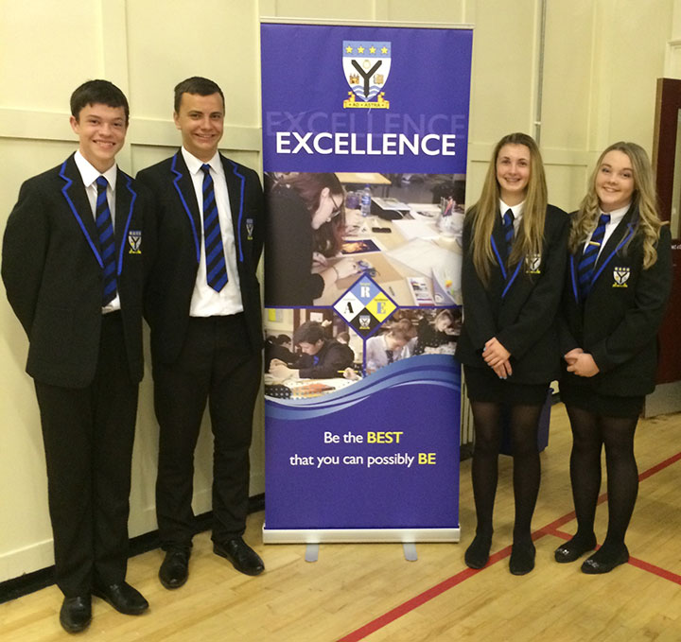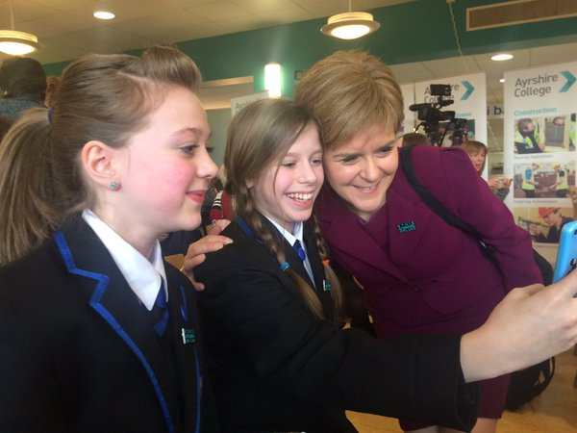

**PUPIL LEADERSHIP &**

**PERSONAL ACHIEVEMENTS (**ctd)

* The following pupils achieved the Duke of Edinburgh **BRONZE AWARD** this session: **Lisa Black, Katie Boyd, Lauren Buckley, Isla Gilchrist, Ethan Gilmour, Luca Giusti, Murray Grayston, Jamie Jack, David Johnstone, Connor Love, Sharon Mannion, Harry MacDonald, Emma McDougall, Lucas McQuade, Cameron Norwood, Andrew Parker, Aria Pascual, Linzi Smith, Hannah Watson, Naeve Wilson.**
* The following pupils achieved the Duke of Edinburgh **SILVER AWARD** this session**: Alice Blades, Alex Bowie, Calvin Bruce, Sophie Gribben, Robyn Gurney, Ross Jack, Clare Monaghan, Fraser Murray, Rachel Skimming, Rachael Waddell, Erin Wigton.**
* S6 pupil **Sophie Gribben** participated in the Scottish Space School in June attending lectures, labs & workshops delivered by NASA representatives.
* S6 pupil **Sophie Gribben** was selected by the Scottish Space School to visit NASA in Houston in October, one of only 10 pupils across Scotland to be chosen for this prestigious opportunity.
* S4 pupils **Iona Welsh** & **Robert Frew**, S2 pupils **Erin Gibbs** & **Andrew Buchanan,** and S3 pupils **Christopher Ribbeck** & **Iona Barclay** hosted the Junior Prize Giving ceremony in June.
* **Isla Kolankaya**, **Denisa Levai**, **Matthew Daly** & **Jamie Neil** worked with the NAC Information & Culture team in June to create a short film called ‘Talking Heads Ayrshire’; pupils were filmed at locations around Ardrossan stating what they liked about living in North Ayrshire.
* The Art & Design Company – **Hannah Brown, Anya Anderson, Isla Kolankaya** and **Nina Mitchell** - competed in the North Ayrshire Heats of the Sir Tom Hunter Challenge event in June.
* Our Developing the Young Workforce group competed in the All Ayrshire Sir Tom Hunter Challenge event in June.
* S6 pupil **Marie-Ann Wales** delivered a presentation on leadership opportunities at the NAC Leadership Conference in June to a host of council officials. She was highly praised for her presentation.
* **Nicole Giffney, Olivia Starr, Joshua Davidson, Erin Gibbs, Christopher Ribbeck, Ramune Bauzys, Lauren Scott** and **Lauren Harker** participated in the launch of the NAC Children's Service Plan in June.

[](https://www.google.co.uk/url?sa=i&rct=j&q=&esrc=s&frm=1&source=images&cd=&cad=rja&uact=8&ved=0ahUKEwjm2LndtcjNAhWIKcAKHbw_CQMQjRwIBw&url=https://www.pinterest.com/pin/401101910542027885/&psig=AFQjCNE7pemwdRwM_Dc8galyeMSaK9f6iw&ust=146712357862)[](http://www.google.co.uk/url?sa=i&rct=j&q=&esrc=s&frm=1&source=images&cd=&cad=rja&uact=8&ved=0ahUKEwj-gsWftcjNAhUqAsAKHXQjB0EQjRwIBw&url=http://cliparts.co/fundraising-clip-art&psig=AFQjCNERtm6G9aAYc2qfabk_VjXPLpT0PQ&ust=146712407312)

**CHARITIES**

* The Textiles club raised £86 for Jeans for Genes by hosting a biscuit sale in September.
* A total of £852 was raised in October for the Syrian Refugee fund via various events organised by S5 pupils **Kirsten McMenemy, Jenny Rogerson, Rachel Greening, Nicola Jamieson & Vari Hood.**
* Pupils and staff donated items to the North Ayrshire Food Bank at various points in the school year including selection boxes in December.
* The annual Christmas Fayre held in November raised £1607 for charitable causes and the school fund.
* A total of £143.50 was raised for Ayrshire Hospice on Christmas Jumper Day in December.
* 25 back packs were donated by pupils and staff to the Malawi Fund in December.
* 100+ Easter Eggs were donated by pupils and staff in March to the local food bank.
* Pupils and staff raised £130 for UNICEF in May as part of the Day for Change.
* **Laurie McFarlane, Lauren McKinnie, Scott Conway, Mark Robertson** and **Ria Shergill** won the Youth Philanthropy Initiative competition in February, securing £3000 for their chosen charity, Alzheimer’s Scotland.
* The Textiles club raised £86 for Jeans for Genes by hosting a biscuit sale in September.
* A total of £852 was raised in October for the Syrian Refugee fund via various events organised by S5 pupils **Kirsten McMenemy, Jenny Rogerson, Rachel Greening, Nicola Jamieson & Vari Hood.**
* Pupils and staff donated items to the North Ayrshire Food Bank at various points in the school year including selection boxes in December.
* The annual Christmas Fayre held in November raised £1607 for charitable causes and the school fund.
* A total of £139 was raised for Ayrshire Hospice in October as part of Go Purple day and a further £143.50 was raised on Christmas Jumper Day in December.
* 25 back packs were donated by pupils and staff to the Malawi Fund in December.
* 100+ Easter Eggs were donated by pupils and staff in March to the local food bank.
* Pupils and staff raised £130 for UNICEF in May as part of the Day for Change.
* **Laurie McFarlane, Lauren McKinnie, Scott Conway, Mark Robertson** and **Ria Shergill** won the Youth Philanthropy Initiative competition in February, securing £3000 for their chosen charity, Alzheimer’s Scotland.

