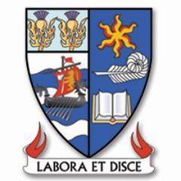
S4 Option Form 2019
Name |  |  | Class
Guidance Teacher |  |  | Parental Signature |  | Date
- All pupils will study English, Mathematics, Personal and Social Education, Physical Education, and Religious and Moral Education in S3
- Pupils should only select school based subjects that they have studied in S3. This does not apply to the college courses in columns D and E
- Pupils must select a subject from each of columns (C to G)
- It should be noted that classes will only run subject to staffing and pupil uptake

 | A | B | C | D | E | F | G
 | English | Maths | Computing Science  Geography  Graphic Communication  History  Modern Studies  Music  Physics  Spanish | Art & Design  Biology  Chemistry  Drama  French  Hospitality  Music Technology  Physical Education | Administration & IT  Art & Design  Biology  Hospitality  John Muir/Rural Skills  Music Technology  Physics  Practical Woodworking  Rugby NPA Level 5 | Biology  Chemistry  Computing Science  Dance National 5  Design & Manufacture  Geography  History  Physics  Religious Moral & Philosophical Studies (RMPS)  Travel & Tourism | Art & Design  Business Management  Chemistry  Geography  German  Graphic Communication  Modern Studies  Music  Physical Education
Ayrshire College Courses
(no other subject choice will be missed
by picking a college course)
 |  |  |  | Tues & Thurs  Afternoons | Mon & Wed  Afternoons
 |  |  |  | Automotive Skills L4  Construction L4  Criminology N5  Early Education N5  Engineering N5 | Beauty & Hair L4  Cyber Security N5
Subject Selection | English | Maths
All pupils will have a guidance interview between Monday 18th February - Friday 22nd February and the final deadline for the return of forms is Friday 1st March 2019

