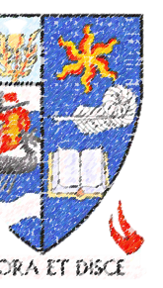
Largs
Academy

Choices for S3

Personalisation & Choice Information for young people, parents and carers in the final year of the
Broad General Education

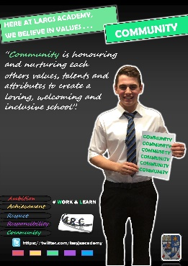
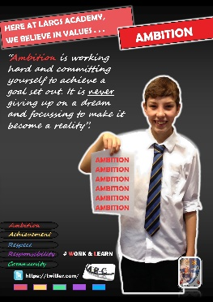
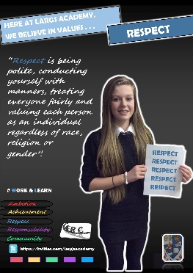
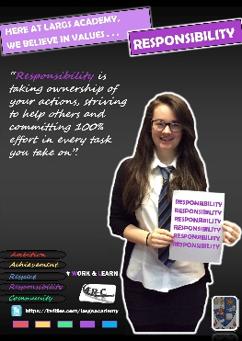
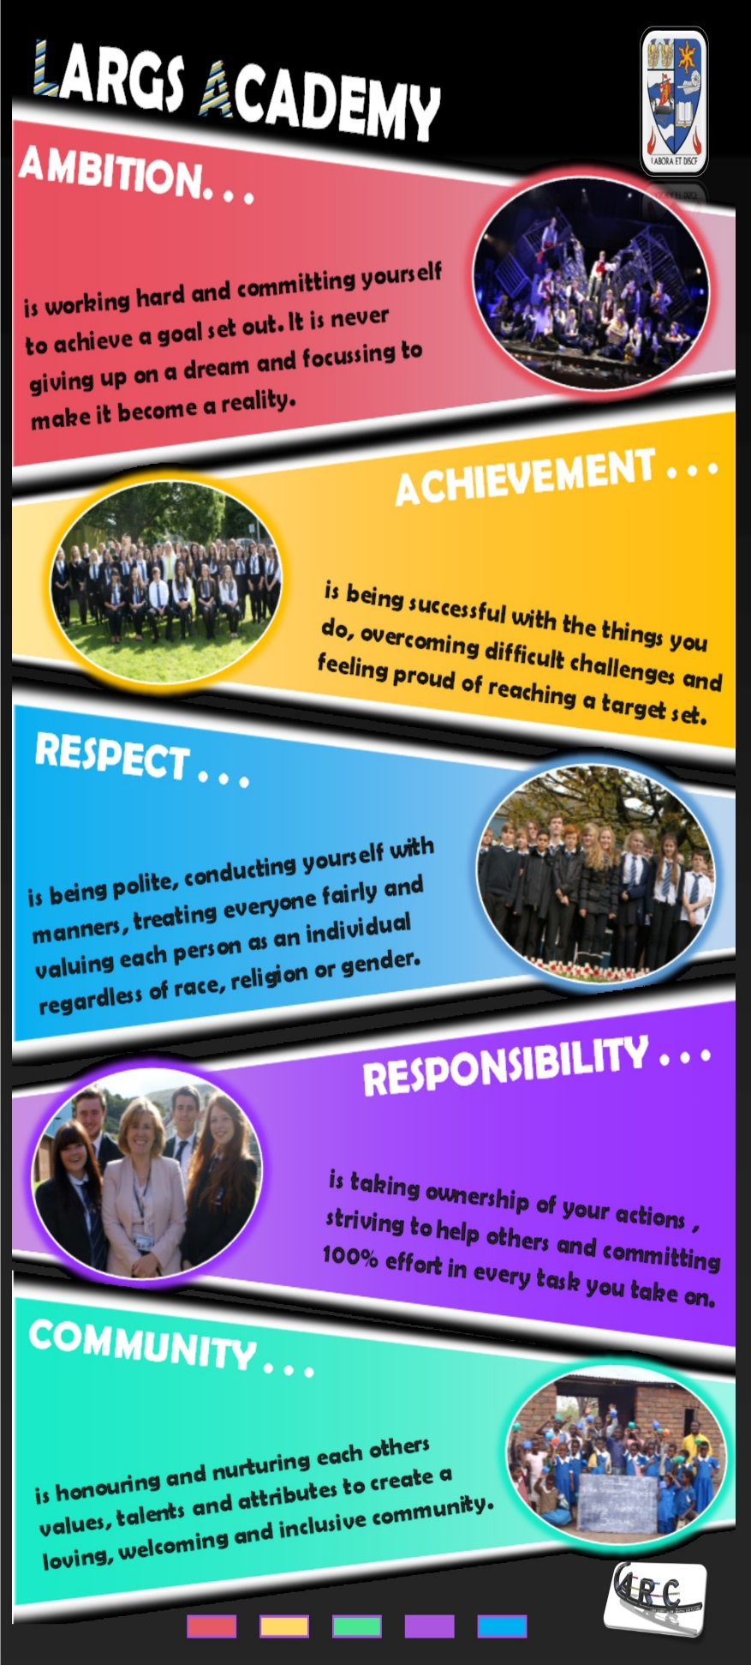
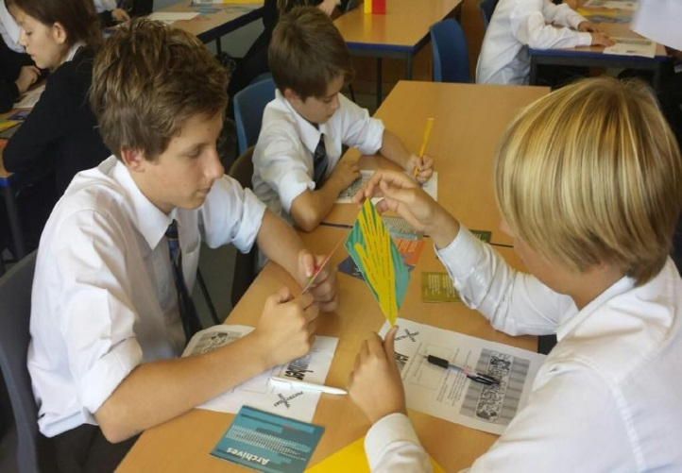

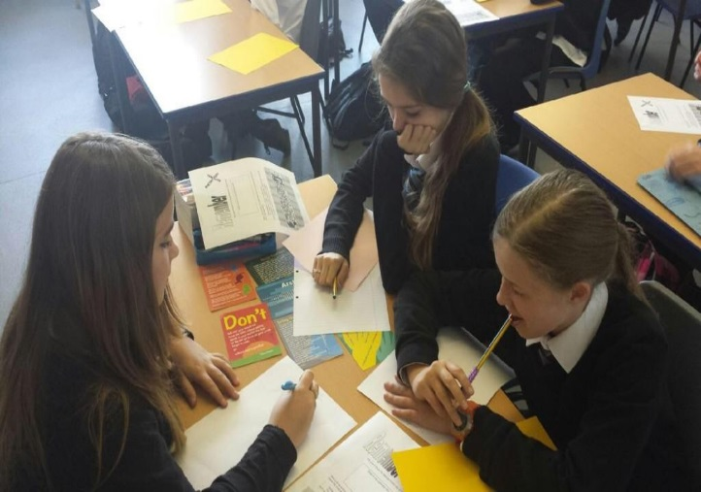

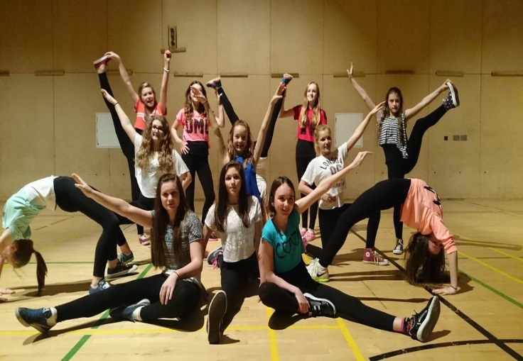
Personalisation & Choice in the final year of the Broad General Education

This booklet is designed to help students decide on a course of study for S3, the final year of the Broad General Education (BGE). In S3 all students will continue to study a number of subjects from each curricular area, including English and Mathematics, while being able to personalise, or choose additional courses. This enables them to begin to specialise in their learning by studying fewer subjects in greater depth. Physical Education, RME and Personal and Social Education will continue for all students.

We continue to review the curriculum each year and aim to maintain a relevant and interesting range of subjects and opportunities for all students, from S1 to S6. Following extensive consultation with staff, parents and young people in session 2014-15 we created our curriculum rationale, which outlines the purpose of the school’s curriculum and explains what we are trying to do for all the young people who attend Largs Academy.

What is the purpose of the S1-3 Curriculum?

Through the curriculum we provide opportunities for all young people to experience the key principles of Curriculum for Excellence:

- Challenge and Enjoyment | - Depth | - Coherence
- Progression | - Breadth | - Relevance
- Personalisation and Choice

What about the development of skills for learning, life and work?

“Every child and young person is entitled to develop skills for learning, skills for life and skills for work, with a continuous focus on literacy and numeracy and health and wellbeing.”
(Building the Curriculum 3: A Framework for Learning and Teaching)

S1-S3 students experience a programme of learning development and study skills through PSE and through the work completed in individual subjects, as teachers prepare them for the challenges of the Senior Phase. Part of this work will also involve them compiling their own S3 Profile, which is a statement of their main achievements throughout the Broad General Education. We want all students to be confident in identifying their strengths and abilities, as well as able to identify those areas which remain challenging, and to look at strategies for improvement. Through inter-disciplinary projects, learning conferences and other events throughout the session, we provide the opportunity to put learning into a practical context and support all students in developing skills which they will use throughout their life and work.
Skills for Learning | Skills for Work
- Analysis | - Communicating
- Application | - Planning and Organising
- Evaluation | - Problem Solving
- Synthesis | - Working with Others
 | - Thinking Critically and Creatively
In addition to the significant aspects of learning from each curriculum area there will also be a focus on developing the core skills for learning, life and work which are important to make a successful transition into the Senior Phase of the curriculum.

What does the S3 Curriculum look like?

As part of the core curriculum pupils will study:

Core Subjects (mandatory) Physical Education,
Personal & Social Education & RME Mathematics (mandatory)

English (mandatory)

Social Subjects 1 subject from History, Geography,
Modern Studies, RMPS, and Business Management

Science 1 subject from Physics, Chemistry and Biology

Modern Languages 1 subject from French, Spanish and German

Expressive Arts 1 subject from Music, Art & Design, PE and Dance

Technologies 1 subject from Design & Manufacture, Graphic Communication, Hospitality Practical Cookery, Computing Science, Music Technology and Administration & IT

Pupils have the option to pick a further two subjects from any curricular area as well as the option of selecting the Duke of Edinburgh Bronze Award, Travel & Tourism, Early Education
& Childcare and/or Rural Skills (incorporating John Muir Award).
(B
All subjects will have progression to qualifications at National 3, National 4 and National 5 in S4.
S2 Personalisation and Choice Programme 2019

Friday 1st February S2 Full Reports Issued

Wednesday 6th February S2 Options Assembly with forms and letters issued with BGE
course descriptor booklets

Thursday 7th February - Friday 15th February S2 Guidance Interviews

Thursday 14th February Careers Evening, 7pm

Friday 22nd February Personalisation and Choice forms to be returned,
signed by parents by 22/02/19
Wednesday 22 February
Please take the opportunity to seek advice from others:

Your subject teacher It is very important that you speak with your teachers and find out your areas of strength and development as this will help you identify the subjects you are strongest in.
Ask yourself, “How good am I in this subject?”.

Your Guidance teacher Your guidance teacher will discuss your options in detail during a one to one interview and they can also provide more information on specific courses you are interested in.

Your Support for Learning Teacher Some of you may wish to consult with your Support for Learning teacher before making your final course choice.

Your parents Your parents have a wealth of knowledge about you and your strengths and will always provide good advice.

The Senior Phase (S4-6)
Courses offered are certified by the Scottish Qualifications Authority (SQA). These qualifications are called Nationals and most students will now study 7 subjects at either National 4 or National 5 in S4; a mixture of National 5s and Highers in S5; and a combination of Nationals, Highers and Advanced Highers in S6.

Assessment
All courses at National 3 and 4 are made up of units assessed internally by the class teacher. To be awarded the overall course, students must pass all of the units. Units for all levels will be graded as pass or fail.

At National 3 and 4 students will be required to successfully complete an Added Value Unit which may be a project, practical work, presentation or test. National 3 and 4 courses will be assessed internally by class teachers and this will be monitored closely by SQA. National 3 and 4 courses will be graded pass or fail.

Courses at National 5 - pupils will have to pass additional assessments, usually a question paper (external exam) and/or an assignment. Both will be marked externally by SQA. National 5 courses will be graded A-D.

Progression through the Senior Phase (S4-6)

It is important to acknowledge that there is no right or wrong pathway through the senior phase and no one route is better than another. The best pathway is the one that is most appropriate to the individual depending upon their skills, abilities and career desires. The table below shows some of the routes available:

S4 | S5 | S6
National 5 | Highers/Foundation Apprenticeships | Ad Highers/Highers/NC College Courses
National 4 | National 5 | Highers/National 5/NPAs/  College Courses
National 3 | National 4 | National 5s/NC College Courses

Our S1-3 Broad General Education will provide students with many experiences and outcomes that will prepare them well for the rigours of S4 courses. Indeed, by the end of S3 many young people will have already encountered work of an equivalent nature to National 4 or National 5. This means that students will be well prepared for the Senior Phase. We are confident that our Broad General Education prepares students for formal SQA assessments in S4-6. One of the biggest challenges in Scottish education has been the move from relatively time-rich S3/4 courses to very intensive, short, content-heavy one year Higher qualifications in S5. Our new model for S4 students is much better preparation for the demands of an S5 which is often the key determinant of a young person’s next steps in life.

Why has Largs Academy opted for a seven subject S4-S6?
Following consultation with pupils, staff and parents it has been agreed that pupils will increase the number of subjects studied in S4 from 6 to 7. This is to provide pupils with an additional qualification in S4 to provide greater flexibility with their option choices in S5/6. With the period allocation dropping from 5 periods per week to 4 periods, the timetable change has been brought forward to early May to provide as much learning time as possible.

How might a seven subject S4 affect an individual student’s Senior Phase?
It is very challenging to visualise the wide variety of pathways that students might take but the examples described below hopefully give a flavour of some of the pathways:
In S4 John sat four National 5 subjects and three National 4s. In S5, John then sat three more National 5 and two Higher courses. In S6 he re-sat one of his S5 Higher courses to upgrade his ‘D’ pass and he sat one additional Higher, one National 5 and Sports Leaders Award. Total Senior Phase credit for John: three Highers, eight National 5s and three National 4s.
Jane planned to leave school at the end of S4 and passed seven National 4 qualifications which were all internally assessed. However, at the end of S4, she decided to stay on and went on to sit four National 5 subjects and a further National 4 subject, before leaving at the end of S5. Total Senior Phase credit for Jane: four National 5s and eight National 4s.
In S6, Jack sat two new National 5 subjects and completed the two Highers he had started in S5. Total Senior Phase credit: two Highers and eight National 5s (6 in S4).
In S4 Jenny completed six National 5s. She achieved five Highers in S5. In S6 she sat three Advanced Highers, one new Higher, plus one YASS Module with the Open University. Total Senior Phase credit: Three Advanced Highers, six Highers, six National 5s and an OU Module.
CONTENTS | PAGE NUMBER
English _  Drama | 9  10
Mathematics & Numeracy | 11
Modern Languages (French & Spanish) | 12
RMPS | 13
Geography _ _ | 14
History _ _ | 15
Modern Studies _ _ | 16
Biology _ _ | 17
Chemistry _ _ | 18
Physics _ _ | 19
Music, including Music Technology _ _ | 20
Art & Design | 21
Hospitality: Practical Cookery __ _ | 22
Design & Manufacture | 23
Graphic Communication | 24
Computing Science | 25
Business Management | 26
Administration & IT _ | 27
Physical Education  Early Education and Childcare  Rural Skills (inc John Muir Award)  Travel and Tourism  Duke of Edinburgh (Bronze Award)  Largs Academy Faculty Structure  SQA Qualifications | 28  29  30  31  32  33  34
English, Drama and Literacy

Why study English in the Broad General Education?

Studying English and Literacy provides students with many of the skills which are essential to their success in school, and beyond. The S3 course will focus on the development of core skills through the study of language, literature and media. They will develop reading, writing, talking and listening skills, enabling students to develop an ability to contribute and communicate effectively in a range of contexts. All students will follow a similar English course as part of a broad general education, covering level 4 Literacy and English outcomes and experiences.

Students will be given opportunities to study a wide range of literature, which they will analyse and evaluate, exploring connections between the texts they read and the world we live in. They will also be given extensive opportunities to create their own texts, both written and spoken, where they will develop their language skills through producing creative, critical and transactional responses.

Most college courses require entrants to have studied English to National 4/5 level and many university courses require students to study beyond National 5 level.

S3 Course
Students will follow an English and Literacy course as part of a broad general education, covering level 4 outcomes and experiences. During S3 students will also undertake some of the National 4 and National 5 outcomes.

Assessment
The course will be assessed throughout the session. These assessments are appropriate to the subject and level of study.

Equipment
There is no special equipment required to complete the English course. Students are, however, expected to take care of textbooks issued to them and come to class equipped with a pen or pencil.

Drama

Why study Drama in the Broad General Education?
Drama is recognised as one of the most effective ways to develop emotional intelligence in young people. Drama promotes communication, teamwork, dialogue, negotiation, socialisation, and leadership traits. The course is designed to stimulate imagination and creativity whilst developing critical thinking skills. Creative Industries are now the third largest industry in the UK, with Scotland’s creative hub contributing £4.6bn to the economy while being the fastest growing export service. Drama fosters problem-solving skills in an ever changing world and encourages students to think for themselves.
Career and Employment Opportunities Include:
- Actor, Advertising, Broadcasting, Journalism
- Cinematographer, Costume Designer
- Director, Drama Therapist
- Further Education Lecturer, Teacher, Youth Worker
- Law, Lighting Design
- Make-up Artist, Marketing
- Press Officer, Production Designer
- Script Writer, Set Designer, Sound Designer ………………and a vast deal more.
S3 Course
Students will initially study the roles and responsibilities of the theatre: Actor, Costume Designer, Lighting Designer, Make-Up Artist, Properties Manager, Set Designer and Sound Technician. Students will then choose two roles to explore further as part of a full production team. Alongside this, students will practise their creativity by responding to differing stimuli to create characters, scenarios and plot lines in both improvised drama and scripted performance. Students will be offered a further opportunity to explore their chosen production roles in created drama.

Assessment
The course will be assessed and marked throughout the session. Assessments may include a combination of practical work, case studies, examinations and projects.

Equipment
All necessary equipment will be provided within school. However, for any students who would wish to invest in any additional equipment (e.g. make-up kit, monologue texts) the class teacher can provide advice.

Mathematics and Numeracy

Why study Mathematics in the Broad General Education?

Maths affects everything we do in our lives. It forms the basis for many other subjects. You may not need to use algebra when you go shopping, but the architects who designed the shop did, and so did the builders who built it, and so did the engineers who designed the machines which made the goods you buy. Physics, Chemistry and Biology all rely on Maths to some extent, and many subjects, such as Business, Computing Studies and Technical subjects will all be much easier if you have a good grasp of Maths.

If you're thinking of going straight from school into employment, then Maths is quite possibly the most important subject you can take, as the ability to understand and manipulate numbers and mathematical concepts is extremely useful for almost any job. Employers rate Maths skills very highly: there is always a demand for employees who can think logically and process information accurately.

The Course allows learners to interpret, communicate and manage information in mathematical form, skills which are vital to scientific and technological research and development. It is designed to develop the learner’s skills in using mathematical language, to explore mathematical ideas, and to develop skills relevant to learning, life and work in an engaging and enjoyable way. It will build on prior learning and develop:

- operational skills in algebra, geometry, trigonometry and statistics
- reasoning skills of investigation, problem solving, analysis and modelling
- some numeracy skills in number processes and information handling

S3 Course
Students will follow a Mathematics course as part of a broad general education, covering level 4 outcomes and experiences. During S3 students will also undertake some of the National 4 and National 5 outcomes.

Assessment
Formative and summative assessment will take place at appropriate times throughout the session.

Equipment
Each student is expected to bring with them on a daily basis:
- any materials the teacher has issued to assist with learning i.e. textbook & jotters
- stationery such as pencils and a ruler
- a scientific calculator
Modern Languages

Why study a Modern Language in the Broad General Education?

Many people think that “everyone speaks English” is a reason for not learning a foreign language but this is a myth. Only 6% of the world’s population speaks English as a first language. 75% of the world’s population doesn’t speak any English at all.

Research shows the benefits of learning a language include:
- Better understanding of different cultures and developing as a global citizen
- Improved self confidence
- Enhanced ability to build new relationships
- Improved literacy and reading skills in your own language
- Enhanced problem solving, interpersonal and communication skills
- Increased employability opportunities

Key features of learning and teaching at Largs Academy are:
- Real communication in relevant contexts, supported by ICT
- An emphasis on how languages work, including grammar
- A focus on culture and international education
- Development of employability skills by teaching the language in relevant contexts
- Participation in events such as European Day of Languages

S3 Course

As well as learning about the background and culture of France, Spain and Germany and other countries where they speak these languages, pupils will be developing the key skills of Talking, Listening, Reading and Writing in a variety of contexts. Pupils can choose between French, German and Spanish and also have the opportunity to study a combination of languages.

Assessment
The course will be assessed throughout the session. These assessments are appropriate to the subject and level of study. The four skills of Listening, Reading, Talking and Writing will be assessed throughout the year and feedback will be provided regularly to pupils and parents.

Equipment
Students should bring the following items to class every day:
- Jotter(s) and Vocabulary notebook
- Pen/pencil
- It would be very helpful for students to have a bilingual dictionary at home to use when completing homework tasks.
Religious, Moral and Philosophical Studies (RMPS)

Why study RMPS in the Broad General Education?

S3 Elective Course
In S3 students have the opportunity to select RMPS as one of their seven elective courses.

This course will involve:

World Religion – Christianity

In this unit, learners will develop skills to explain and comment on the meaning and context of sources related to Christianity. They will develop detailed factual and abstract knowledge and understanding of the impact and significance of Christianity today through studying some key beliefs, practices and sources.

Morality and Belief – Environment and Global Issues

In this unit, learners will develop skills to explain and express reasoned views about resource management, environmental crisis, poverty and trade and aid. They will develop detailed factual and theoretical understanding of these moral issues and will explore various responses to them, including religious and philosophical perspectives.

Religious and Philosophical Questions - Existence of God

In this unit, learners will develop skills to analyse religious and non-religious responses to the Existence of God(s).

Assessment
The course will be assessed throughout the session. These assessments are appropriate to the subject and level of study.

In S3 all Largs Academy Students will continue to have one period per week of Core Religious Education.

Equipment
Students should bring the following items to class every day:
- Pen/pencil.

Social Subjects

Geography

Why study Geography in the Broad General Education?

Geography is a subject which studies people, place and our interaction with the environment. It opens up the world for learners. The purpose of Geography is to develop the learner’s understanding of our changing world and its human and physical processes. Opportunities for practical activities, including fieldwork, will be encouraged, so that learners can interact with their environment. The contexts for study are local, national, international and global. Geography draws upon the social and natural sciences: interdisciplinary learning is therefore fundamental to geographical study and encourages links with other disciplines. In the 21st century, with growing awareness of the impact of human activity upon the environment and scarce resources, the study of Geography fosters positive lifelong attitudes of environmental stewardship, sustainability and global citizenship. This qualification will furnish learners with the knowledge and skills to enable them to contribute effectively to their local communities and wider society. Learners will develop skills which are transferable to other areas of study and which they will use in everyday life. The main aims of Geography are to enable learners to:
- Appreciate the ways in which people and the environment interact in response to physical and human processes at local, national, international, and global scales.
- Be aware of spatial relationships and develop an understanding of the changing world in a balanced, critical and sympathetic way.
- Acquire a geographical perspective on environmental and social issues.
- Develop an interest in, and concern for, the environment leading to sustainable development.

S3 Course
Students will follow a Geography course as part of a broad general education, covering level 4 outcomes and experiences. During S3 students will also undertake some of the National 4 and National 5 outcomes.

Assessment
The course will be assessed and marked throughout the session by teachers. These assessments are appropriate to the subject and level of study. Assessments may include a combination of practical work, case studies, examinations and projects.
Equipment Students require pens and pencils for general course work. Coloured pencils, a calculator and a ruler will also come in handy.
Social Subjects
History

Why study History in the Broad General Education?

History opens up the world of the past for learners. The purpose of History is to provide learners with insights into their own lives and the society in which they live. By examining the past, we discover our heritage as members of a community, a country and a wider world. History provides learners with both a perspective on, and an understanding of, the forces which have shaped their own society and societies in other countries. The main aims of this Course are:
- To develop learners’ conceptual understanding and foster their ability to think independently;
- To enable learners to acquire breadth and depth in their knowledge and understanding of historical themes;
- To develop learners’ skills of explaining historical developments and events, evaluating historical sources and drawing conclusions;
- To develop learners’ imagination and empathy with people living in other periods;
- To encourage learners to debate issues and, on the basis of evidence, form views and respect those of others;
- To foster in learners an interest in history which will enhance understanding of our modern, multi-cultural society and provide a life-long interest.

History lends itself to the development of important skills, not only reading, writing, researching and using historical sources to reach conclusions, but also the ability to think, argue and debate. Pupils will also develop a range of transferable skills through the use of active learning such as role-plays, debates and discussions.

S3 Course
Students will follow a History course as part of a broad general education, covering level 4 outcomes and experiences. During S3 students will also undertake some of the National 4 and National 5 outcomes.

Assessment
The course will be assessed and marked throughout the session by teachers. These assessments are appropriate to the subject and level of study. Assessments may include a combination of case studies, examinations and projects.

Equipment
Students are encouraged to come to class armed with pens, pencils and a ruler. Highlighters can be handy too.
Social Subjects

Modern Studies

Why Study Modern Studies in the Broad General Education?

In Modern Studies you examine society and the world around you. It encompasses three main elements: Political, Social and Economic areas of study. Being able to analyse information and make decisions is an essential life skill, as is having an awareness of current affairs and how they can affect you. Modern Studies is an interesting and highly relevant subject that provides many opportunities to actively participate. Students who undertake this subject go on to be employed in many different fields including Law, Journalism, Teaching and Social Work. The main aims of this course are to enable learners to develop:

- A range of research and information handling skills
- Straightforward understanding of the democratic process
- Straightforward understanding of social and economic issues at local, national and international levels and ways of addressing needs and inequalities
- Awareness of different views about the extent of state involvement in society
- Awareness of the nature and processes of conflict resolution
- Understanding of human and legal rights and responsibilities and their application in different societies

Modern Studies opens up the world of society for learners. The purpose of this course is to develop learners’ knowledge and understanding of contemporary political and social issues in local, Scottish, United Kingdom and International contexts. Learners will develop an awareness of the social and political issues they meet in life.

S3 Course
Students will follow a Modern Studies course as part of a broad general education, covering level 4 outcomes and experiences. During S3 students will also undertake some of the National 4 and National 5 outcomes.

Assessment
The course will be assessed and marked throughout the session by teachers. These assessments are appropriate to the subject and level of study. Assessments may include a combination of practical work, case studies, examinations and projects.

Equipment
Students are encouraged to come to class armed with pens, pencils and a ruler. Highlighter pens can be handy.

Science

Biology

Why Study Biology in the Broad General Education?

Biology, the study of living organisms, plays a crucial role in our everyday existence, and is an increasingly important subject in the modern world. Biology affects everyone and aims to find solutions to many of the world’s problems. Advances in technologies have made this varied subject more exciting and relevant than ever. It explores the use of genetic modification to produce new plants and drugs, devising fertility treatments, curing genetic diseases, solving crimes by understanding crime scene material, and developing new sources of food for our expanding population. The course develops scientific understanding of biological issues and aims to develop learners’ interest in and enthusiasm for biology, by using a variety of approaches, with an emphasis on practical activities.

S3 Course
Students will follow a Biology course as part of a broad general education, covering level 4 outcomes and experiences. During S3 pupils will also undertake some of the National 4 and National 5 outcomes.

Assessment
The course will be assessed throughout the session. These assessments are appropriate to the subject and level of study. Assessments may include a combination of practical work, case studies, examinations and projects.

Equipment
Students should take responsibility for their own learning. To help students be active in their learning they should come to class prepared with all the necessary equipment e.g. jotter, pen, pencil, calculator etc.

Science

Chemistry

Why Study Chemistry in the Broad General Education?

What in the world is not chemistry? We live in an age of chemistry based technology. No matter what you look at, a chemist has probably been involved in its manufacture or development! By studying chemistry, you will find out how chemistry is vital to everyday life. It will help you understand how society’s needs are met and how you could shape the world in which we live. Chemistry is an important subject in many careers such as medicine, plastic manufacture, renewable energies, pharmaceuticals, cosmetics, forensics, environmental science and the food industry. The course consists of knowledge, skills and practical work. You will develop scientific understanding of issues relating to chemistry, consequently becoming scientifically literate. Successful chemists think creatively, analyse and solve problems by working individually and in groups where they will apply critical thinking in situations especially practical work to develop their learning.

S3 Course
Students will follow a Chemistry course as part of a broad general education, covering level 4 outcomes and experiences. During S3 pupils will also undertake some of the National 4 and National 5 outcomes.

Assessment
The course will be assessed throughout the session. These assessments are appropriate to the subject and level of study. Assessments may include a combination of practical work, case studies, examinations and projects.

Equipment
Students should take responsibility for their own learning. To help students be active in their learning they should come to class prepared with all the necessary equipment e.g. jotter, pen, pencil, calculator etc.

Science

Physics

Why Study Physics in the Broad General Education?

Learners will gain an appreciation of the immense contribution that physics has made to our lifestyle, comfort and security as well as a deeper understanding of the world around us. They will acquire knowledge of concepts in physics, relevant to this level of the Course, and be able to apply their understanding to practical situations. They will develop skills in making informed decisions, and be prepared to make reasoned evaluations on environmental and scientific issues. They will develop investigative and experimental skills in a physics context. By completing this Course, learners will develop important and relevant skills, attitudes and attributes related to physics, including: scientific and analytical thinking skills in a physics context; an understanding of the role of physics in science is the ability to apply knowledge and understanding of concepts in physics; and an understanding of relevant applications of physics in society.

Learners will also gain valuable transferable skills for learning, life and work, including those of literacy and numeracy.

S3 Course
Students will follow a Physics course as part of a broad general education, covering level 4 outcomes and experiences. During S3 students will also undertake some of the National 4 and National 5 outcomes.

Assessment
The course will be assessed and marked throughout the session. These assessments are appropriate to the subject and level of study. Assessments may include a combination of practical work, case studies, examinations and projects.

Equipment
Students should take responsibility for their own learning. To help students be active in their learning they should come to class prepared with all the necessary equipment e.g. jotter, pen, pencil, calculator etc.

Expressive Arts

Music and Music Technology

Music

Why study Music in the Broad General Education?
Music provides learners with rich opportunities to be creative and to experience inspiration and enjoyment. Performing and creating music will be the prominent activities for all learners. Through these activities, they develop their vocal and instrumental skills, explore sounds and musical concepts, and use their imagination and skills to create musical ideas and compositions. Music involves self-discipline and determination to succeed, both essential qualities in the world of work. There are numerous career choices, with jobs in teaching or music therapy, production, promotion and management as well as performance.

S3 Course
There will be choice between Music Performance studies and Music Technology studies.

Music Performance
The Music performance course will be made up mostly of performing and creating music and through these activities learners will develop vocal and/or instrumental skills. They will develop an understanding and enjoyment of music through listening to musical performances and commenting on them. Some learners may choose music software to create their work.
Music Technology
The Music Technology course will consist mainly of the building of skills in using Digital Audio Software on computers to capture audio and then manipulate, edit and process the audio to create individualized assignments. Pupils will discover techniques in a variety of media contexts such as radio broadcasts, film foley work, computer game composition and songwriting.

Assessment
The course will be assessed throughout the session as appropriate to the subject and level of study. The Music Course Assessments may include a combination of practical work, presentations, examinations and projects. The Music Technology Assessments may include a combination of practical work, presentations and audio recording projects.

Equipment
All necessary specialist musical equipment can be provided. All students are expected to have a pen, pencil and eraser and the appropriate music with them for all lessons.
Expressive Arts

Art and Design

Why study Art and Design in the Broad General Education?

Art & Design provides learners with opportunities to continue to acquire and develop the attributes and capabilities of the four capacities as well as skills for learning, skills for life and skills for work. The courses are designed to encourage pupils to be creative and to express themselves in different ways. Learning through Art and Design helps learners to develop an appreciation of aesthetic and cultural values, identities and ideas. Students will develop their knowledge of media handling skills in both expressive and design contexts. Learning in this Course will include the creative use of media, materials and/or technologies.

Studying Art and Design opens up a world of wonderful career opportunities including:

- Architecture, advertising, animation
- Ceramics, costume design
- Floristry, Garden design, graphic design
- Illustration, Interior design
- Medical illustration publishing, product design
- Special effects work
- Textile design, theatre set design
- Visual merchandising
- Web site design ……..and many, many more

S3 Course
Students will follow an Art and Design course as part of a broad general education, covering level 4 outcomes and experiences. During S3 students will also undertake some of the National 4 and National 5 outcomes.

Assessment
The course will be assessed and marked throughout the session. Assessments may include a combination of practical work, case studies, examinations and projects.
Equipment
Learners are encouraged to come to class with their own basic drawing materials i.e. pencil, rubber, hand writing pen & colouring pencils.

Technologies

Hospitality: Practical Cookery

Why study Hospitality: Practical Cookery in the Broad General Education?

The Scottish catering and hospitality industries are large, vibrant and growing, collectively employing a significant proportion of the nation’s workforce. Employers are looking for well-educated and skilled workers capable of further professional training, and this qualification in Practical Cookery provides the basic skills. The main purpose of this Course is to develop learners’ practical cookery skills as well as their knowledge and understanding of ingredients. It will provide a set of foundation skills for those who wish to progress to professional hospitality work either as a career or for part-time work while studying. Practical Cookery does this by developing the following skills, knowledge and understanding. The course aims to enable learners to:

- Become familiar with basic cookery skills, simple preparation techniques and simple cookery processes
- Understand the importance of food safety and hygiene and work safely and hygienically at all times
- Acquire an understanding of ingredients and their uses and an awareness of responsible sourcing and sustainability
- Develop an awareness of the impact of the choice of ingredients being used on health and general wellbeing
- Follow simple recipes to produce a range of dishes
- Be able to plan to manage time in an efficient manner
- Plan and produce simple meals then present them appropriately

S3 Course
Students will follow the Hospitality course as part of a broad general education, covering level 4 outcomes and experiences. During S3 students will also undertake some of the National 4 and National 5 outcomes.

Assessment
The course will be assessed and marked throughout the session. These assessments are appropriate to the subject and level of study. Assessments may include a combination of practical work, case studies, examinations and projects.

Equipment
Students will be required to bring additional ingredients for some practical lessons as well as containers to take food away.
Technologies

Design and Manufacture

Why Study Design and Manufacture in the Broad General Education?

Design and Manufacture introduces learners to the multi-faceted world of product design and manufacturing. The Course provides a broad practical introduction to design, materials and manufacturing processes. It provides opportunities for learners to gain skills in both designing and in communicating design proposals. It allows learners to explore the properties and uses of materials and to make models and finished products. The Course allows them to consider the impact that design and manufacturing technologies have on our environment and society. It also provides a solid foundation for those considering further study, or a career, in design, manufacturing, engineering, science, marketing, and related disciplines.

The aims of the Course are to enable learners to develop:
- skills in the design and manufacturing of models, prototypes and products
- knowledge and understanding of manufacturing processes and materials
- an understanding of the impact of design and manufacturing technologies on our environment and society.

S3 Course
Students will follow a Design and Manufacture course as part of a broad general education, covering level 4 outcomes and experiences. During S3 students will also undertake some of the National 4 and National 5 outcomes.

Assessment
The course will be assessed and marked throughout the session. These assessments are appropriate to the subject and level of study. Assessments may include a combination of practical work, case studies, examinations and projects.

Equipment
All necessary equipment will be provided within schools. However, for any students who would wish to invest in any additional equipment (eg drawing equipment or CAD software, etc) class teachers can provide advice.

Technologies

Graphic Communication

Why Study Graphic Communication in the Broad General Education?

The course introduces learners to the diverse and ever increasing variety of presentation methods employed in graphic communication. It provides opportunities for learners to gain skills in reading, interpreting and creating graphic communications. They will develop spatial awareness and visual literacy. It combines elements of creativity and communicating for visual impact with elements of protocol and an appreciation of the importance of graphic communication standards, where these are appropriate. The course provides a solid foundation for those considering further study, or a career, in graphic design, engineering, advertising, marketing, and related disciplines. Learners will also gain valuable transferable skills for learning, life and work.

The aims of the Course are to enable learners to:
- develop skills in graphic communication techniques, including the use of equipment, materials and software
- extend and apply knowledge and understanding of graphic communication standards and protocols, where these apply
- develop an understanding of the impact of graphic communication technologies on our environment and society.

S3 Course
Students will follow a Graphic Design course as part of a broad general education, covering level 4 outcomes and experiences. During S3 students will also undertake some of the National 4 and National 5 outcomes.

Assessment
The course will be assessed and marked throughout the session. These assessments are appropriate to the subject and level of study. Assessments may include a combination of practical work, case studies, examinations and projects.

Equipment
All necessary equipment will be provided within schools. However, for any students who would wish to invest in any additional equipment (eg drawing equipment or CAD software, etc) class teachers can provide advice. It is highly recommended that all pupils have drawing equipment at home to allow completion of homework tasks and to consolidate what has been taught in class.

Enterprise and IT

Computing Science

Why study Computing Science in the Broad General Education?

Computing Science is vital for everyday life, it shapes the world in which we live and its future. Computer scientists play key roles in meeting the needs of society today and for the future, in fields that include science, communications, entertainment, education, business and industry. Our society needs more Computer Scientists and for all young people to have an informed view of the IT industry and its contribution to the economy.

Learners will develop a range of transferable skills for learning, skills for life and skills for work, opening up a wide range of career and study opportunities. Computing science does this by beginning to develop the following skills, knowledge and understanding:

- Developing short computer programs using software development environments eg Visual Basic, Games Design
- Understanding the role and impact of computing and information technologies on the environment and society
- Investigating an emerging and innovative software development technology
- Developing simple information systems
- Web authoring
- Applying basic computing and information science knowledge and skills to create solutions.

S3 Course
Students will follow a Computing Science course as part of a broad general education, covering level 4 outcomes and experiences. During S3 students will also undertake some of the National 4 and National 5 outcomes.

Assessment
The course will be assessed and marked throughout the session. These assessments are appropriate to the subject and level of study. Assessments may include a combination of practical work, case studies, examinations and projects.

Equipment
No specialised equipment will be required for the study of Computing Science.

Enterprise and IT

Business Management

Why Study Business Management in the Broad General Education?

Business plays a vital role in our society. We all rely on businesses to create wealth and wellbeing, prosperity, jobs and choices; so it is essential that society has effective businesses and business managers. This course will enable you to understand and make use of business information to interpret and report on overall business performance in a range of contexts and will develop your enterprise and employability skills.

This course will allow you to develop:
- knowledge and understanding of the way society relies on business to satisfy our needs
- an insight into the systems organisations use to ensure customers’ needs are met
- enterprising skills and enterprising attributes by participating in activities in realistic business situations
- an understanding of financial awareness through a business context
- an insight into how organisations utilise resources for maximum efficiency
- an understanding of the steps taken by organisations to improve their overall performance.

S3 Course
Students will follow a Business and Finance course as part of a broad general education, covering level 4 outcomes and experiences. During S3 students will also undertake some of the National 4 and National 5 outcomes.

Assessment
Assessments are appropriate to the subject and level of study. Assessments may include a combination of practical work, case studies, examinations and projects.

Equipment
No specialised equipment will be required.
Enterprise and IT

Administration and IT

Why study Administration and IT in the Broad General Education?

Administrative and IT job opportunities are increasing and studying Administration and IT will enhance a learner’s employability by teaching them how to use IT software to an industry standard and how to contribute positively to the Administrative systems that ensure a business is running successfully. Moreover, the Course makes an important contribution to supporting the wider curriculum and a learner’s general education through developing a range of essential organisational and IT skills.

Administration and IT does this by developing the following skills, knowledge and understanding:
- IT skills in the use of word processing, desk top publishing, spreadsheet and database software
- IT skills in using technology for communication and investigation (eg multimedia, e-mail and internet)
- Organisational skills (eg preparing business events and meetings)
- Understanding of how to develop good customer care systems
- Understanding of how key legislation affects businesses and employees
- Problem solving skills.

S3 Course
Students will follow an Administration and IT course as part of a broad general education, covering level 4 outcomes and experiences. During S3 students will also undertake some of the National 4 and National 5 outcomes.

Assessment
The course will be assessed and marked throughout the session. These assessments are appropriate to the subject and level of study. Assessments may include a combination of practical work, case studies, examinations and projects.

Equipment
No specialised equipment will be required for the study of Administration and IT. However, access to IT outside of school would allow learners to practice and consolidate their IT skills.
Physical Education

Why study Physical Education in the Broad General Education?

Physical Education involves pupils in a diversity of learning experiences contributing to their intellectual, social and moral development. It provides learners with the opportunities to develop:
- The skills necessary for improved physical performance
- The knowledge and understanding to analyse their performance and suggest ways for improvement
- Their ability to make up improvement programmes and to carry them out
- The knowledge and understanding required to enhance their physical, social, emotional and mental wellbeing
- The knowledge of how to maximise active engagement to sustain an active, enjoyable and healthy lifestyle.

Learners will work both independently and collaboratively reflecting on personal development and achievement while developing thinking, personal, interpersonal and ICT skills. Living in today’s world allows people much more leisure time with greater opportunity for employment in this expanding area. Pupils who have studied PE would fit easily into the market place having developed the ability to problem solve, team build and team work while improving their interpersonal skills of self-confidence, self-esteem, self-reliance and determination.

S3 Course In S3 all students will follow a Physical Education course as part of a broad general education, covering level 4 outcomes and experiences. For the first time pupils can opt for a course which is either games based or has an aesthetic focus, or choose dance:

Games Based: Pupils who choose this option will focus on completing the course mainly through activities like Badminton, Basketball, Football, Volleyball, Handball and Rugby, with a small amount of time spent on Aesthetic activities.
Aesthetics Focus: Pupils who choose this option will focus on completing the course mainly through activities like Gymnastics, Trampolining, Fitness and Dance. There will be a small amount of time spent on Games activities too.
Dance: This course provides opportunities for learners to be inspired and challenged by creating, demonstrating and appreciating dance. This course is suitable for pupils who have an interest in choreography and expressive arts.

Assessment The course will be assessed throughout the session. Assessments may include a combination of practical work, case studies, examinations and projects.
Equipment Students are expected to come prepared for practical sessions (appropriate P.E. kit) and classroom sessions (textbooks, notes etc.)
Early Education and Childcare (EEC)

‘’ Working with children can be the most rewarding job in the world. No two days are the same and no two children are the same. Each day you’re helping to develop their young minds and are making an important and lasting difference to their future.’’

Is this course right for you?
- Do you want to work with children?
- Do you enjoy learning new things?
- Do you like practical work?
- Would you like to visit Early Education providers and gain experience working with young children?
If you answered yes to all or some of the questions, this course is right for you!

This course provides an introduction to Early Education and Child Care. Progression into S4 will lead to a National 4/5 in Early Education and Childcare: Skills for Work

Preparation for Parenthood | - The responsibilities of being a parent  - Range of support services available  - Family structures and respectful relationships.
Health & Safety for Babies & Young Children | - The care and protection of infants and the developing child  - How to keep babies and children healthy – immunisations, common childhood illnesses  - Safety in the home, car, garden and outside the home  - Breast and bottle feeding.  Practical work – bathing, nappy changing
The Pre-school Child –  Food, Clothing & Play | - Why is play so important?  - Different types of play  - Choosing correct clothing and footwear for children  - Feeding babies and toddlers.  Practical work – making a toy for a child/ toy investigation/surveys
Food Preparation for Healthy Eating | - Learning to plan and prepare healthy meals for babies and children that are nutritionally balanced, age appropriate and hygienically prepared.  Practical work – preparing and cooking for babies and children.
Skills for Work | - Develop employability skills through engaging with local employers eg: class talks, nursery visits and work placements where possible  - Developing skills for the work place - respect, communication, reliability, work ethic.

Rural Skills (incorporating John Muir Award) 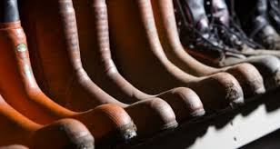

Why study Rural Skill and John Muir Award in the Broad General Education?

“The John Muir Award is a course which gives young people the opportunity to experience a range of different activities and roles involved in land-based industries. 'The John Muir Award' will enable our young people to gain invaluable experience in working outdoors whilst providing a foundation for a Rural Skills qualification in S4”.

Is this course right for you?
- Do you like being outdoors?
- Do you like getting your hands dirty?
- Do you like walking?
- Do you like working with other people?
If you answered yes to all or some of the questions, this course is right for you!

COURSE OUTLINE AND PROGRESSION
This award is all about loving the outdoors and doing something positive for the environment. If this sounds like you then sign up for the John Muir Award. Progression into S4 will lead to a National 4 in Rural Skills and Literacy: Skills for Work.

Travel and Tourism

Why study Travel and Tourism in the Broad General Education?

“This course is designed to let you gain knowledge on a variety of tourist destinations in
Scotland, the UK and the rest of the world. It offers essential vocational and employability skills that will develop the knowledge and attitudes needed to work in the travel and tourism
industry.”

Is this course right for you?
- Do you enjoy learning about different places?
- Do you want to learn more about Travel & Tourism?
- Do you like helping others?
- Would you like to develop your people skills?
If you answered yes to all or some of the questions, this course is right for you!

COURSE OUTLINE AND PROGRESSION
This internally assessed course provides an introduction to Travel & Tourism. Progression into S4 will lead to a National 4/5 in Travel and Tourism and help you develop your Literacy: Skills for Work.

Duke of Edinburgh (Bronze Award) 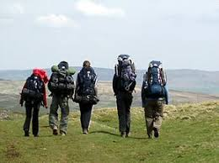

Why study Duke of Edinburgh in the Broad General Education?

At Largs Academy, we are committed to creating well rounded young people that will leave school with skills for life. The school is offering the opportunity for a small group of students to access the bronze award of the Duke of Edinburgh Award Scheme as part of an extended curriculum programme. (The Award will still be offered to students as an extra-curricular programme). The Award seeks to develop independence, teamwork and leadership. The Award requires commitment, determination and hard work of the young people taking part.

Why do the Award?
Expectations of young people are higher now than ever before. That 'edge' when applying for university, college and jobs is what makes the difference. The Duke of Edinburgh's Award allows young people to develop and learn skills and attributes to use throughout life from within the classroom and beyond the school gates. The award provides young people with the opportunity to make friends and build new relationships with other pupils. This challenging, yet beneficial award improves self-confidence and encourages young people to become more independent before moving onto the next stages in life. The bronze award is comprised of four assessed sections;
- Volunteering, b) Skills, c) Physical fitness and d) Expedition.

Your child might focus on the expedition but it is almost mandatory that he or she completes their first three sections before they will be permitted to take part in the final assessed expedition. The duration of the 1st three sections are
- Two sections for three months i.e. 13 weekly sessions of an hour or more
- One section for six months i.e. 26 weekly sessions of an hour or more
- If your young person should choose DofE as one of their options they will do most of their sessions within the school week.

There will an assessed expedition, in June or September and requires your child
to attend regular teaching sessions after school covering topics such as:
Camp Craft - Cooking - Navigation and Equipment – Packing
In addition to:
- taking part in a one day practice walk in March
- participating in an overnight practice expedition in May/ June 2020

Progression
Successful bronze candidates could progress onto the silver award. The young person would normally be expected to do this as an extra-curricular activity.

Faculty and Associated Courses | Faculty Leader
English, Drama and Literacy  (English and Drama) | Mrs Gilmour
Enterprise and IT  (Administration and IT, Business Management and Computing Science) | Mrs Simpson
Expressive Arts  (Art and Design, Music and Music Technology) | Mr Smith
Health and Wellbeing  (Physical Education and Dance) | Mr Cavani
Mathematics and Numeracy  (Maths) | Mr Blair
Modern Languages and RMPS  (French, German, Spanish and RMPS) | Miss Gall
Pupil Support  (Rural Skills with John Muir Award, Duke of Edinburgh and  Travel & Tourism) | Mrs McTaggart
Science  (Biology, Chemistry and Physics) | Mrs C Scott
Social Subjects  (Geography, History and Modern Studies) | Mrs G Scott
Technologies  (Practical Cookery, Early Education and Childcare, Design & Manufacture and Graphic Communication) | Mrs Lyon

