**RECOGNISING YOUR INVOLVEMENT AND ACHIEVEMENT**

Use the following headings to help you to report on what you are involved with both in school and outwith in the Community.

**PERFORMING ARTS RECOGNITION**

* **Music** – what instrument do you play and for how long, at what level, do you play in a band or orchestra – in school or in Community?
* **Dance** – what type of dancing do you do and for how long? Have you done exams or leadership qualifications, do you perform on stage?
* **Drama** – are you a member of a club, are you involved in a production, do you help with other back stage work if so what? When did you start?

**SPORT RECOGNITION**

What Sports do you play?

What Club – School, Community or both?

How long have you been playing?

At what level do you play?

* Social
* Competitive
* Squad

List any achievements this year.

**MEMBER OF AN ORGANISATION?**

**E.g.** Scouts Army Cadets Air Cadets

Sea Scouts St Johns Ambulance Guides

Tell us how long you have been involved, what you do, your role and highlight your achievements.

**DO YOU VOLUNTEER IN THE COMMUNITY?**

**In School** – e.g. Malawi Group

**Out of School** – e.g. Charity Shop Assistant, Forres in Bloom

**At Home** – e.g. Young Carer, Baby Sitter

Tell us when you started this voluntary work, how often you volunteer and the type of work you do.

**ARE YOU A MEMBER OF A CHALLENGE GROUP?**

E.g.

Debating Club

Duke of Edinburgh

Young Enterprise

Tell us how long you have been involved, what you do/your role and highlight your achievements.

**LEADERSHIP**

* Are you involved with School Committees?
* Are you are Prefect?
* Are you a Peer Mentor / Buddy?
* Have you taken on Leadership Roles?

Tell us how long you have been involved, what you do/your role and highlight your achievements.

SCHOOL – COMMUNITY - HOME

I

N

V

O

L

V

E

M

E

N

T

A

C

H

I

E

V

E

M

E

N

T

S

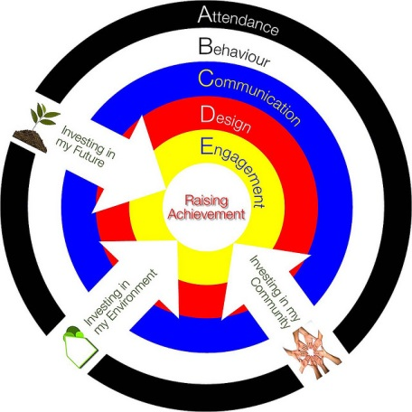





Name:

House Group: **Atyre**  Year:

Academic Session:

Do you wish to be recognised at the Annual House Achievements Assembly?

SCHOOL – COMMUNITY - HOME

I

N

V

O

L

V

E

M

E

N

T

A

C

H

I

E

V

E

M

E

N

T

S