Physical Education – Level Three Gymnastics Profile
HWB 3-16a |  | Pupil Outcomes |  | Bronze | Silver | Gold
I am learning to assess and manage risk, to protect myself and others, and to reduce the potential for harm where possible. |  | I can safely support a partner when they practice a headstand and handstand. |  | 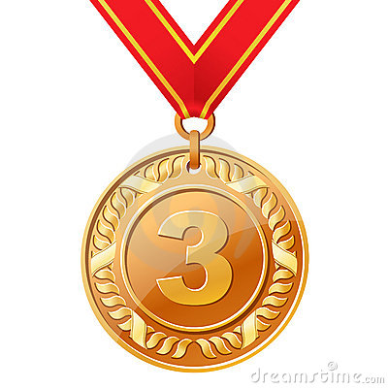 | 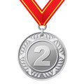 | 
 |  | I can assess risk and manage my own safety when working on apparatus equipment.
HWB 3-21a
As I encounter new challenges and contexts for learning. I am encouraged and supported to demonstrate my ability to select, adapt and apply movement skills and strategies, creatively, accurately and with control. |  | I can perform a range of core skills that involve flight, rotation, balance and inversion.
 |  | I can use a range of skills and my imagination to create an interesting sequence of gymnastics movements on the floor.
HWB 3-22a
I practice, consolidate and refine my skills to improve my performance. I am developing and sustaining my level of fitness. |  | I can use a range of skills and imagination to create an interesting group sequence of gymnastics movements on apparatus equipment.
 |  | I understand the physical requirements of gymnastics. My current fitness level is…
HWB 3-24a
I can analyse and discuss elements of my own and other’s work, recognising strengths and identifying areas where improvements can be made. |  | I can use internal feedback and peer feedback to set future targets and develop my performance further.
 |  | I can analyse another pupil’s work and help them by giving feedback on their strengths and weaknesses.
Select two pupil outcomes that you would like to focus on next time:
Level of Enjoyment Level of Challenge
 |  |  |  |  |  |  | 
My teacher believes that I am currently working at:-
Level 2 |  |  |  |  |  |  |  | Level 3

