**Straight “A” Success**

*Eve Newlands and Niamh Henderson*

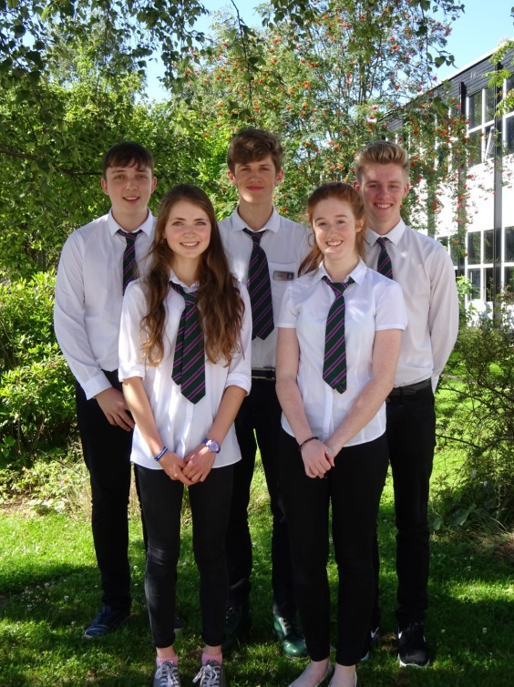August 9th was D-Day for senior students and for the majority the results were very positive. For five senior pupils the results could not have been better. Robert Fraser, Anna Macfadyen, Amber Kenny, John Bonsall and Ross Tulloch all gained five A grades in their Higher exams. Ross Tulloch said that he was “surprised” with his exam results and Robert Fraser told us that he was very “relieved”. Robert who received A’s in English, History, Modern Studies, French and Chemistry would like to go on to study International Relations. Robert advised that students should study throughout the year to gain the best qualifications possible. He also commented: “I am relieved that I’ve given myself options to help me in the future.” Other students also have big ambitions such as Amber Kenny who wants to study History and Archaeology and Ross would like to study Medicine. Anna Macfadyen who was Junior Dux and is now also Senior Dux was also presented with her Senior Dux medal by Head teacher Carol Stuart. All round the pupils are very happy as well as the Mrs Stuart who said: “Like many of our students, the results are testament to their hard work and the quality of support provided by both staff and parents.” She also added how Forres Academy’s Advanced Higher passes were the highest in the Local Authority with 27% of students gaining one or more Advanced Highers.