**Pupil Forum Welcomes New Members**

*By Neve Kidd, Lucy Black and Emma Lawrence.*

The new school year has started and the Pupil Forum has welcomed some new members from S1. They met for the first time on Thursday 3 September to share some thoughts and ideas for future meetings.

The Pupil Forum meets on a monthly basis and each Registration class is encouraged to put forward a representative who can then bring up issues which affect them and report back.

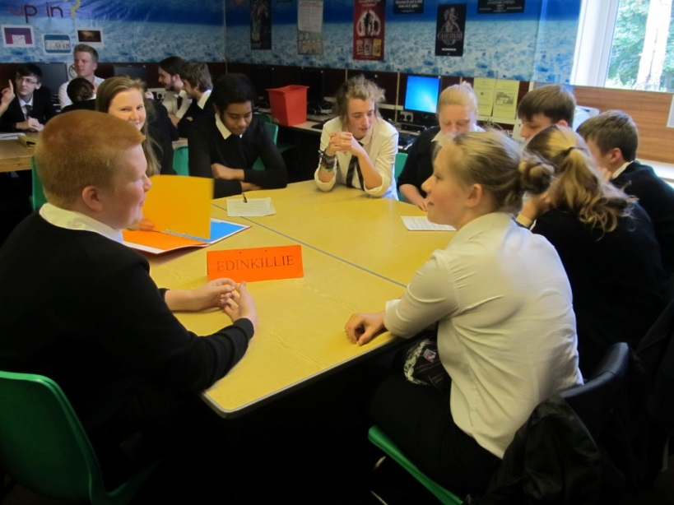Previous meetings have discussed issues such as school uniform, format of registration classes and possible charities the school should support.

This year it is hoped that the Pupil Forum will promote the Blytheswood Shoebox appeal and run various charity events

Ellie Pearce, S5, who has been part of the pupil forum for the last 2 years said: “It gives members of staff an idea about what’s important to the students.” Holly Reinert, S2 added: “I really enjoy the meetings and having the opportunity to discuss issues which matter to us.” Depute Head, Ainsley James, who is in charge of running the Pupil Forum feels that it plays an important role within the school in that: “it provides the opportunity for the pupils to have their voice heard.”