Lesson 3: Factors that Impact our Weather | Date: 12/6/20
Look again at the BBC materials: : https://www.bbc.co.uk/bitesize/articles/z79yvk7.
You will see that the UK is classed as having a TEMPERATE CLIMATE, giving us the four seasons (Spring, Summer, Autumn & Winter) that we are all familiar with.
But there are a number of factors that impact our weather in the UK:
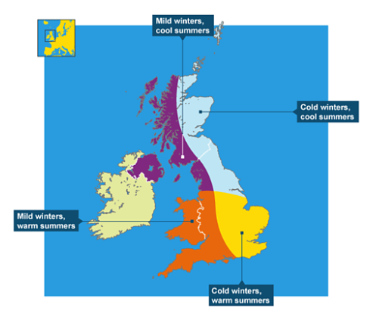

FACTORS:
- Latitude,
- Altitude,
- Distance from Sea,
- Prevailing Winds

TASK: Match these factors to the definitions below.

Factor | Definition
ALTITUDE | For every 100m increase in height, the temperature drops by approximately 1ºC. This explains why mountains are cooler than lowland areas. Often high ground is also more likely to receive precipitation.
DISTANCE FROM SEA | The sea takes longer to warm in summer and longer to cool in winter, this gives coastal areas a more even temperature across the year, while inland areas may have warmer summers but much colder winters. Coastal areas are also impacted by ocean currents – for example, the west coast is kept warm by the North Atlantic Drift current.
LATITUDE | Areas closer to the Equator receive more energy, so tend to be warmer. Areas further from the Equator receive less energy and have bigger differences between winter and summer. For example, Shetland’s conditions are quite different to those on the south coast of England!
PREVAILING WIND DIRECTION | In the UK this comes mostly from the West / South West. As this bring warm moist air from the Atlantic Ocean, it brings wet & mild conditions to the UK (and to the west coast in particular!)
TASK: Apply your knowledge and understanding from the previous task to attempt these questions. Please attempt in full sentences
Note: Explain = give reasons, use words like because, due to, results in

- Explain why the summit of Cairngorm mountain is often covered in snow when Aviemore village can feel quite mild.

This is due to ALTITUDE. Cairngorm Mountain summit is at 1,245m while Aviemore is 230m so you
would expect a difference of over 10ºC from village to summit!

- In summer, the Shetland Islands struggle to get above 14ºC whilst London commonly experiences temperatures over 30ºC. Why might this happen?

This is due to LATITUDE. Shetland sits at 60ºN of the Equator while London is at 51ºN!
Being surrounded by the North Sea & North Atlantic also keeps Shetland cool in summer!

- A Speyside High student moves to Glasgow to study at University. What ways might the weather be different to what she is used to?

Several possible answers including:
Wetter & milder winters (due to west coast location)
Warmer / less snow (due to lower altitude)

- Thinking just about weather conditions, which part of the UK would you most like to live in and WHY?

This will be personal to you, just make sure you have included some REASONS!

