Lesson 1: The difference between weather and climate | Date: 28/5/20

In S2 we would normally start with the topic From Climate Change to Climate Crisis. However, we are obviously all doing our best to work from home. So, we are going to start with a little bit of background weather and climate. This will be a fine introduction and if anyone is struggling to access work they will not miss out on the exciting bits!

INTRO TASK: Write down all the words you can think of to describe the weather. Ask someone at home to look over this and add any other words they suggest.
There are loads of words you can add here but avoid “good” or “bad”!

Weather
Terms
In Scotland, we love to speak about the weather! Can you add any local / Scottish words or phrases (my favourite is dreich!).

During your South American Adventure in S1 we discussed the difference between weather and climate. It is very important that you can define this difference.

View BBC Bitesize Weather & Climate page: https://www.bbc.co.uk/bitesize/articles/z79yvk7

TASK: Watch the Bitesize film and read the information. Complete the table below to define WEATHER and CLIMATE:

WEATHER | The day to day conditions of the Earth’s atmosphere (the air around us).
CLIMATE | The average conditions in a place over a longer period of time, usually a year.

TASK: Which statements describe WEATHER and which ones describe CLIMATE?
Statement | Weather | Climate
Yesterday it rained all day long and was quite windy.
June, July and August are usually the warmest months of the year in the UK.
The rainforest is a tropical environment, where rain is expected every single day.
Tourist often travel to Florida in January to catch some winter sunshine.
Last Tuesday it was very foggy on the motorway.
Tomorrow it is forecast to be cold and frosty in the morning.
In India, monsoon rains are common from June to September.

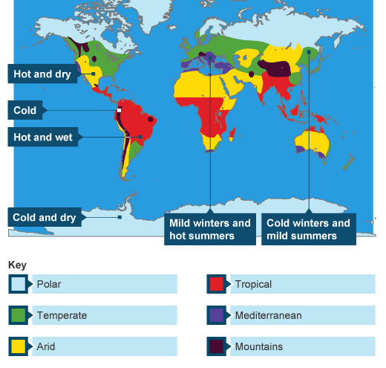
When discussing climate, we often speak about Climate Zones:

This map shows climate zones around the world. The image comes from the BBC Bitesize page given above.

TASK: Name a country for each of these zones (you can use an atlas or the internet to help):

BELOW ARE JUST SOME EXAMPLES, BUT PLEASE, COUNTRIES ONLY!
Polar | ICELAND | Tropical | BORNEO
Arid | YEMAN | Temperate | DENMARK
Mediterranean | ITALY | Mountain | NEPAL

