Higher Geography Task sheet: Week 3 – Cairngorms Nature Festival w/b 18th May
STOP PRESS…STOP PRESS… The Cairngorm Nature Festival has gone online this year, due to lockdown. There is so much that is relevant to Higher Geography that I would like you to look at.
http://www.cairngormsnaturebigweekend.com/programme/
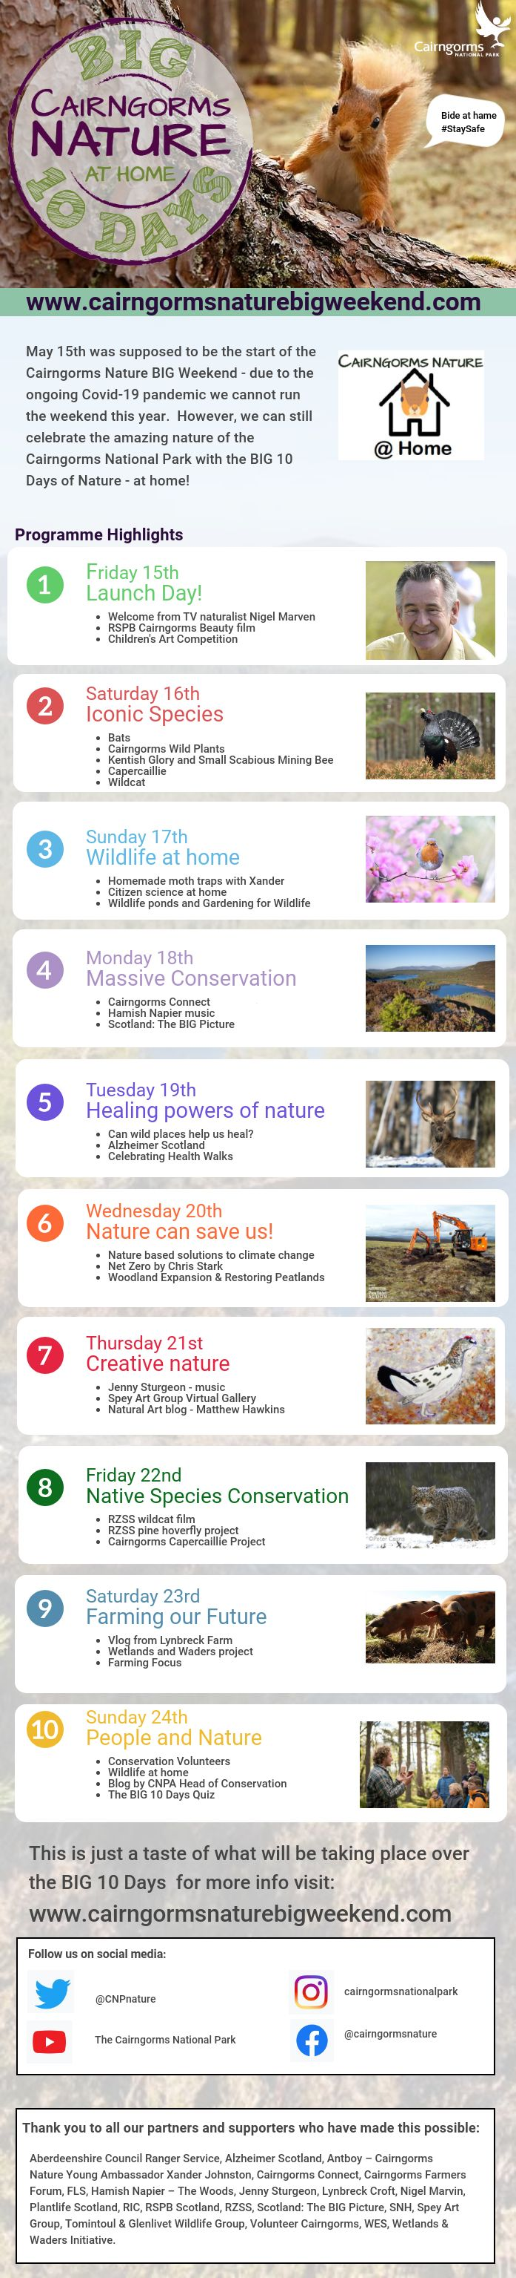 | So much great Geography at this year’s Nature Festival!  I would like you all to engage with  AT LEAST THREE EVENTS at the Festival.  TASK 1: Monday 18th Cairngorms Connect  TASK 2: Wed 20th Net Zero by Chris Stark  TASK 3: Any other event of your choice  But I would particularly recommend:  - Any other events on Wed 20th  - Any of the Farming events of Sat 23rd  - Capercaillie Project Fri 22nd  For each event please write a 200-word summary of that event. As well as summarising the content, you can also think about questions you might have on these topics. These summaries can include graphics, photos, maps etc.  If you engage with MORE than 3 events, you only need to submit 3 summaries, but I would love to hear what else you took part in!  Submission: You can use the Nature Festival Google Forms (attached to the GC Assignment) or create your summaries & submit via GC or SMHW or glow email. You can send a pic, but please keep the original.  REMEMBER: 3 SUMMARIES PER PERSON  These themes link to future case studies & issues topics, please retain all your notes.

