Mission Four: Selecting a site  TEACHER SOLUTIONS / SUGGESTIONS | DATE: 6th May

GRID REFERNCE TRAINING EXERCISE – please complete this first
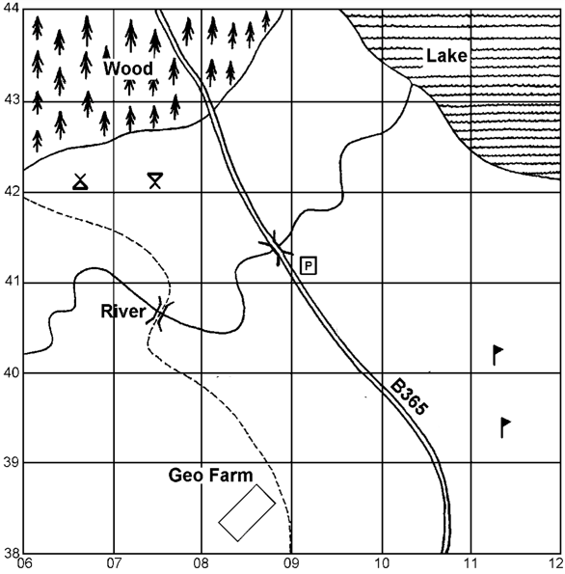

 | Feature | Grid Reference
 | A car park | 0941
 | The Camp site | 0642
 | Woodland | Any 1 from: 0643, 0743, 0843, 0642, 0742
 | Picnic Site | 0742
 | Golf Course | 1139 or 1140
 | A bridge for cars | 0841
 | A bridge for walkers | 0740
 | Geo Farm | 0838

MISSION: Identify a landing site for the alien visitors which meets their requirements

Alien Visitor Requirements
Cannot land in forestry | Aliens have a fear of water | Spotted by as few people as possible

The grid reference for my selected landing site is:
Give 3 detailed reasons for your choice of landing site.  Make use of grid references, the map key & compass directions in your response | JUST SOME THOUGHTS FOR THIS TASK
 | There are many possible grid references for the landing site.
 | Your 3 reasons COULD comment on some of the following
 | - Avoid the forestry areas in the North West corner
 | - Avoid the lake in the North East of the map extract
 | - Avoid the river that runs NE from 0640 to 1043
 | - Avoid either side of the main road running north from 1038 to 0743
 | - Avoid the golf courses in 1139 / 1140 due to numbers of people
 | - Could consider 0638 as it is far from water, people or trees
 | REMEMBER TO TRY TO USE COMPASS, KEY & GRID REFERENCES

