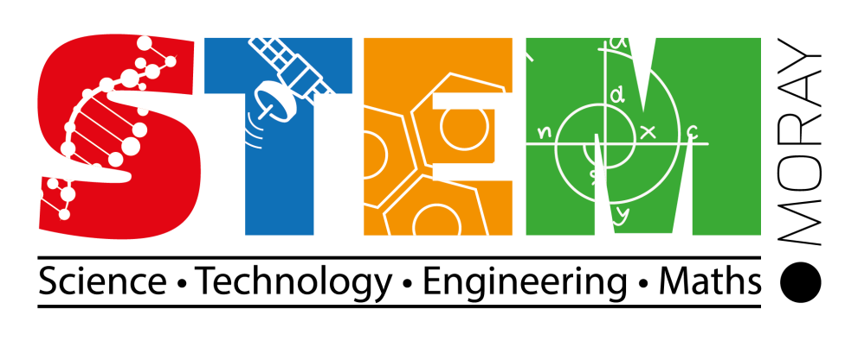

***In response to the publication of the National STEM Education & Training Strategy, the Moray STEM Strategy Group is launching their partnership work with:***

**STEM Moray Position Statement 2018 - 2021**

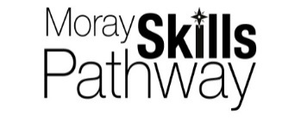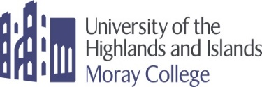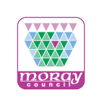



**STEM Moray Position Statement 2018 - 2021**

**Our vision**

By creating a common language around STEM education in line with the Moray Skills Pathway and Family Learning Strategy; we are ensuring our young people, parents, practitioners and partners work collaboratively to support the development of STEM based skills, knowledge and opportunities. In turn increasing the skills for life, learning and work of all our young people and supporting Moray’s economic development.

**What is STEM?**

STEM stands for Science Technology Engineering and Mathematics. We include numeracy and digital skills within our definition of STEM. However, STEM is not just the collation of discrete curricular areas; it is integral to all aspects of the curriculum. STEM represents a key driver for the development of the skills and knowledge across subjects, skills that are at the heart of the development of Scotland’s Young Workforce and of Moray’s future economy and prosperity.

***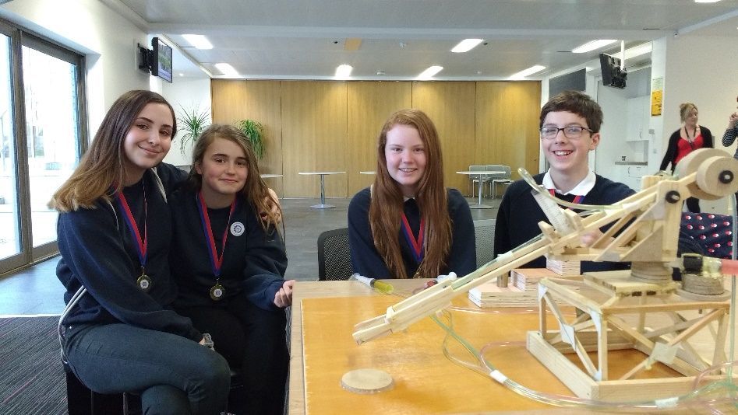*What are we trying to achieve?**

Our aim is to bring together partners from across Moray to implement the national STEM Education & Training Strategy within our local context.

**How will we do this?**

There are a number of local and national policy drivers that support the development of a STEM strategy for Moray as part of Curriculum for Excellence. These include; Developing the Young Workforce, the Digital Learning and Teaching Strategy, Family Learning Strategy and the National STEM Education & Training Strategy for Scotland.

Following National Implementation Guidelines the development of a Moray STEM strategy and associated action plan will focus on four key priorities linking to the National Aims:

|  |  |
| --- | --- |
| **National STEM Strategy Key Aims:** | **Moray Key Priorities:** |
| To build the capacity of the education and training system to deliver ***excellent*** STEM learning so that employers have access to the workforce they need | **Staff development**: continue to support staff to build confidence and understanding in STEM through high quality career long professional learning and opportunities to develop Professional Learning Networks. |
| To close ***equity*** gaps in participation and attainment in STEM so that everyone has the opportunity to fulfil their potential and contribute to Scotland’s economic prosperity | **Equity in Learner experience**: ensure that all learners have an entitlement to high quality STEM experiences throughout their education from 3-24 in line with the four interactions in each sector through the Moray Skills Pathway. |
| To ***inspire*** children, young people and adults to study STEM and to continue their studies to obtain more specialist skills | **Family Learning:** support Associated School Groups (ASGs) in their development of family learning approaches that develop parental confidence to support their child’s STEM learning. |
| To ***connect*** the STEM education and training offer with labour market need – both now and in the future – to support improved productivity and inclusive economic growth | **Partnerships**: develop and strengthen our work with partners including colleges, universities, business and public sector through the Moray Skills Pathway. |

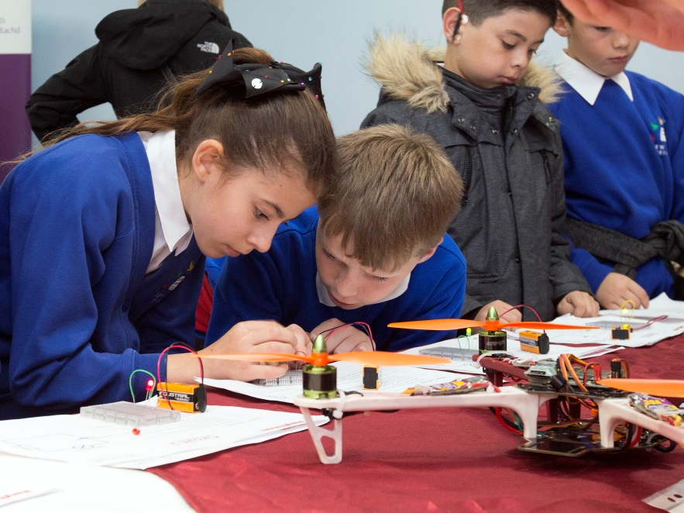**Why study STEM?**

Studying STEM subjects and developing the associated skills offers considerable opportunities for our young people to access opportunities for further study and rewarding careers through developing Career Management Skills. It is important to recognise that the development of skills associated with STEM (creativity, employability, self-management, teamwork, communication, thinking, interpersonal and leadership) opens doors to employment that may not be initially recognised as associated with STEM. The message that STEM keeps options open is one that needs to be reiterated to our young people, their families and our community.

**Moray’s economic context**

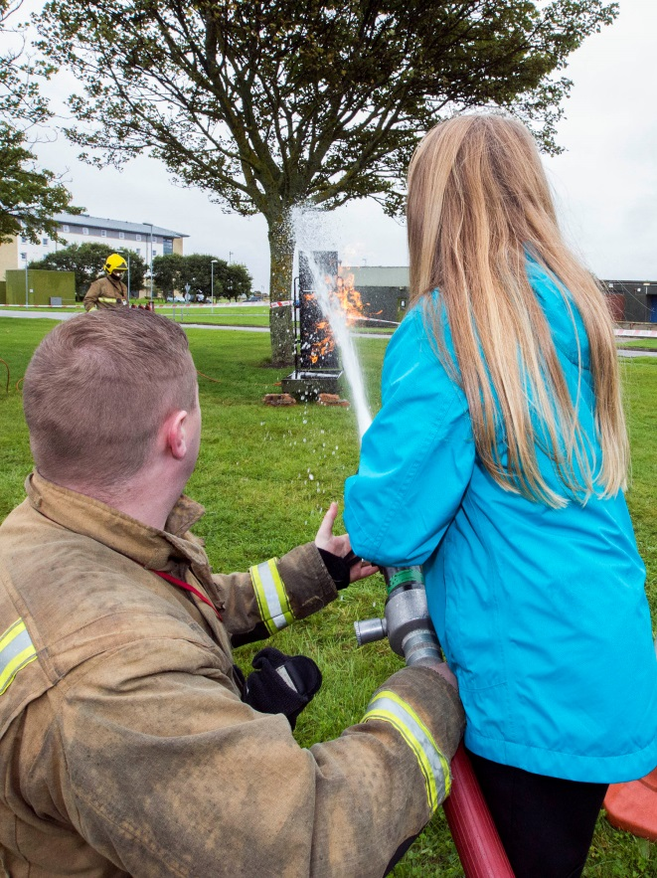The eight key sectors for Moray’s economy, as defined by [Moray Skills Pathway](https://education.gov.scot/improvement/practice-exemplars/dyw45-moray-skills-pathways) these are Early Education & Childcare, Health & Social Care, Engineering, Construction, Food &Drink/Tourism, Information Technology/Creative Industries, Business/Professional services and Land Based. STEM and its associated skills are integral to these sectors.

The commitment of the partnerships within the Moray Skills Pathway is four interactions in each of the eight sectors throughout a young person’s broad general education (BGE). Providing clear pathways for young people to follow their career aspirations and promoting the development of STEM skills in our young people will allow them to be well equipped for these growth areas in their future.

Labour market intelligence from Skills Development Scotland highlights that the business base in Moray is aligned with STEM – through the[Regional Skills Assessment Moray](https://www.skillsdevelopmentscotland.co.uk/media/44079/moray-la.pdf).

Moray’s [Local Outcome Improvement Plan](http://www.moray.gov.uk/downloads/file119323.pdf)aims to Grow a diverse and sustainable economy and Build a better future for our children & young people in Moray.

**Supporting STEM in Moray**

**Context:**

Developments in the field of STEM offer considerable opportunities within a challenging context for effective implementation of a strategy:

* *Scale*: our strategy must support the development of STEM skills and knowledge for all children and young people, 3-24, regardless of which one of our establishments they attend, ensuring equity of access
* *Breadth*: STEM covers a significant part of the curriculum while supporting responsibilities for all - literacy, numeracy, health & wellbeing and digital literacy
* *Confidence*: research evidence shows that there is a lack of confidence in teaching STEM skills and knowledge in many staff in primary schools and ELCs nationally
* *Education Staff numbers*: there remain particular challenges nationally in ensuring that there are sufficient numbers of appropriately qualified STEM practitioners in the secondary and HE sectors
* *Perceptions of careers in STEM*: The Aspires report highlights that ingrained perceptions about STEM careers remain; such as that they are predominantly for male, white and middle class people and for the “brainiest” students. It also highlights a lack of awareness in young people and families of the range of STEM careers and pathways, and importantly, the transferability of STEM qualifications

**Partners in the Moray STEM Strategy Group:**

**Local Authority:**

Education Services directly support schools and practitioners to develop their approaches to delivering STEM education.

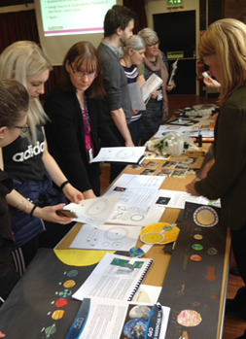

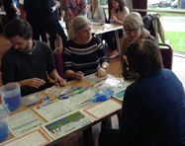

Moray is one of ten local authorities who are piloting RAiSE (Raising Aspirations in Science Education) programme in partnership with the [Wood Foundation](https://www.thewoodfoundation.org.uk/developing-young-people-in-scotland/raise/), Education Scotland and the Scottish Government.

Moray appointed a PSDO through the RAiSE partnership - [Moray Strategic Plan for RAiSE.](https://blogs.glowscotland.org.uk/my/morayscience/)

The Moray Skills Pathway is a partnership between Moray Council, Moray College UHI, DYW Moray (employers) and SDS, the aim being a collegiate provision towards developing the Skills agenda using a collaborative approach to the recommendations as stated in DYW Youth Employment Strategy and BtC4. The delivery of co-designed and co-deliver curriculum allows the real STEM context to be added to curriculum deliver in a local and national context.

The Moray Digital Learning Team is dedicated to supporting the use of technology within schools across Moray. They are here to provide advice, training and support in the use of technology enabling you to decide how best to use technology to improve the outcomes for all learners in Moray.  This covers all types of technologies that are currently used in the classroom but also technologies that schools may use in the future.

They offer a wide range of professional development opportunities for teachers and students, details of which can be found via Gateway CPD Manager or via their twitter page @DigiLearnMoray

Following training on STEM and STEM Ambassadors, the CLD practitioners will support the sectors with whom they work including; ELC, parents and families, and community learning and development to engage with STEM through the STEM Ambassador programme.

**Moray College:**

Moray College UHI has a curriculum that provides a high-quality, responsive STEM offering in both further and higher education and promotes the STEM Strategy themes of excellence, equity, inspiration and connection. College learners are supported to develop their STEM skills and grow their STEM literacy, which enables them to develop specialist STEM skills to gain employment in the growing STEM sectors. More generally, the college aims to improve the development of digital skills across all subject areas for both learners and teaching staff, in order to respond effectively and quickly to the evolving digital skills requirements across all employment sectors. Moray College UHI also has the responsibility for leading the BSc Computing and BSC Interactive Media degrees offered across the partnership of the University of the Highlands and Islands.

For the past 23 years, Moray College UHI has very successfully run an annual Science Festival week of activities for all Moray primary and secondary schools culminating in a Family Day of activities. This year, this activity was replaced by a STEM Celebration week, where pupils from primary and secondary schools participated in STEM competition regional finals, as well have the opportunity to participate in STEM activities delivered by college staff, college learners and partner organisations.

Moray College UHI provides a STEM Ambassador programme for all interested college learners and staff. The STEM Ambassadors support the delivery of activities, which inspire young people to consider STEM career pathways. As part of this programme, Moray College UHI has become the only Scottish BLOODHOUND hub, working in partnership with the RAF and Rolls Royce.

**Skills Development Scotland:**

STEM is an integral part of Scotland’s current and future economy. STEM-related sectors of have been growing faster than Scotland’s economy as a whole and this trend is set to continue. To fully realise this potential we must support the development of a skilled and adaptable workforce equipped to take advantage of the growing number and evolving range of STEM jobs. This requires a systematic and co-ordinated approach based on strong partnerships across the public and private sectors, with a focus on promoting greater diversity in STEM, improving attainment and strengthening pathways into STEM occupations.

Currently, SDS supports STEM learning and careers in a range of ways and contexts and is working with partners to ensure that:

* children, young people and adults are encouraged to develop an on-going interest in STEM
* the education system has the right number and balance of teachers and other practitioners with STEM expertise and that they provide high quality learning and teaching
* the education and training system is equipping people with the skills that employers need and can respond changes in labour market demand
* gender imbalances and other inequities relating to race, disability, deprivation and geography are addressed and do not undermine inclusive economic growth
* more coherent, joined-up action within and across different sectors in the STEM education and training system
* there are clear STEM education and training pathways from the early years into employment.

**DYW Moray:**

The Scottish Government’s STEM Education and Training Strategy clearly shows the principles of Developing the Young Workforce (DYW) embedded throughout. DYW Moray is supporting improvements across early year’s settings, primary and secondary schools with a focus on science, technology, engineering and mathematics (STEM) through the implementation of the Moray Skills Pathway. DYW Moray works with all sectors to ensure that young people have the skills, knowledge and capability required to adapt and thrive in the fast-paced changing world and economy. We will also continue to provide a link between education and employers to ensure the accuracy and relevance of the STEM learning in schools within the context of the workplace.

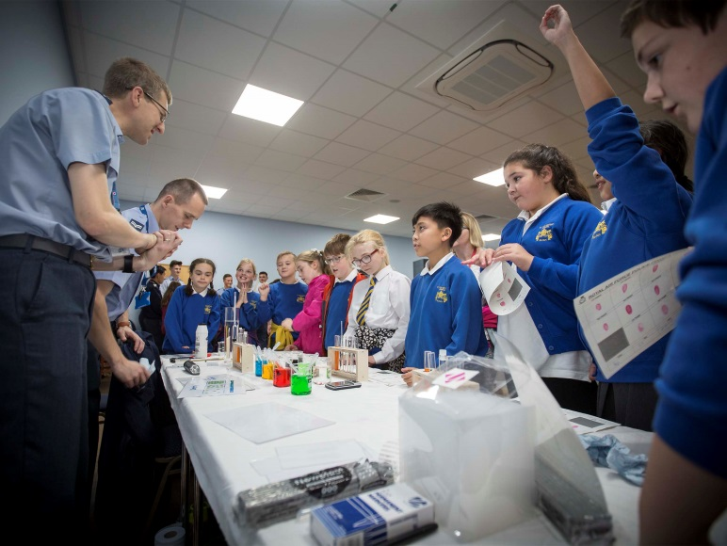**RAF:**

RAF Lossiemouth, as part of the wider RAF STEM Strategy, is committed to engaging and inspiring young people to consider a career in engineering and technical pathways and in doing so help address the national skills shortage. From cyber specialists to aerospace, aviation, electronics, medical and mechanical disciplines, the Royal Air Force employs a diversity of STEM based roles both locally and further afield creating an ideal opportunity to showcase how important STEM skills are to the workplace. By combining direct outreach work in Secondary schools linked to the curriculum with specialist project work and the annual Primary school focussed “STEM in the Workplace” event, RAF Lossiemouth adopts a partnership approach and welcomes the development of this Moray wide policy statement

**Case Studies of STEM Partnership work:**

* Little Lighthouse Project - <http://www.yecscotland.co.uk/primary_school_resources.html>
* Video/Media Projects - Buckie High School pupils produced a film to explain planning issues their peers will experience in the coming years. The video is available online at: <https://www.youtube.com/watch?v=FzOr00-xymM>
* Primary & Secondary Engineer <http://www.moray.gov.uk/newsroom/news.html#/pressreleases/pupils-engineer-success-at-celebration-event-2480913>
* SCDI Young Engineers & Science Clubs
* [Bloodhound project](http://www.bloodhoundssc.com/education) – STEM Ambassadors from Moray College UHI (Bloodhound Hub)
* CLPL sessions – Early Years, Primary Science Mentors, Improving Gender Balance
* App Design – Lhanbryde PS, Speyside HS
* Moray Skills Pathway – Activity Overview Guides examples:
* Biomass Plant Visit: <https://docs.wixstatic.com/ugd/8146dd_d0671d9100c7474a91c5f140a15da4a1.pdf>
* Energy Workshop: <https://docs.wixstatic.com/ugd/8146dd_ca13e04d7e8a4a75bff378da4b13591f.pdf>
* Visit to Industry: <https://docs.wixstatic.com/ugd/8146dd_ea5796f4d5584a74a02843b1ee19c6d4.pdf>
* DYW Moray videos:
* <https://www.youtube.com/watch?v=tVtmjGMz6bU> – Early Learning and Childcare
* <https://www.youtube.com/watch?v=txfUIjYhay0> – Creative Industries and IT
* <https://www.youtube.com/watch?v=U8ruawNL-mo> – Business and Professional Services
* <https://www.youtube.com/watch?v=Wjc3ce3KzSI> – Engineering
* <https://www.youtube.com/watch?v=mX77i4dvNdM> – Land Based
* <https://www.youtube.com/watch?v=KvdIsrynuhc> – Food, Drink and Tourism

**Web links:**

**P3**

[Moray Skills Pathway](https://education.gov.scot/improvement/practice-exemplars/dyw45-moray-skills-pathways) - <https://education.gov.scot/improvement/practice-exemplars/dyw45-moray-skills-pathways>

[Regional Skills Assessment Moray](https://www.skillsdevelopmentscotland.co.uk/media/44079/moray-la.pdf) -<https://www.skillsdevelopmentscotland.co.uk/media/44079/moray-la.pdf>

[Local Outcome Improvement Plan](http://www.moray.gov.uk/downloads/file119323.pdf) - http://www.moray.gov.uk/downloads/file119323.pdf

**P4**

[Wood Foundation](https://www.thewoodfoundation.org.uk/developing-young-people-in-scotland/raise/) - <https://www.thewoodfoundation.org.uk/developing-young-people-in-scotland/raise/>

<Moray Strategic Plan for RAiSE - https://blogs.glowscotland.org.uk/my/morayscience/>

**Administrative Information**

**Published:** November 2018 (Version 2.0)

**History of Changes**

|  |  |  |
| --- | --- | --- |
| **Version** | **Description of Change** | **Date** |
| 2.0 | Added Summary of Web links to final page | 7/11/18 |
|  |  |  |
|  |  |  |

