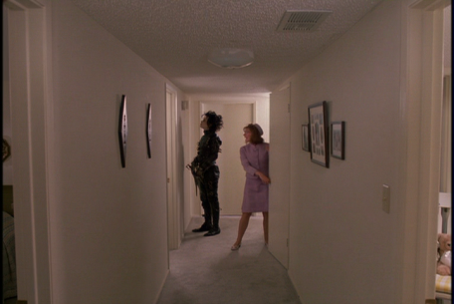
Scene Title: Peg Welcomes Edward into Her Home (16.53-23.00)

Scene Summary:

As you watch the scene, jot down significant observations for the following elements of the film:

Theatrical Elements (costumes, props, sets, acting, etc.)

Literary Elements (characterisation, setting, tone, point of view, irony, dialogue)

Cinematic Elements (framing, angles, editing, sound, lighting, focus, movement)

After Viewing: Look back over your notes and explain the intended effect of two of the cinematic elements you noticed. In other words, why did the director choose to use them

How does this scene relate to the overall themes of Edward Scissorhands?

