Beginning scenes

Read through the notes below and in your jotters, for each of the 5 elements, write your personal response (e.g.thoughts/emotions/views.)
Literary Elements | Description/Retelling
Point of View (4:10-5:17)  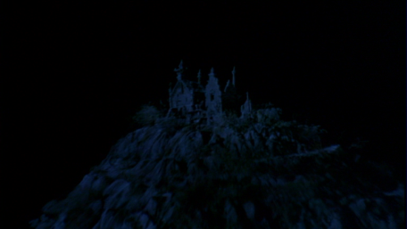  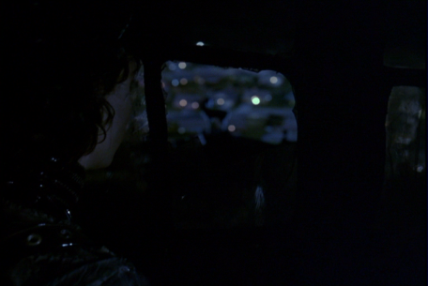 | The story within the story begins with the old woman telling the little girl about the inventor who lived on the mountain and the man he created and left there after he died.  As the old woman speaks, the audience sees the old mansion on top of the mountain out the window. Then we move over the snowy, sleepy, suburban town below the mountain, pausing on the old mansion again. Finally, we look out the window down on the town, over the shoulder of a man looking out the window.  If we think in terms of traditional narrative, the point of view is third person limited. Because film applies point of view a little differently, we can understand that when we are looking up at the castle, we are in an omniscient narrative, and when we look over Edward’s shoulder, we are in a restricted narrative. This distinction will come in useful later in the film when we are put in the position of Edward at the dinner table.
Irony (8:00- 11:00)  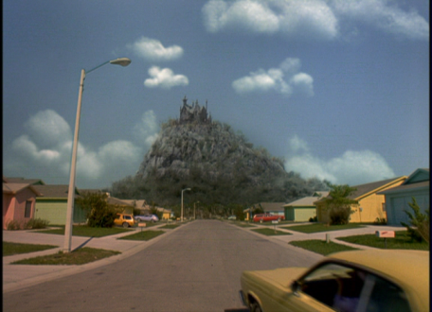  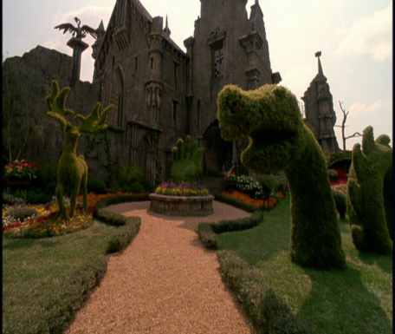 | As Peg becomes more and more dejected with not being able to sell cosmetics to her neighbors, she catches sight of the dark mansion in her rearview mirror. She figures she might as well try there too. After driving through the gates, she walks through the yard of the mansion. It is beautiful and delicately manicured. The sun shines down from the perfect blue sky.  The scene is ironic if we understand the horror genre, which tells us that dark homes on top of mountains are indicators of rundown yards and evil homeowners. Ironically, Peg and the audience find a lovely garden within the gates, as well as a compassionately lovely man within the mansion’s shadows.
Characters (22:53-23:15)  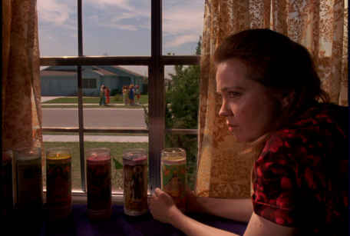 | The CHURCH LADY watches from her window as the other women in the neighborhood rush over to Peg’s house to find out about the mysterious guest. As in other scenes, she is frowning and seems to be planning something.  This character seems like a small character, but in this story, no character is without significance. Here she is shown looking out her window, just like Edward was in the opening scene. We quickly identify her, according to dialogue and Peg’s decision not to sell Avon cosmetics to her, as an outsider or reject. She, like Edward, looks in on the perfect neighborhood from their outside locations of kitschy living room and dark mansion.  If we compare characters, we can understand why we might feel uneasy with the neighborhood ladies seeming to immediately accept Edward. We know that he is also an outsider, and we come to expect them to turn on him.
Setting (15:44-16:35)  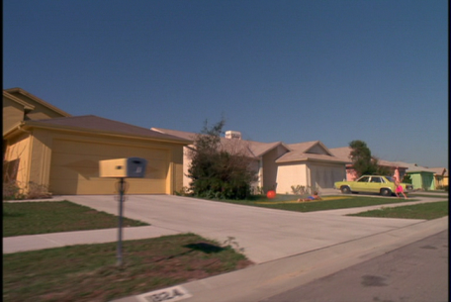  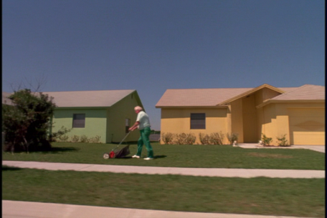  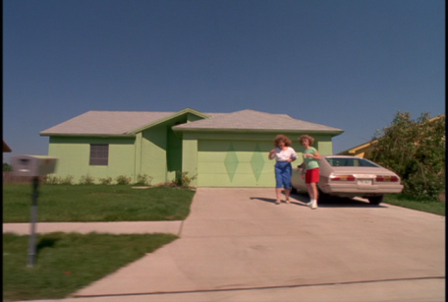 | As Peg drives Edward home, he looks out the car window and observes the happenings of the suburban neighborhood. The homes are painted in various shades of pastel, and the citizens participate in outdoor activities such as cutting the lawn, talking in the driveway, playing on the slip and slide, and watering the flowers with a hose.  The setting of the town is portrayed visually and through dialogue. Pay attention to how you feel about the neighborhood versus the mansion on the hill, as they are both important locations in the development of plot and symbolic meaning.  Other important settings include: the shopping center, the bank, Jim’s house, the time period of the flashbacks, and the time period of the beginning scenes from when the story is told.

Tone (31:25-36:46)  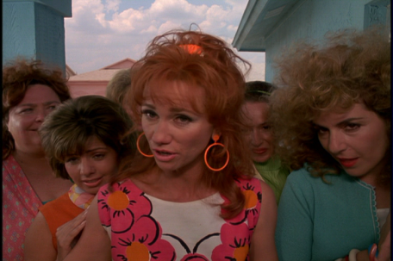  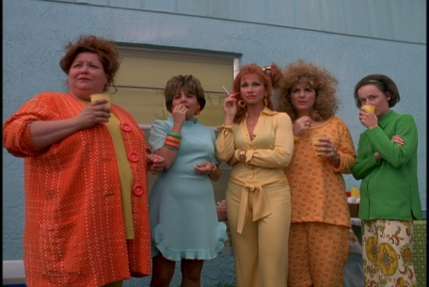 | The neighborhood ladies push their way onto Peg’s doorstep, exclaiming that it is rude for her to keep her mysterious guest to herself. Peg tries to call Bill to the door to help ward off their self-invites to a BBQ Peg didn’t even plan on having. They are later shown grouped together at the BBQ, still consumed with curiosity about Edward.  Tone is the most subtle of literary elements presented in the movie. Why do we feel so uncomfortable in front of these women? They break the conventions of etiquette that Edward learned from the inventor. Their actions and words make Peg (up to this point, our narrative guide) feel uncomfortable. They always move in a large group of solid color.  What is Tim Burton, or the old woman telling the story trying to tell us about these women? How do you feel about them?

