Book Recommendations 2014 (6S)

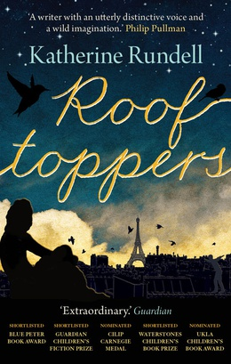

**‘Roof Toppers’** By Katherine Rundell

This is an adventure book telling the story of Sophie, who was found floating in a cello case in the middle of the English Channel on her first birthday after a shipwreck.

When she is found by a man named Charles, he looks after her and brings her up in his scruffy house in England. She is taught to enjoy music and takes up cello just like her mother had. But she has never really been taught how to be ladylike. When the social services interfere on her twelfth birthday, and warn that they will be collecting her to take her to an orphanage. Both Sophie and Charles are nervous, until they find a clue in Sophie’s cello case triggering hope that they still stand a chance in finding her missing mother. They both leave on a journey to Paris in search of Sophie’s long lost Mother.

In Paris Sophie soon become friends with a young boy named Matteo who lives on the roofs of Paris not setting a single foot on land. She then meets his friends Anastasia and Safi who stay hidden in Paris’ tallest trees. Running along the rooftops of Paris listening for a song that they can hear in the distance they are hunting down a mother who is nowhere to be seen.

‘Rooftoppers’ is an enjoyable and adventurous book that enchants you, and makes you want to read more. I liked the mystery of the mother, and finding out she also lived a part of her life in disguise, that nobody else knew about. I would definitely recommend this book as it hypnotizes the reader, and makes you feel as if you are there because of the amazing detail and description.

‘I enjoyed it tremendously... An ultra stylish writer with a true gift for imaginative storytelling. The next time I go to Paris I will be looking up at the rooftops.’ (*Jacqueline Wilson*)

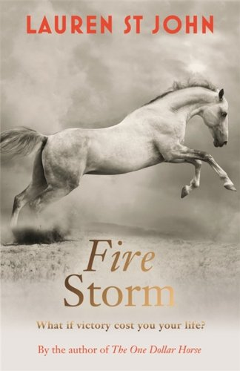‘Fire Storm’ - Lauren St John

Fire Storm, written by Lauren St John, is the third and final book to the “One Dollar Horse” series. Fire Storm is a teenage fiction. Casey Blue, a girl from the East end of London with not a very good upbringing, is riding her knackers yard Horse to win Burghley horse trials and go down in the history books as the youngest ever winner of the Rolex Grand Slam. When Casey and her coach, Mrs Smith, have a fallout and leave each other, Mrs Smith is diagnosed with life threatening cancer. Casey has to decide which is more important, friendship or victory?

A breathtaking book with moments where you didn’t know whether to laugh or cry. An amazing end to the series which left me speechless. I simply couldn’t put it down. I would recommend this to any girl, especially those with a passion for horses, who would love a great read.

One of the best characters in this thrilling rags-to-riches tale is Storm Warning. You can't help but identify with this courageous animal and St John makes you feel the thrill of what it must be like to jump over a fence on such a horse with such heart and soul. No nagging doubts, this book's a winner. (Martin Chilton TELEGRAPH ONLINE 2012-03-23)

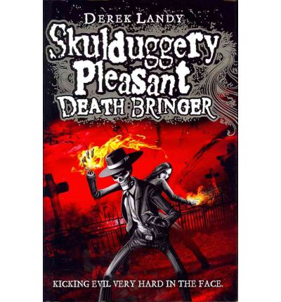 “Skulduggery Pleasant, Death Bringer” By Derek Landy,

action/thriller.

Skulduggery Pleasant and Valkyrie Cain (Stephanie) are sorcerers. In the 6th book of the series so far they face a danger more powerful and more perilous than ever before, the Death Bringer.

Melancholia had been shunned, she had been scarred. She had been looked down upon, ignored, snubbed in favour of someone else; she was angry. She was not angry at the ones who had shunned, scarred, ignored, snubbed and looked down upon her. Oh no. She was angry at Valkyrie Cain. The time of the Passage was nearing, and Valkyrie was not on her list; so she had better be on her guard.

"Humour and magic combine in this thrilling adventure." Waterstone's Books Quarterly

‘Attack on Titan’ By Hajime Isayama

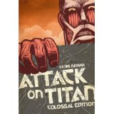

‘Attack on Titan’ follows the story of Aren Yegaer, Mikasa Akerman and Armin Arlet as they explore an altered past where giant humanoid creatures, called the titans rule the land and humanity is forced to hide behind a series of walls in fear of being devoured by them. Aren, Mikasa and Armin along with a lot of other friends join the scout legion an elite group of titan slaying human’s whose soul job in life is to kill as many titans as possible and defend humanity at all costs they join this group to avenge the death of their loved ones and to defend the rest of humanity.

I enjoyed how the drama filled ever twisting plot was made even richer by the addition and fleshing out of characters. This in addition to the action packed horrifying characters of the titans makes this worthy of it’s critical acclaim.

Written by Hajime Isayama, ‘Attack on Titan’ is one of those series which against all odds, presents an original concept and makes it work. Its story is simple: a threat has befell humanity as ‘Titans’ appeared out of nowhere and drove humans to near extinction after they began devouring one person after another. In order to avoid total annihilation and rebuild society, humans have been forced to live in a small section of the world where three walls defend them from the Titans devouring them.

**‘Ballet Shoes’** by Mr Noel Streatfeild

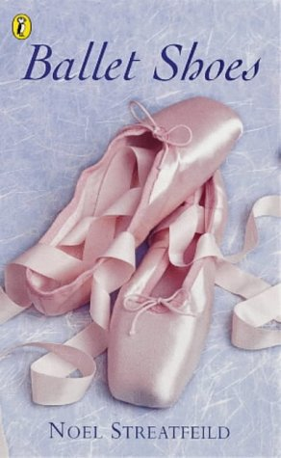The story starts with Great Uncle Matthew, (known as Gum.) He is a fossil hunter and he travels all over the world looking for them. Gum lives in the UK (That is when he wasn’t travelling) with Silvia and Nana. One year when on his travels he found what he called a “Fossil,” he had found a little baby alone in a lifeboat when a ship sank. Gum named the baby Pauline and gave her to Silvia and Nana. Two years later he made another discovery a little girl called Petrova whose parents died she was from Russia. Finally four years later Posy arrived Gum had taken her in after her mother had no time for a baby as she was a dancer. Gum left his three girls with Silvia and Nana while he went traveling. Pauline, Petrova and Posy named themselves fossils and vowed the fossil name would get in the history books. The girls were very different but Posy had an exceptional talent for Ballet making the others jealous.

I love this novel because it has such an interesting plot and something is always happening throughout the whole story, there was never a dull moment.

*“The much-loved children's classic, beautifully reissued.” “A timeless and magical read -- The Sun, September 10, 2004.”*

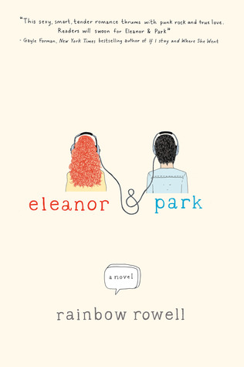‘Eleanor and Park’

Eleanor and Park’ is a love story, and therefore is a romance, the book is written by Rainbow Rowell. I liked this book very much and enjoyed reading it; I could read this book over and over again. I think teenagers could relate to this book because it is a story of becoming of age. It includes a romance and hard family life as a teenager as well as living with a new step dad.

Eleanor Douglas is the new girl, the girl with the crazy red hair and weird clothes. Park Sheridan is the quiet Asian boy who tries to hide and get the least attention he can. They both live in Omaha, Nebraska. When Eleanor sits on the bus she goes next to him and they never speak until they realise they have the same interests in common including comics and mixed tapes. Once their awkward silence is broken they fall in love, and go through a high school relationship.

"Eleanor & Park reminded me not just what it's like to be young and in love with a girl, but also what it's like to be young and in love with a book."-John Green, the New York Times Book Review

"This sexy, smart, tender romance thrums with punk rock and true love. Teen readers-not to mention their Gen X parents-will swoon for Eleanor & Park." -Gayle Forman, New York Times bestselling author of If I Stay and Where She Went

"A breathless, achingly good read about love and outsiders." -Stephanie Perkins, author of Anna and the French Kiss and Lola and the Boy Next Door

“The Perks of Being a Wallflower”written by Stephan Chbosky.

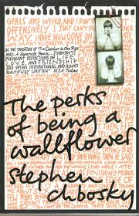

“The Perks of Being a Wallflower”, is a classic novel written by Stephan Chbosky. It’s about a boy called Charlie who has recently suffered from depression, doesn’t have any friends and is just about to start his first year of high school. Charlie doesn’t feel the need to fit in and prefers to sit back and watch as his life passes by him. Throughout the book he manages to make new friends, love life and overcome the guilt he holds about his Aunt Helen’s death. I thought this book was really intriguing I didn’t want it to end! Although at some parts it can be a bit depressing and sad, it truly is a wonderful book. It is also so beautifully written. I would definitely recommend that people read this book because I can guarantee that they will love it. Any gender could read as I think both boys and girls will find it enjoyable. However, people who are into a more life relatable stories and a novel with a more serious plot would be more attracted to “The Perks of Being a Wallflower.

What is most notable about this funny, touching, memorable first novel from Stephen Chbosky is the resounding accuracy with which the author captures the voice of a boy teetering on the brink of adulthood. Charlie is a freshman. And while's he's not the biggest geek in the school, he is by no means popular. He's a wallflower--shy and introspective, and intelligent beyond his years, if not very savvy in the social arts. We learn about Charlie through the letters he writes to someone of undisclosed name, age and gender; a stylistic technique that adds to the heart-wrenching earnestness saturating this teen's story. Charlie encounters the same struggles many face in high school--how to make friends, the intensity of a crush, family tensions, a first relationship, exploring sexuality, experimenting with drugs--but he must also deal with the devastating fact of his best friend's recent suicide. –Amazon Review.

‘The House of Hades’ (Percy Jackson follow on series) Author: Rick Riordan

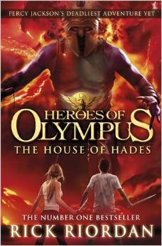Genre: Adventure

This was the best book I read all summer. I really liked the way that the author has kept on going with the Greek Gods series but changed or added a few characters to keep things fresh. I also really liked the way he has used the characters personalities to develop the story. I would recommend this book to people who have read the Percy Jackson books and wants to read more from Rick Riordan.

The plot of this book is where Greek and Roman Demi-gods are on a quest to save the Earth from the Earth Mother (Gaia). However, two of their team fall into Tartarus so both groups have to make their way to the Doors of Death and they have to arrive at the same time otherwise they will not be able to rescue the two who fell into Tartarus.

“A cracking read” (*Sunday Express*)

‘The Thornthwaite Inheritance’

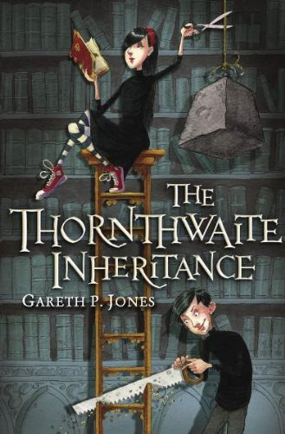The Thornthwaite Inheritance is a mystery, thriller by Gareth P. Jones and it keeps you guessing right to the end. I loved this book as the plot was extremely intricate with many twists to the story line. However I feel that the characters are the most interesting part of the book. They all have extremely different backgrounds, personalities and hobbies. I also feel that there is something about the relationship between the twins in the book that makes you always want to read on.

The book starts by introducing you to all the characters. This is where I observed the differences in the people working at Thornthwaite manor. The book is about twins, Lorelli and Ovid Thornthwaite, who have a nasty habit of conjuring the evilest plans and ways to dispose of their dreaded sibling. However they make a truce, and the family lawyer, Mr Farthing arrives at the door of Thornthwaite manor to get the papers concerning the truce signed with his son, Adam Farthing; something about this young man seems too good to be true. One day the twins knew that their lives would change and nothing would be the same for them ever again. Unfortunately for them, this was the day that destiny had chosen to come calling.

From then on there was a strange and mysterious mood in the manor. Following this an unusual set of murder attempts ensued leaving Ovid and Lorelli, who blame the murders on two different people, with no choice but to put their trust into each other’s hands. The next murder attempt however was on young Adam Farthing who was merrily playing the piano as it blew up right before him. Then a call came to announce the death of Adam, but a day later Ovid and Lorelli see him driving off in a car with his dad and a police officer.

The police man then enters the living room (one of the many rooms in Thornthwaite manor) along with all the workers, Mr Farthing, Adam Farthing and obviously Lorelli and Ovid to find out the person behind these strange set of events. The blame is passed to many of the people in the room until there is an unfriendly interruption... from a huge bear! They all manage to evacuate the room except for the twins and their guardian. This is when he tells them who is behind these murder attempts...

I really enjoyed this book and would recommend it to everyone I know. Boys and girls from 10-16 years of age. It is a thrilling novel of two hundred and sixty three pages and keeps you guessing almost until the end when it is spelt out for you. This is a very complicated book, however it explains what is going on in little chunks every now and again throughout the book. Also, to find who was behind all these murders, you will HAVE TO READ IT.

*Critics Review: `Blackly comic, with its compelling cover and all the fun of taking sibling rivalry to a fantastical extreme, this book is surely material for a film'  
-- Children's Book of the week, The Times*

‘Angus, Thongs and full- frontal snogging’ By Louise Rennison

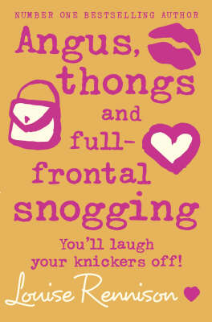

Genre: Rom- Com

This book in the series is the very first one. These books look into the mind of Georgia Nicolson who at the age of 14 is finding out what the big wide world is all about. Boys are all Georgia can think about especially Sex God Robbie. This book is about Georgia and the problems she has to face; Boys, Friends, Family and School. And according to Georgia’s world everything is extremely hard. But with some help along the way she can eventually overcome these issues, well that’s what we think just now anyway...

I really enjoyed this book. It was extremely funny, with those little serious moments. It will sometimes leave you on the end of your seat and is always sending your stomach in knots. I really liked this book and recommend it to teen girls who like a good Rom- Com.

Critics Review: **“This very funny book perfectly captures the agony of being a teenager.” Book of the Week, Sunday Mirror**

**And I couldn’t agree more!**

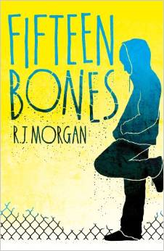‘Fifteen Bones’ by R.J. Morgan

‘Fifteen Bones’ is a teen fiction book written by R.J. Morgan. It is her first novel. I thoroughly enjoyed this standalone book. Through the whole story I was drawn in and pleasantly surprised by the slight twists and turns. I felt really drawn to Jake the main character as the writer cleverly related him to the life of modern day teenagers both boys and girls. My favourite part in the book was when Jake found Robin as I instantly felt the fumbling connection between them. This book has made me want to read more of R.J. Morgan.

*+ I think the novel treads a fine line between total, serious realism and enjoyable, gripping plot. It's a difficult + trick and it definitely pulls it off.*

*By Mark off Amazon*

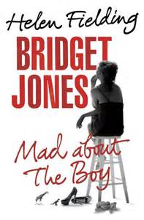

‘Bridget Jones: Mad About the Boy’

‘Bridget Jones: Mad About the Boy’ by Helen Fielding is a mix of both romance and humour. Bridget Jones is widely known as a beautiful young woman but in this novel we see her as fifty one year old widow with two young children who doesn’t really know where she wants to go in life.

It is styled as a diary and as she tries to get her life back on track by counting calories and her intake of alcohol. She finds herself counting the unsteady number of twitter followers she is gaining and losing and the bags of grated cheese she is shoving into her mouth. As she juggles her ‘busy’ social life with her two children she realises she is very lonely and rather unhappy with the increasing disappointment that her life has become.

I like this novel because it is so normal to the average single parent life yet it is so bazaar to a life of any kind. It shows the sad and honest truth about life but in a funny and quick-witted way. It has been cleverly written to make it very humorous for the reader.

It's funny, it's sad, it's so typically Bridget Jones - I couldn't put it down! -Review from Amazon.

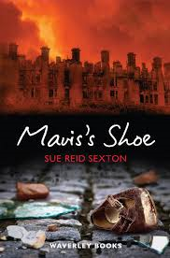

**‘Mavis’s Shoe’ By Sue Reid Saxton**

A historical Fiction Novel written by Sue Reid Sexton, Mavis’s Shoe tells the tale of Lenora, Lenny for short, and her search for her little sister, Mavis. Set during the Clydebank blitz, Lenny, Mavis and their mother live in a tiny tenement. When their mother goes out for the day, it is up to Lenny to look after Mavis. But when Lenny is pushed into the canal, Mavis runs off and Lenny is left with a shoe. Then the sirens go off, and Lenny loses her home, street, sister and mother - everything she ever had - to the flames and confusion. Running from the bombs, she meets her teacher, a grumpy old man from her close and a little girl named Rosie, whose family is known to be dead. Together they travel to Carbeth - a hut community just outside Clydebank. But Lenny is haunted by the images of the bombing, and all she wants is Mavis. She walks back Clydebank to search through the rubble for Mavis, keeping her shoe with her at all times.

This is a compelling book, and it makes you realise how traumatic the blitz really was. I couldn’t put it down, and was hooked in from the start. It is one of those books that make you want to keep turning the page to find out what happens to the characters.

'This haunting, beautifully-written blend of fact and fiction captures the strength of humanity, the courage in adversity and the heart-breaking loss caused by one of the most tragic episodes in our nation's history.' --The Daily Record

“The fault in our stars” By John Green

Genre: Young adult fiction/ Romance

I like this book because it makes you completely aware of the situation at hand, and that even though some people do suffer from deadly diseases they can still find love. This book is good because it uses more adult literature.

Over all I really enjoyed this book because it’s that kind of book that you just get into really easily.

“Starring Tracy Beaker” By Jacqueline Wilson

Genre: Childrens Literature/ Comedy

I enjoyed this book because it is very amusing and enjoyable. The main character Tracy Beaker has a very comical personality, this book is fun and the characters are very well created.

“Best Friends” By Jacqueline Wilson

Genre: childrens literature

I enjoyed this book because it is quite down to earth as it could happen to anyone, the main characters, Gemma and Alice, both are complete opposites personality and looks wise but somehow they are the best of friends.

‘Animal Farm’ Author: George Orwell

[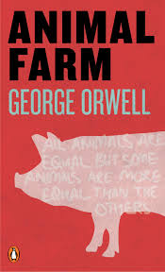](https://www.google.co.uk/url?sa=i&rct=j&q=&esrc=s&frm=1&source=images&cd=&cad=rja&uact=8&docid=LnJuVTFa3vyugM&tbnid=Q3Pk6ccwE41yJM:&ved=0CAcQjRw&url=https://generaljohnstrickermslibrary.pbworks.com/w/page/33097214/Animal%20Farm%20Pathfinder&ei=HwwWVN7CC5LN7Ab624AQ&psig=AFQjCNGFlwps6B4lUkl58ywAvpTwcOKMxg&ust=1410817)Genre: (based on events in real life but changed to a children's story)

Recommended to all boys and girls

"Animal Farm" is a simple fable of great symbolic value, and as Orwell himself explained: "it is the history of a revolution that went wrong". The novel can be seen as the historical analysis of the causes of the failure of communism, or as a mere fairy-tale; in any case it tells a good story that aims to prove that human nature and diversity prevent people from being equal and happy, or at least equally happy.

When farmer Jones neglects the animals of his farm what do they do? They decide to rebel against their masters and soon they create a world that would be called "animal paradise "but for some reason things never go the way you want it to go and soon the animal leaders start to quarrel and their once beautiful farm turns into a place ruled by dictatorship and with their new leader turns their life a bit pear shaped

I like this book because the cunning author, George Orwell manages to create one of the most interesting books I have read in my life and I think that other people should have the chance to read the magnificent book that George Orwell has made. simply amazing that he manages to turn Russian communism into a story about animals.

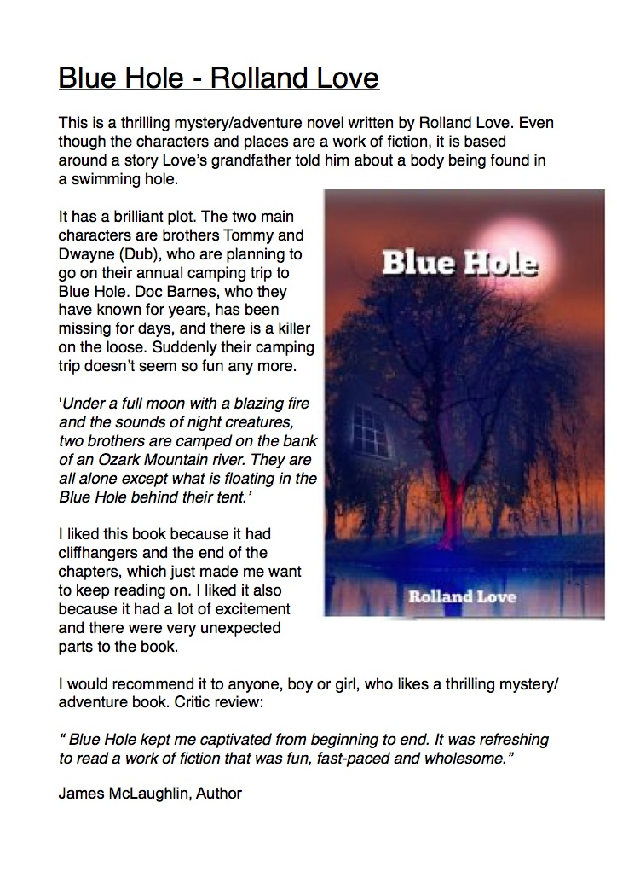

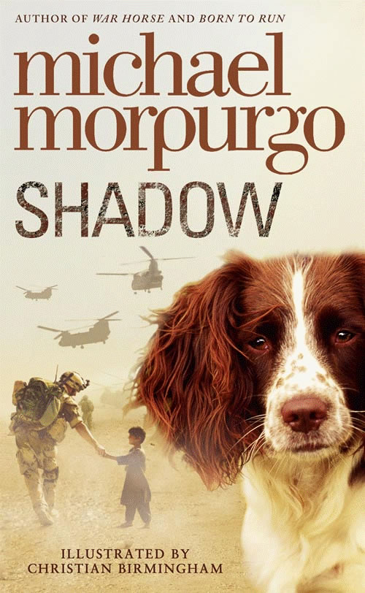**‘Shadow’ By Michael Morpurgo**

Shadow is an adventurous diary entry by Michael Morpurgo.

When a western dog appears outside the caves in Afghanistan where Aman lives with his mother. It is n0t customary for people to keep dogs as pets in his country, but when Aman and his mother decide to make a bid for freedom, the dog Aman called Shadow will not leave their side. Later I becomes clear that the destinies of the boy and dog are linked and always will be.

I think this book is a very sad and interesting book. It’s a fantastic read especially if you like diary entries and adventurous type of books. You would also enjoy it if you like war type books or anything to do with war. This is a story which captures the complex of relationships and situations for a group of different people who have one thing in common, the courage to fight for freedom.

I think this book is aimed at both boys and girls for the age of 11-15 year olds.

**Critic’s review :**Aman, his Mother and his Grandma live in an Afghan cave when a springer spaniel appears, all thin and battered. Initially Aman's Mother tries to chase him away "Dirty dog"! Dirty foreign dog"! But Aman brings this springer spaniel back to good health and he decides to call her shadow, but Aman and his mother need to go to England to get out of Afghanistan's raging war. Just how far can shadow lead them..?

This book was really really really good! It is my favourite book ever. It only took me five days to read, I couldn't put it down.

‘Black Beauty’ By Anna Sewell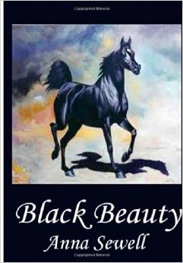

This book is based on a black horse that got abandoned once his owner left and got put into this place where they use horses as slaves. Then one day they took Black Beauty to a selling place and his owner’s friend noticed him and brought him back off the slaves and then he lived happily ever after.

'I give this book five stars, some may say that I am over rating this book but it is brilliant it had me hooked from the start to the finish. The book describes the hardships horses had to suffer and the friendships Beauty had as well. Considering that this book was written and published quite a while ago it reflects upon the author and mankind. I recommend it to book worms, and horse-lovers.'

‘The World of Norm’ By Jonathan Meres

Genre: Comedy

‘Fans of Jeff Kinney who pick up The World of Norm will not be disappointed… A funny, clever.’- Books for Keeps.

This book is a funny, detailed book. Jonathan has really told us about Norm, his family, his friends and how he gets on in school and outside of school. Norm is a very forgetful boy and takes everything out on his brothers, his friend Mikey and this very annoying character called Chelsea. In the story Norm gets very jealous of Mikey, Chelsea and also his granddad just because they have IPads so Norm decides he has to have one. He ask his mum if he could get one, his mum offers him to pay half of it but buys it all of it and Norm has to pay the other half. Norm gets a job as a newspaper boy but doesn’t really like it.

I would recommend this book to both girls and boys because everyone likes a bit of a laugh.

‘Uglies’ By Scott Westerfield

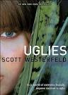

Sci-Fi, Futuristic, teen Fiction

Tally Youngblood is just a normal uglie waiting to turn 16 and become a Pretty. Having visited her newly turned pretty best friend Peris in pretty Town and almost getting caught, she decides tow ait the last couple of months out with her new friend Shay. But whey Shay goes missing, Tally is force to find her or be stuck an Uglie forever…

In a world of extreme beauty, anyone normal is ugly. This book will have you gripped and wanting more at every twist and turn.

I noticed this book on the shelf in the library and was intrigued by both the cover and the title. I started reading it in class and wow just wow. I could not put it down. It is actually quite scary how similar it seems to our society. The thing that you have to look ‘pretty’ and be the picture perfect model is so clear in our society and in Tally’s world, at 16, you become that picture perfect model.

I love how Scott Westerfield writes. This is the first book of his I’ve read and his style of writing is clever. It really gets into the character and he must have a magic pen as the words seem to just flow together effortlessly and I found it so easy to read.

Tally’s character is interesting. She can seem very independent but under pressure, she does crack. She isn’t outgoing but very curious at the same time. She lives for the thrills that the uglie life brings and cannot wait to be a pretty and join her best friend.

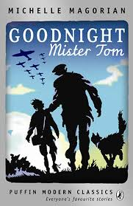 *Goodnight Mr Tom -* Michelle Magorian

Goodnight Mr Tom is a very indulgent book, it draws you in with its captivating language and each chapter you discover something that leaves you curious, disconsolate or content. William Beach is a young boy born in London who is evacuated to the country so he can be safe from German bomb raids. He is nervous and deprived child who is treated appallingly by his mum. When he arrived at Mr Tom Oakley he is extremely quiet and reserved. But a strong relationship begins to form between the two characters as Mr Tom realises something is going on at his home back in London. Some time later William was sent home because his mother was ill and then isn’t heard from for some weeks. Eventually Mr Tom decides to go and find him. When he did find him he found him in a horrific state and takes him to a hospital. Where he is treated badly and has nightmares. Mr Tom ends up taking him forcefully back to Little Weirworld where he adopts him officially. When William returns he is met with the grave news that his best friend, after travelling to London got killed in a bomb attack. He is distraught and lonely but eventually he finds peace and lives with him in his heart. It shows you how strong relationships can become so real if you word it right & how love can give someone the courage to go on. This book has a lot of feeling in it, and the author is very good at making you feel what she is feeling. Because then you can take the words and know what it was like for that character in a way that you almost feel like you know the person it has been written so well. In conclusion I think this book is inspiring it shows the love between two people one of which used to be a fusty, bad tempered and grumpy man. I would recommend this book to older or more advanced readers because it has quite a grown up way of writing and there is are many ‘hard to read’ points.

Genre- Fiction, a historical book

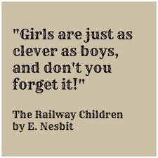

***The Railway Children*** –Edith Nesbit

The Railway Children is quite an adventurous novel. I like it because there is no mean character to spoil things because the children manage to befriend all the other characters by either saving them or by generally being friendly. This author creates a feeling of mystery by making the mum quite nervous when she talks about their father it makes you question the information you are being given through the dialog said by the mother. There is also the feeling of tension as the author makes it clear that this family is gradually getting poorer so they have to start doing things like not having bread, butter and jam its either one or the other. This makes it much more exciting to read as you begin to analyse the dialog more to see if there is something more behind the black ink letters and white sheet paper which is presented to us. If you do this you will start coming up with questions which you’ll obviously want answering and this book will undoubtedly answer them. It also helps us understand that words aren’t just words, words are feelings that come from the heart and that these letters are the way that this author shows her emotions through a good book. In conclusion I think this book is cleverly written and will entice anyone who likes action will that little bit of maturity.

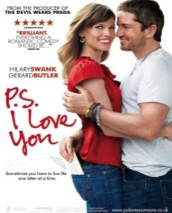

‘P.S. I LOVE YOU’ By Cecelia Ahern

Genre-Fiction, children literature

The book I would recommend is P.S. I LOVE YOU by Cecelia Ahern because it’s really sad, but it’s also about reality and getting over someone you really love. Holly and Gerry met when they were very young and fell in love instantly. They are married and very happy… But when Gerry starts getting awful migraines he and holly should be prepared for the worst news yet…

Gerry is dead and Holly now needs to get over him, she finds this difficult but just as she’s about to lose hope Gerry’s first letter arrives. Gerry has sent her letters throughout the course of a year to help Holly get over him, each letter signed at the bottom with **P.S. I LOVE YOU.** Gerry’s letters help Holly get through some tough times and get her back on her feet after his death.

‘A bitter-sweet storyline guaranteed to tug on your heartstrings.’

*Glamour*

**‘Roxy’s Baby’ – By Catherine Macphail**

**Teenage/young adult fiction**

A book about a young girl called Roxy who falls pregnant and as she is too scared to tell her family she runs away.

In the process, she finds out about a place where young girls can go and have their babies. Amazed yet still unsure about the sound of it. Roxy goes to the house to lots of girls in the same situation as her.

Was everything as perfect as she thought?

This story had me hooked and I couldn’t put it down. The story line is very exciting and the ending is unexpected.

‘Wolf Brother’ By Michelle Paver

Adventure

‘Wolf brother’ is the start of a series and is set in the far past when men lived in clans. A boy called Torak has set of on a dangerous journey to destroy a demon bear which has put the whole forest into fatal danger. The bear was created to kill Torak’s father but it breaks free of the spell and destroys everything in its path.