Top Ten Fiction in Moray in May 2014 Top Ten Non-Fiction in Moray in May 2014

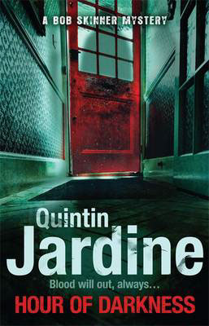 | Hour of Darkness by Quintin Jardine |  | 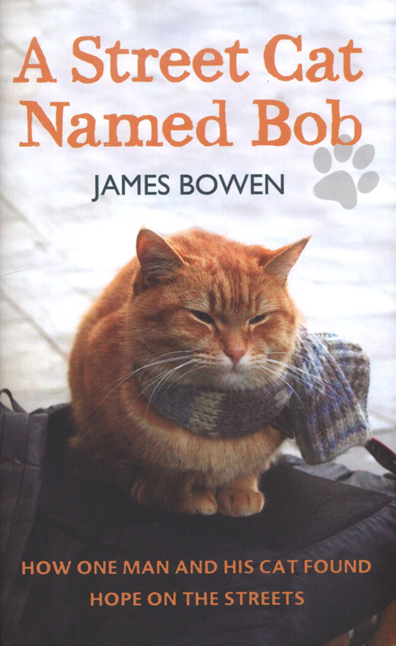 | A Street Cat Named Bob by James Bowen
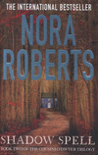 | Shadow Spell by Nora Roberts |  |  | Hebrides by Peter May
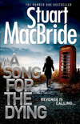 | A Song for the Dying by Stuart MacBride |  |  | All God’s Children Need Travelling Shoes by Maya Angelou
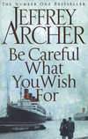 | Be Careful What You Wish For by Jeffrey Archer |  | 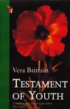 | Testament of Youth by Vera Brittain
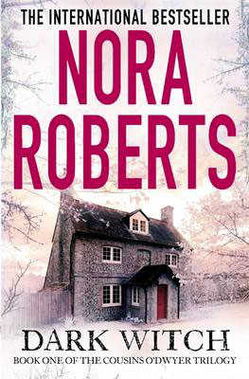 | Dark Witch by Nora Roberts |  |  | Force Benedict: Churchill’s secret mission to save Stalin by Eric Carter
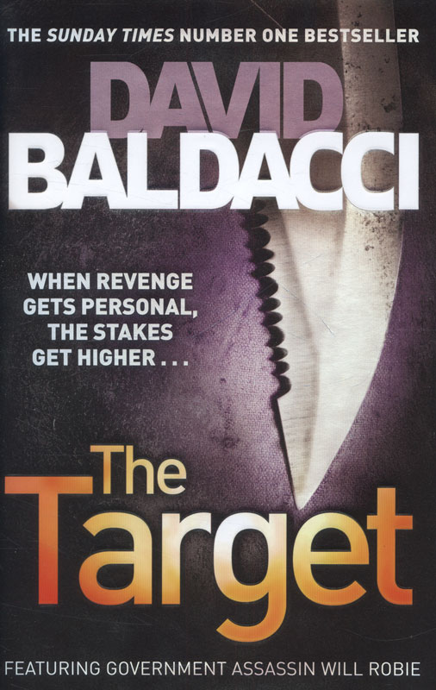 | The Target by David Baldacci |  |  | Save with Jamie: shop smart, cook clever, waste less by Jamie Oliver
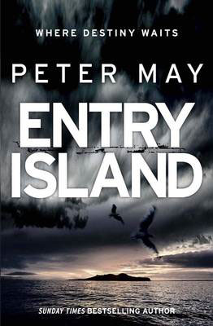 | Entry Island by Peter May |  | 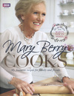 | Mary Berry Cooks by Mary Berry
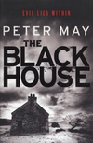 | The Blackhouse by Peter May |  | 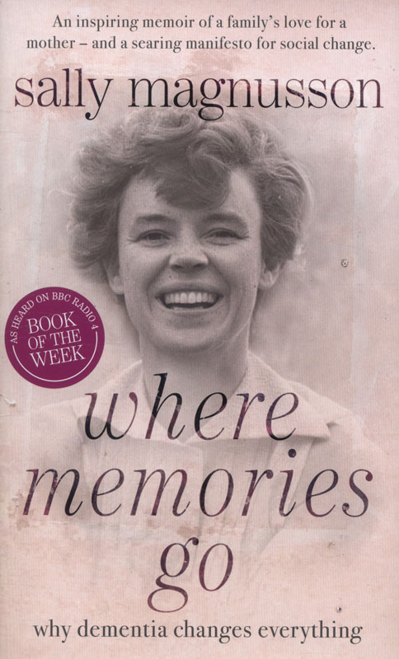 | Where Memories Go: why dementia changes everything by Sally Magnusson
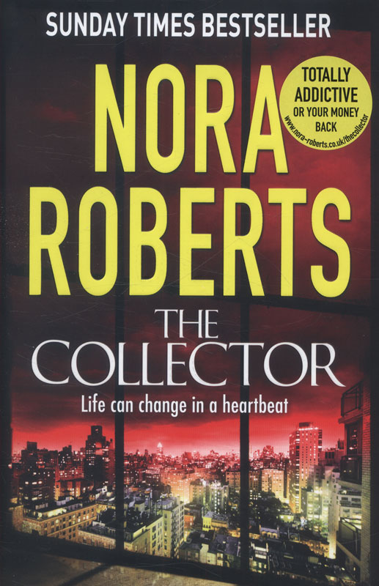 | The Collector by Nora Roberts |  | 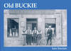 | Old Buckie by Iain Sinclair
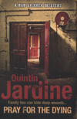 | Pray for the Dying by Quintin Jardine |  |  | I am Malala: the girl who stood up for education and was shot by the Taliban

Here are the most popular books borrowed from Moray Libraries in May 2014.

Use our online reservation facility to reserve your copy.

http://capitadiscovery.co.uk/moray/

You can browse, place a reservation or renew your loans by clicking on the ‘My Account’ button.
Borrowers wishing to use this facility will require their borrower and PIN numbers.

The Spirit of Moray Book Festival
20th – 27th September 2014


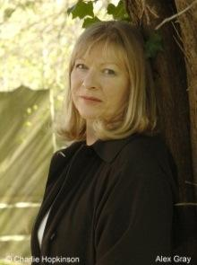
Among the many authors appearing at this year’s festival will be Alex Gray talking about her latest novel, The Bird That Did Not Sing, Jack Webster, world travelled journalist, author and broadcaster talking about his autobiography A Final Grain of Truth, and D A (Denzil) Meyrick talking about crime writing and his novels Whisky from Small Glasses and The Last Witness.

The National Library of Scotland will be presenting free sessions including an event celebrating great characters from Scottish literature.



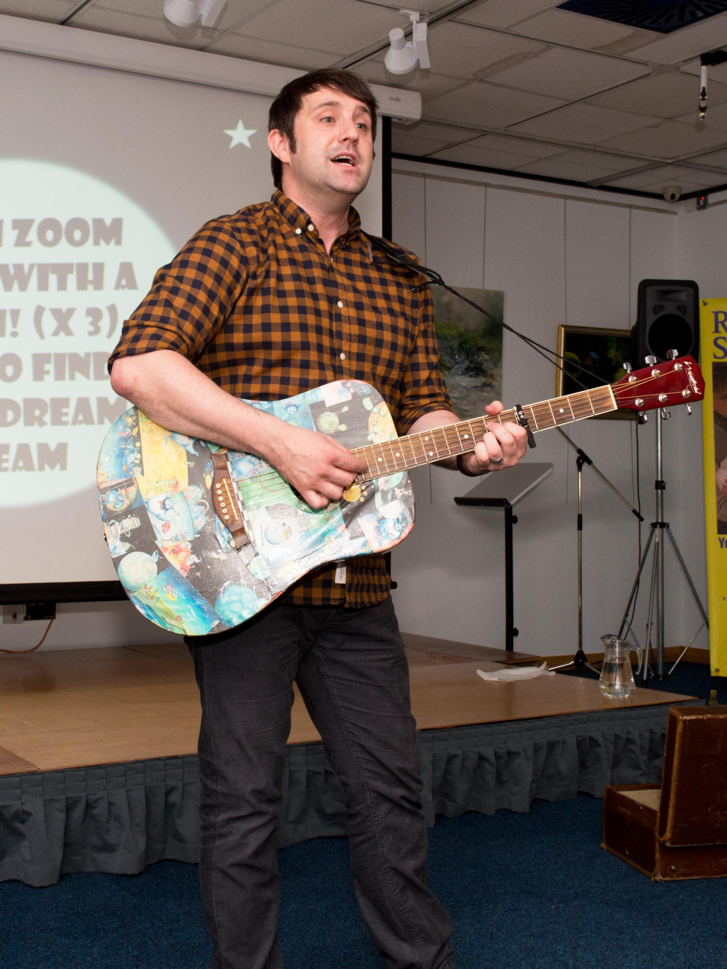
A schools programme is also offered with a range of authors specialising in books for nursery aged children to those in Primary 7.

Scottish Children’s Book Award 2014 authors Chae Strathie and Janis Mackay are two of the well reputed writers who will be appearing.

Look out for the full programme in the coming weeks.

Reading Group Snippets
Here are some opinions of books read by some of our Reading Groups in May.

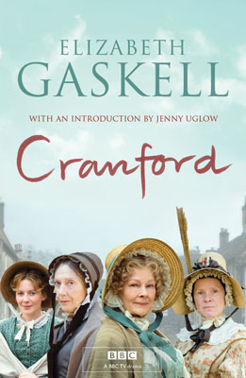
Elgin Library Afternoon Reading Group discussed Cranford by Elizabeth Gaskell at their May meeting. The group was divided over this book. One member said it was just the tonic she needed during the stressful time of moving house and that she frequently returns to old favourites at times like this. Those who enjoyed the book thought the characters had been well drawn, although with a minimal use of language, and several members of the group could draw parallels between the characters and formers neighbours in the rural communities in which they had grown up. Those who did not like the book were irritated by its silliness and superficiality – so little actually happens and the characters are so unlikeable on the whole that one does not care what happens to them. These readers wished for something more challenging. It was felt by all that young adults would find little of interest in the book
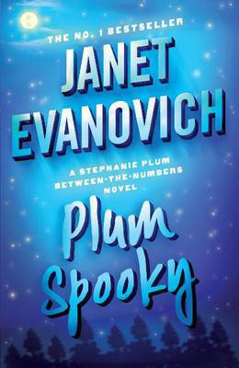
The book on offer at Forres Library Wednesday Reading Group was Plum Spooky by Janet Evanovich. This was enjoyed only by a couple of group members but the majority didn’t like it. It was thought that it was about the worst book to read as an introduction to the ‘Plum’ series of books by those who were fans of Evanovich. It was given a ‘thumbs down’ as the group believed it included poor context, bad language and was crude and had too many characters which had been introduced in other Evanovich books and just dropped into this particular series.
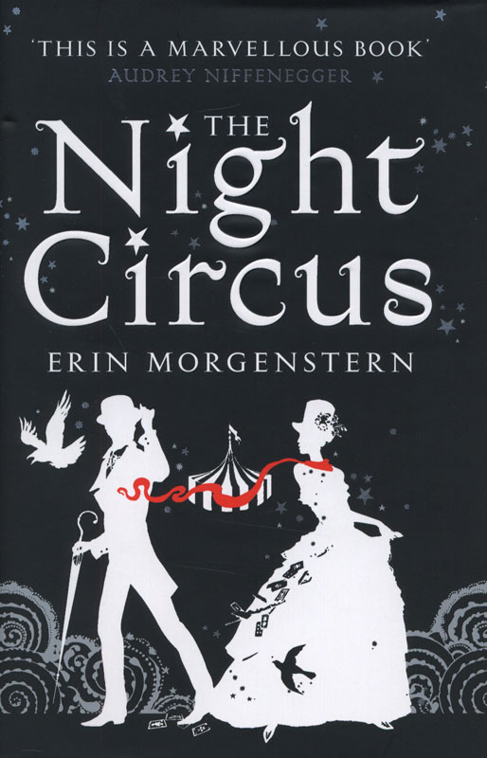
Cullen Library Reading Group’s May book was The Night Circus by Erin Morgenstern. There was an overwhelming ‘thumbs down’ for this book as the group members found it strange and absurd. However, one member did think it was an imaginative, well-written piece of writing but wouldn’t really recommend it to others.



Buckie Library Evening Reading Group were impressed by Toni Morrison’s Beloved. One member thought that the book deserved to be called a masterpiece. The feeling was that the writing was beyond brilliant although the story was deeply disturbing.

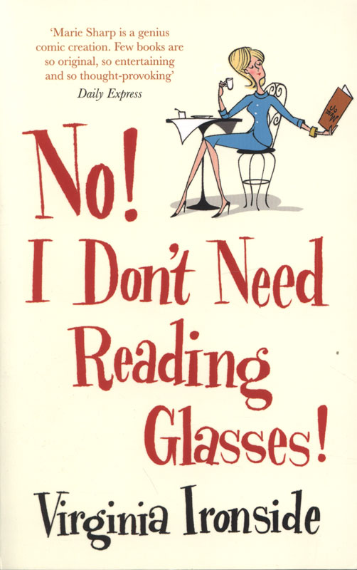
No! I Don’t Need Reading Glasses by Virginia Ironside was the chosen read for Lossiemouth Library Reading Group this month. The group enjoyed the book but found it a bit superficial. However, they all indentified with some aspects of the main character, mainly relating to the forgetfulness that increases with age. Most of the characters were appealing and entertaining. Some of the group though it was a bit ‘Londonish’. The group thought it would not appeal to men but would recommend it to ladies looking for some light entertainment or some cheering up.

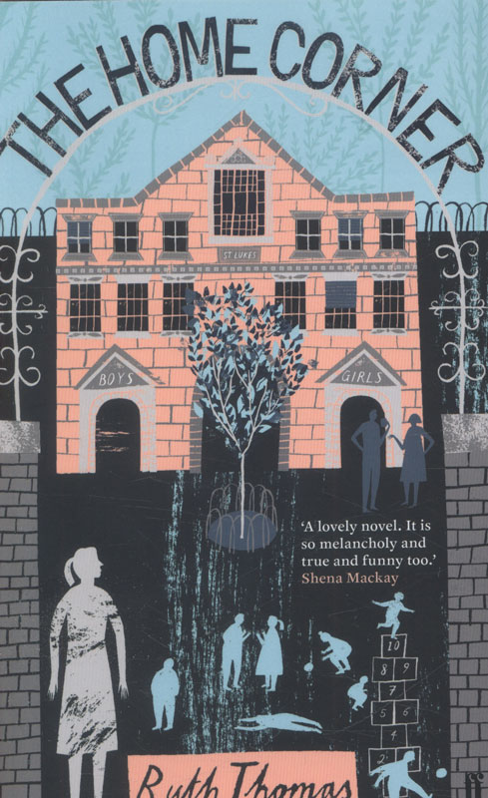
Keith Library Reading Group received free copies of The Home Corner by Ruth Thomas to review from the publisher. Unfortunately the group found it very disappointing. They did agree that it was well-written and a quick and easy read. They felt that the author had lots of good ideas but she didn’t develop them or the characters in any depth. The description of the school was good, you could have been there, and again lots of hints at good ideas, but nothing developed. They believed that there was no sense of the audience that it was aimed at and if it was intended for teenagers to make them realise the consequences of unprotected sex, then it wasn’t anything like punchy enough to keep their attention. As a whole they came to the conclusion that although the setting was good and there was lots of potential for a good story the good story just didn’t happen. They wouldn’t recommend the book to their friends.

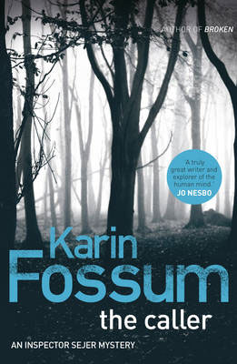
The Caller by Karin Fossum was discussed by Forres Library Thursday Reading Group. It was generally enjoyed by all of the group members attending although it was not as full of suspense as many psychological thrillers. One group member went on to read another title by the author. It was given a very good by the group as there were many twists and turns which kept the reader guessing.

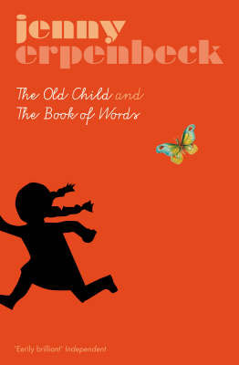

At Aberlour Reading Group the discussion was about The Old Child & the Book of Words by Jenny Erpenbeck. The group’s comments on this title ranged from ‘Weird and nothing explained’, ‘Self-indulgent (possibly lost in translation) and attuned to psychotherapy and not literature’, ‘Ghastly!’ and ‘Who published this – life’s too short’. So a resounding negative for this book all round.

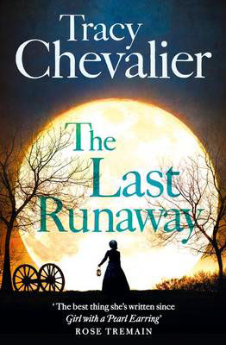
The Last Runaway by Tracy Chevalier was read by Elgin Library Evening Reading Group. Most of the group enjoyed the book (only one group member was not keen on it) but they especially enjoyed finding out about the helping of escaping slaves via the ‘Underground Railway’ and about Quakers in the US. It was interesting to hear that Quakers although perceived as ‘good’ still had the human traits of petty jealousy, spitefulness and self-righteousness. The information about the quilts and quilting was interesting to start with but became somewhat monotonous. The storyline on the whole was interesting and kept the attention, the characters were believable and the group would recommend this title although they disagreed with reports in the media that it was Chevalier’s best work since Girl with a Pearl Earring.

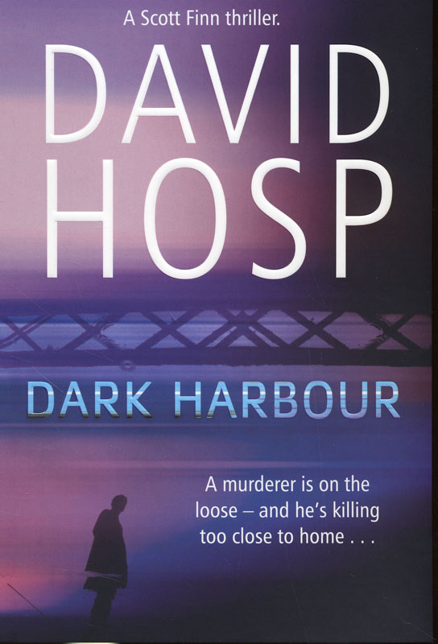
A gritty suspense thriller was on the agenda at Dufftown Reading Group – Dark Harbour by David Hosp. The majority of the group enjoyed this well-written, pacey thriller. They thought the descriptions of sadistic killings and torture were extremely graphic and gruesome and not for the faint-hearted. The characters were likeable and believable but there were a lot of peculiar names to remember. The story provided a couple of good red herrings. Overall the group would recommend this upbeat page-turner although some said only to those who could handle scenes of grisly torture.

Have you read any of these books – what do you think of these?


Have you tried our eBook and eAudio services?

Ebooks http://moray.libraryebooks.co.uk

Eaudio http://moray.oneclickdigital.eu
to create your account enter MC before your library card number.

No reservation charges – no late fees!

Look out for these new titles in June.

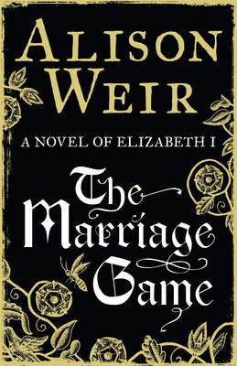
Here is the new historical novel from Alison Weir – the Marriage Game.
The relationship between the young Elizabeth I and the dashing but married Lord Robert Dudley is the most extraordinary and controversial of royal love affairs. Whether the self-styled Virgin Queen and Robert, the son and grandson of traitors, slept together or not was a pre-occupation of the court and their open flirtation, whether or not it was consummated, very nearly cost Elizabeth the crown.

Mr Mercedes is the new book from master of suspense Stephen King
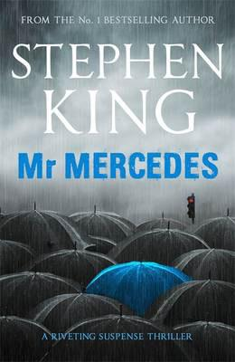
It’s a cat-and-mouse thriller featuring a retired homicide detective who's haunted by the few cases he left open, and by one in particular - the pre-dawn slaughter of eight people among hundreds gathered in line for the opening of a jobs fair when the economy was guttering out. Without warning, a lone driver ploughed through the crowd in a stolen Mercedes. The plot is kicked into gear when Bill Hodges receives a letter in the mail, from a man claiming to be the perpetrator. He taunts Hodges with the notion that he will strike again. Hodges wakes up from his depressed and vacant retirement, hell-bent on preventing that from happening.

The Baileys Women’s Prize for Fiction 2014


The Baileys Women's Prize for Fiction winner was announced as Irish debut author Eimear McBride with her first novel A Girl is a Half-Formed Thing.
Helen Fraser, Chair of Judges, said: “An amazing and ambitious first novel that impressed the judges with its inventiveness and energy. This is an extraordinary new voice – this novel will move and astonish the reader.”

