
KEITH PRIMARY: STANDARDS AND QUALITY REPORT 24-25
SUMMARY VERSION
Every year, schools work with their communities to decide on priorities for improvement. The actions are recorded in a School Improvement Plan (SIP). At the end of session, progress is measured and reported in a Standards and Quality Report. This document summarises progress in session 24-25
Learning and Teaching | Raising Attainment | Digital Skills | Supporting All Learners
The MetaSkills 4.0 Framework was introduced across all classes. This helps pupils learn about the skills they require for life and work beyond school.  Teachers used a book called ‘Power Up your Pedagogy’ to help improve their teaching  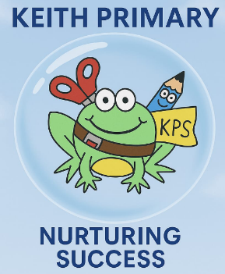  We simplified and revised our vision (Keith Primary: Nurturing Success) and simplified our values (Aspirational, Inclusive, Resilient)  Rationales / policies for Play and Active Start were created by teachers. | Our P4 classes and P5BW took part in a national writing programme which we call ‘The CYPIC approach’. We saw lots of benefits:  - Improved attainment    - Greater confidence  - Longer pieces of writing produced  - Greater motivation  New interventions, to support those who require extra help, were introduced  - Hi 5 awards  - Inner Wings  - LIAM training  - Art therapy  - Swimming |   A new progression was introduced for computer / ICT skills to help ensure learners learn all the skills mentioned in the curriculum.  Digital profiles replaced paper versions of the Learning and Achievement Profiles. Learners and staff are becoming more confident with this. However, the success of this was limited due to various issues with IPads. Some P6 pupils were trained as ‘Digital Leaders’ so they can help younger pupils. | The Circle Framework was introduced to teachers. This helps teachers make their classrooms more inclusive. This is a large document so more work will be done in 25/26.    A literacy difficulties / dyslexia framework was created and all staff received additional training on how to assess and identify literacy difficulties.  New assessments were purchased and introduced to help this work.

