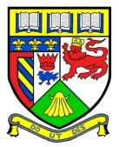**Keith Primary School**

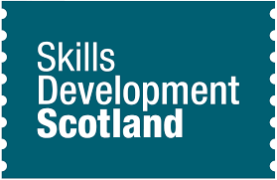Meta-Skills: A Guide for Parents  
August 2025

*Meta-skills are a set of skills and abilities that help everyone adapt and succeed in various life situations, including work and education.  From birth, children use and develop meta-skills as they test and explore the world around them. These skills continue to develop as we grow up.*

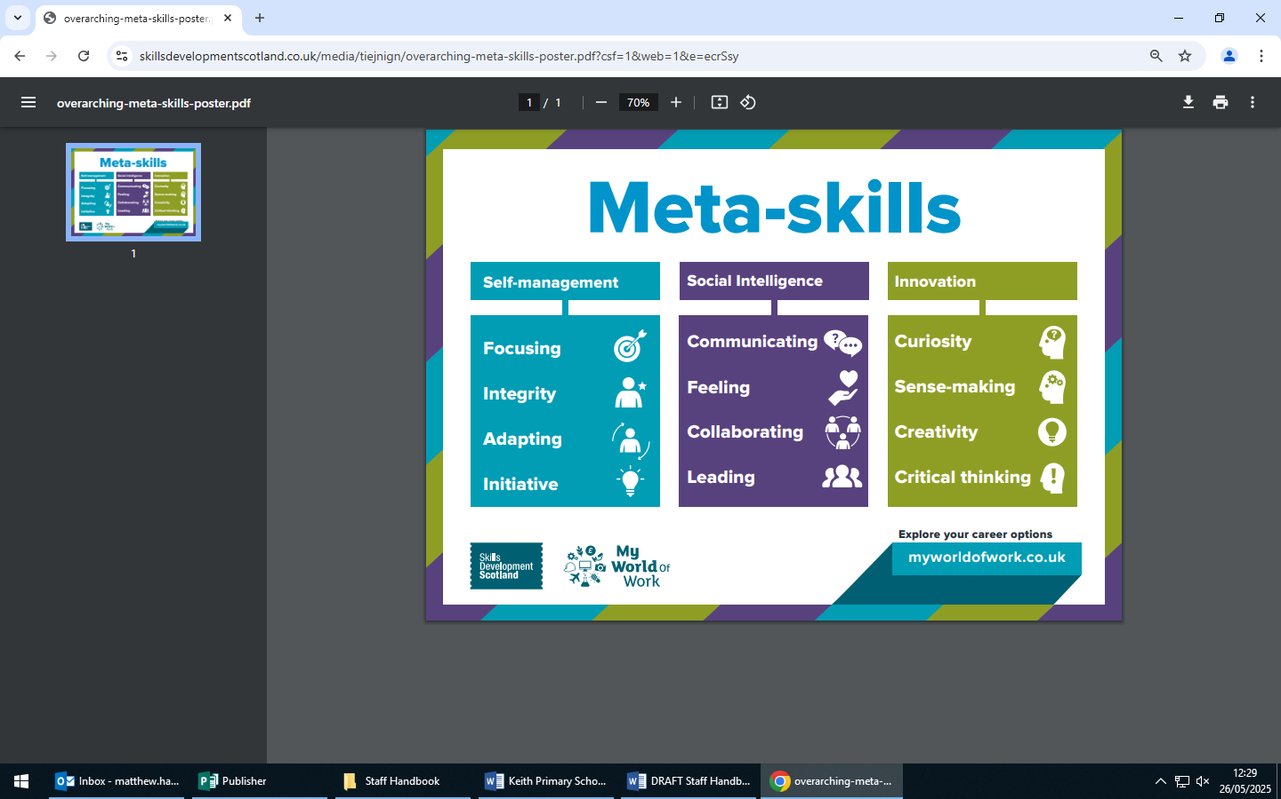

Supporting learners to identify and understand meta-skills is important to help build the qualities that their future employers will need.

At Keith Primary we follow the   
*Meta-skills Toolkit* developed by **Skills Development Scotland**. The toolkit introduces learners to the language of meta-skills at a young age.

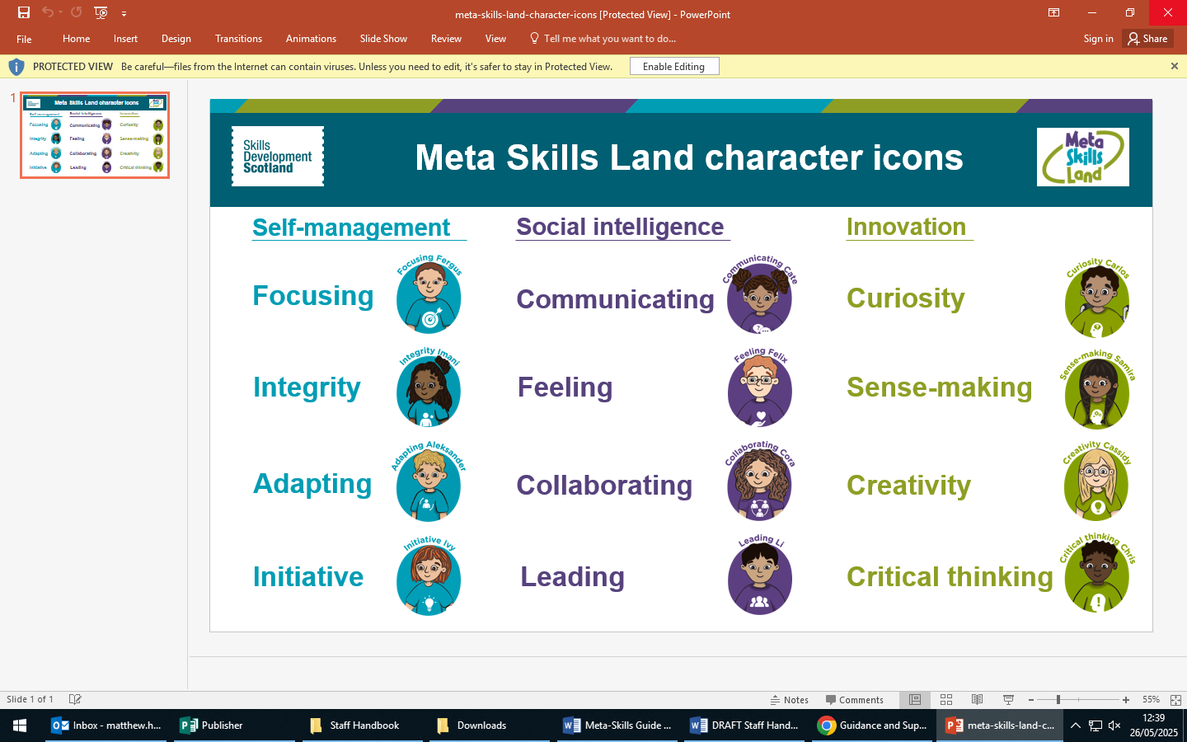

Both children and teachers use these terms in lessons to help children recognise and understand which skills they are developing.

Meta-Skills are taught alongside other subjects so, when pupils are doing art or science for example, they naturally talk about the skills they are using

At KPS we use the logos provided by **Skills Development Scotland** in each class to help children identify each skill. Some classes also use the character icons, pictured, to help make the skills and their descriptions more visual and child-friendly.

At Keith Primary we hope that by using the *Meta-skills Toolkit* as a natural part of everyday it will empower young people to be successful learners, confident individuals, responsible citizens and effective contributors.

For more information on the *Meta-skills Toolkit*, log on to **the Skills Development Scotland** website at: <https://www.skillsdevelopmentscotland.co.uk/what-we-do/scotlands-careers-services/education-team/meta-skills-toolkit>